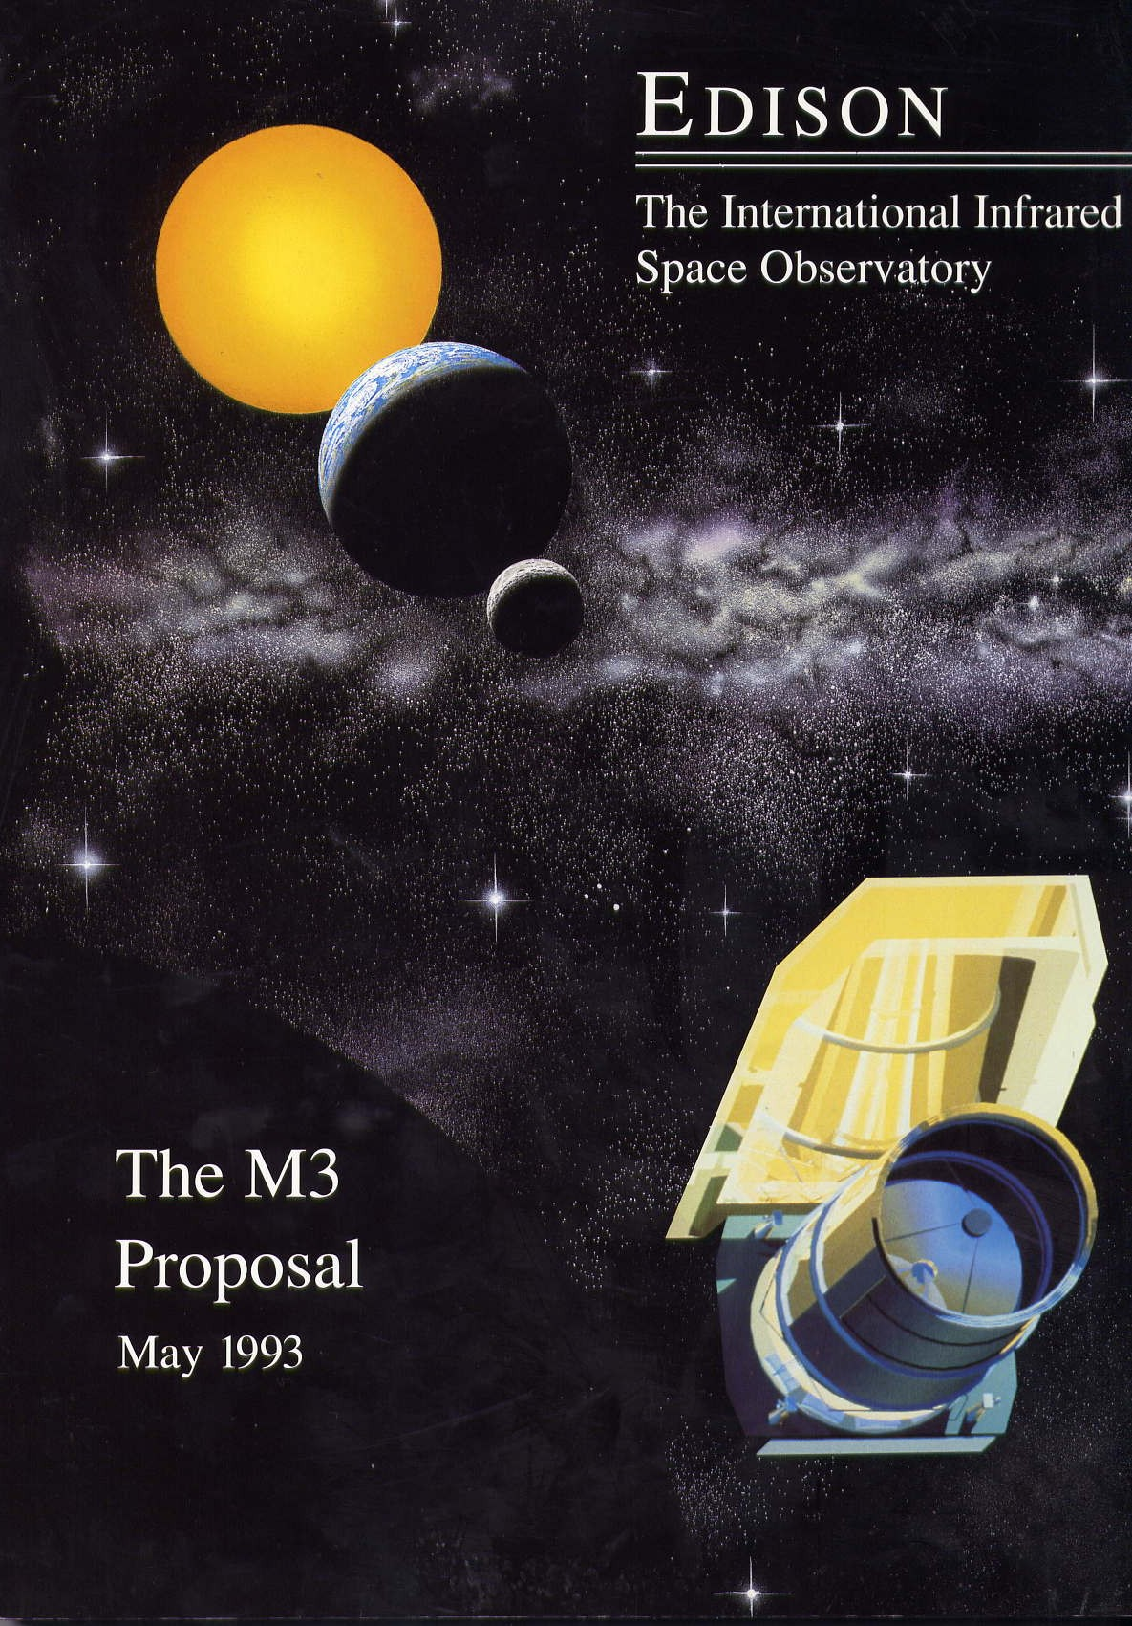

A decade before the Spitzer infrared telescope and twenty years before the expected launch of the James Webb Space Telescope, a small band of European and American astronomers proposed a large-aperture, lightweight radiatively cooled infrared telescope operating at the Sun-Earth L2 point The story of how a radical new way to do infrared astronomy from space was conceived, and refused to go away, is a lesson for anyone who seeks to buck conventional wisdom and struggles to persuade others to think ‘outside the box’. (Image courtesy Rutherford Appleton Laboratory).

It will never work! An idea that changed infrared astronomy from space.

By John K. Davies.

The major challenge to operating infrared telescopes is that at these wavelengths warm mirrors ‘glow’, emitting infrared radiation of their own. Unless the telescopes are very cold, the tiny infrared signals they seek to collect simply drown in the heat from the telescope itself. To operate at long infrared wavelengths, a telescope must be cooled down to temperatures not far above absolute zero (0 Kelvin or -273 degrees C), something only possible in space. The first generation of infrared space telescopes, such as IRAS (1983) and COBE (1989), accomplished this by putting the telescope inside a liquid-helium filled Dewar. This conceptually simple, albeit technically challenging, method works very well, but mission lifetime is limited as the supply of cryogens boil away. Attempts to design bigger or longer lasting infrared telescopes in the 1990s were hamstrung as the Dewar and its cryogens soon became far too large and massive to launch.

A solution came from an unlikely quarter. In the early 1980s Tim Hawarden was an astronomer at the Royal Observatory Edinburgh (ROE) in Scotland who had been thinking about the preliminary (Phase-A) design of the European Space Agency’s Infrared Space Observatory (ISO). The ISO concept used traditional liquid cryogen cooling plus a large sun-shade to reduce the heat load on the outside of Dewar. It occurred to Hawarden that it would be interesting to consider another, radically different approach. If the helium cryostat was removed entirely, protection from the Sun was improved and a series of concentric cylindrical radiators were fitted around the telescope, the optics would cool solely by radiation to cold space. Without the need for a Dewar, the telescope mirror could be two or three times larger for the same size of satellite. Furthermore since there were no cryogens to run out, it would have a much longer lifetime. It looked like a win-win situation, but the critical question was would radiation alone cool the telescope enough? Some very basic calculations showed that a telescope temperature of 30-100K should be achievable, adequate to observe at wavelengths out to10-20 microns. At longer wavelengths, where the infrared sky is dominated by very many closely spaced galaxies which act like a confusing background wallpaper, the better angular resolution of the larger mirror would outweigh the reduced sensitivity that comes from higher telescope temperatures.

If correct, this was the breakthrough that would make a generation of large-aperture infrared astronomy missions possible. Other ideas quickly emerged. Lower telescope temperatures would be achieved by putting the satellite into a high orbit, where the radiant heat from the warm Earth would be reduced. Mechanical coolers could cool the sensitive infra-red detectors still further. Working part-time Hawarden refined his thinking and when, in 1989, ESA called for ideas for its second medium-sized mission, he felt ready to respond. He proposed a 1.5 metre telescope, dubbed the Passively-cooled Orbiting Infrared Observatory Telescope (POIROT) and was invited to present it to the ESA assessment panel. On being told of this development, ROE director and the Astronomer Royal for Scotland, Malcolm Longair, called for a weekend ‘brains trust’ to reassure himself and his senior staff that Hawarden was not leading the observatory on an expensive and embarrassing wild goose chase. After several hours of intense scrutiny, the proposal went forward. Unfortunately, although well received, POIROT was not one of the proposals selected for further consideration. Meanwhile, a handful of similar studies were beginning to show the same result: in 1989 Phillip Tulkoff published a paper on how a 10-metre diameter telescope, a possible successor to the Hubble Space Telescope, could be cooled to 70 Kelvin solely by radiative cooling.

Although disappointing, ESA’s rejection was only the beginning of the road for radiative cooling. Hawarden’s idea had caught the attention of Harley Thronson, an astronomer from the University of Wyoming spending a sabbatical year at ROE. He had participated in the original POIROT proposal and, after its rejection by ESA, he started to promote the idea, adopting the name, Edison in recognition of the American inventor’s early contributions to infrared astronomy. Hawarden’s years of quiet work was about to be imported to the US and collide head on with a large, community working on more conventional designs for infrared space telescopes. Edison was immediately controversial as it was in direct conflict with traditional open loop cryogenic cooling concepts which had considerable engineering heritage and a large and committed community behind them.

In the environment of the early 1990s, Thronson could secure very little funding for so radical a design. Thus, he observes wryly that the first US design for a large-aperture, non-cryogenic space observatory was paid for on his MasterCard and carried out by a University of Wyoming engineering graduate student alternating with his official work on snowplough design. As time went on Edison’s supporters had to fund increasingly sophisticated designs creatively and via the unpaid efforts of volunteers who one by one became convinced of the value of doing away with cryogens. However, the more the radiative approach was examined, the more promising it seemed. There simply were no obvious show stoppers.

The work led by Hawarden in Europe and Thronson in the US resulted in a series of papers beginning in 1990 and a conference hosted by the Royal Observatory Edinburgh in 1991. At this meeting John Farrow, an engineer with British Aerospace, drew attention to the work of Robert Farquhar and David Dunham on orbits at the Sun-Earth L2 Lagrangian point, some 1.4 million kilometres from Earth. He suggested that Edison be located there. The L2 orbit has the advantage that while close enough to the Earth for relatively high data rates, it is far enough that the Earth and the Moon do not affect the telescope optically or thermally. Thus, with its lightweight mirror, warm launch with radiative cooling, and operation at the Sun-Earth L2 point, Edison became a model for a generation of future space observatories. 1n 1991 Thronson submitted the first Edison proposal to NASA but the agency, busy trying to realise the helium cooled SIRTF mission whose size, launcher, orbit and budget had already undergone major changes, rejected the proposal.

Frustrated but still determined the Edison team worked on. A detailed proposal involving a large consortium of European and US astronomers was made to ESA in May 1993 in response to its third medium mission proposal round. The Edison team proposed a 1.7m telescope with twice the diameter – hence four times the collecting area -- of any liquid helium cooled rival. The mirror temperature would be about 20K, limiting the telescope performance only at wavelengths longer than 50 microns, but even at these wavelengths the larger aperture would simplify the problem of the confusing background galaxies. Finally, with no cryogens to run out, the mission lifetime would be constrained only by component, or budgetary, failure.

The proposed leap in performance by Edison was now so great that it aroused even more scepticism. Edison would be launched warm and cool down on orbit, how long would this take? Could large mirrors be made to keep their shape as they cooled? Could the mechanical coolers alone cool the detectors to their operating temperatures of a few Kelvin? Under what circumstances would a large-aperture telescope at 25 K outperform a much smaller telescope at a few K? However, ESA became convinced enough to study Edison further, even while NASA refused to explore the idea seriously. Although ESA judged Edison feasible, they decided that another new infrared mission would not fit in to their scientific programme (their own cryogenic mission ISO, with its 60cm telescope, was heading to the launch pad in 1995). By this time, however, the concept of radiative cooling, as demonstrated by the POIROT and Edison design work, was becoming established: in late 1993, the Very Cold Telescope (VCT), a more ambitious version of Edison was designed, using mechanical coolers connected to its primary mirror to reach temperatures comparable to cryogenic telescopes, while maintaining the very large aperture of a radiatively cooled observatory. Another opportunity then presented itself, with a US call for proposals in 1994 for new concepts that could follow the NASA “Great Observatories” missions. Peter Stockman, at the Space Telescope Science Institute, organized some of the POIROT and Edison teams to try again but, once more, the proposal - High Z - was not selected.

Thus, over a period of five years – 1989 to 1994 -- the two major space agencies had rejected a total of four major proposals for large radiatively cooled telescopes operating at infrared/sub-millimetre wavelengths. Nonetheless, the paradigm had shifted. For the first time large infrared telescopes seemed possible and the L2 Lagrangian point became the preferred location for missions of all kinds. Although proposals for a large-aperture radiatively cooled infrared telescope would never win either an ESA or a NASA competition, “conventional wisdom” had moved on from cryogenic cooling. In 1996, the Dressler Committee’s “HST & Beyond” identified Edison and High-Z as the design paradigm for future infrared telescopes. As a result, Edward Weiler at NASA HQ directed modest funding for the NASA Goddard Space Flight Center to begin preliminary design work on three concepts for future post-HST space telescopes. All the design groups, two aerospace teams and the GSFC team, led by John Mather and Pierre Bely, who were early supporters of Hawarden’s work, developed designs for large, passively cooled infrared telescopes. The convergence of those three concepts would eventually lead to the JWST.

It is sobering to consider lessons learned from this story. First, changing paradigms takes time and effort. It was about a decade between Hawarden’s first controversial calculations in the mid 1980s and the Edison proposal to ESA which finally tipped the scales. During this period, the concept of purely radiative cooling of space telescopes was strenuously criticised by many scientists and engineers in the US, even as the designs became more robust and a few experienced engineers began to confirm Hawarden’s prescient intuitive work. Second, it is important to knock on every door. When one agency turned down a proposal, this small group of visionaries proposed to another and kept trying. And third, paradoxically, there can be an advantage of being outside the mainstream - and so less constrained by programmatic demands and engineering inertia. POIROT and Edison came from people who were not based within the space agencies or at universities with large space science departments

Finally, we should not forget the human side of this adventure. The POIROT/Edison team was frequently and widely criticised for half a decade, but even when proved right, they have yet to achieve wide recognition. SIRTF, today renamed Spitzer, struggled on with various cryogenic concepts and redesigns until late 1993 and then switched to a new design which made aggressive use of radiative cooling after a warm launch. JWST adopted radiative cooling from the beginning. Hawarden, recently retired although still active, is sanguine. He observes “I seem to have gone from headstrong upstart to grand old man without any of the respectful stuff in between.” Your author, who played a minor part in this saga, was recently at a meeting when a speaker said ’Yes, passive cooling, this is obvious’ Well it is now, but it took some people longer than others to realise it.

John Davies is an astronomer with the UK Astronomy Technology Centre at ROE, who participated in the 1989 POIROT brains trust, and helped write the Edison proposal to ESA in spring 1993. He is the author of ‘Astronomy from Space’ published in 1997.

