Document Title | Operations & Maintenance Manual  (Including Handling/Maintaining Optics & Spare List)
Document Number | 1.1 d 062 G
Issue | v0.2
Date | 24 June 2004

Document Prepared By: | David Montgomery  Ken Laidlaw  Jim Elliot  Keith Burch  David Henry | Signature and Date
Document Approved By: |  | Signature and Date
Document Released By: |  | Signature and Date

CHANGE RECORD
Issue | Date | Section affected | Change Description
0.2 | 24 June 04 | Various | Changes to text

TABLE OF CONTENTS
List of figures 6
1. FOCUS MECHANISM ASSEMBLY 8
1.1 Introduction 8
1.2 Preparing for assembly 8
1.2.1 Spider support 8
1.2.2 Personnel required 8
1.2.3 Equipment required 8
1.2.4 Part masses and centres of gravity 9
1.2.5 Completing the checklist 9
1.3 Focus mechanism assembly 9
1.3.1 Internal carriage 9
1.3.2 Assemble composite flexures 11
1.3.3 Assemble flexure brackets 12
1.3.4 Lead screw and focus motor support structure 14
1.3.5 Assembling main focus bracket 15
1.3.6 Focus Mechanism to spider assembly 19
1.3.7 Horizontal counterbalance weights 22
1.3.8 Thermal wick assembly 24
2. FOCUS MECHANISM SETUP and flexure tests 29
2.1 Introduction 29
2.2 Test setup 29
2.3 Test procedures 29
2.3.1 Adjusting the limit switches 29
2.3.2 Detector box tilt 30
3. Filter Paddle mECHANISM ASSEMBLY 34
3.1 Introduction 34
3.2 Preparing for assembly 34
3.2.1 Mechanism support 34
3.2.2 Personnel required 34
3.2.3 Equipment required 34
3.2.4 Part masses and centres of gravity 34
3.2.5 Completing the checklist 35
3.3 Moving arm assembly 35
3.3.1 Worm wheel assembly 35
3.3.2 Assembly into paddle mount 36
3.3.3 Assemble bearings 36
3.3.4 Shaft end caps 37
3.3.5 Filter paddle 38
3.3.6 Balancing the moving arm assembly 40
3.4 Fit worm shaft assembly 41
3.4.1 Setting pre-load 43
3.5 Datum switch assemblies 44
3.5.1 Datum switch block 44
3.5.2 Micro-switch mounting block 44
3.5.3 Micro-switch housing 44
3.5.4 Setting up micro switches 44
3.6 Motor assembly 45
3.7 Brake assemblies 46
3.7.1 Brake pads 46
3.7.2 Brake spring 46
3.8 Filter housing baffle 47
3.8.1 Stand offs 47
3.8.2 Filter housing baffle 48
3.9 System information 48
3.9.1 Mechanism set-up 49
3.9.2 Torque settings 49
4. FILTER PADDLE SETUP 50
4.1 Introduction 50
4.2 Filter positioning 50
4.3 Test setup 50
4.3.1 Software and electrical 51
4.3.2 Level the top ring to the control cabinet 51
4.4 Tests procedure for deployed angle 52
4.4.1 Datum devices 52
4.4.2 Checking deployed angle 52
4.4.3 Adjusting angle 53
4.4.4 Repeat for redundant datum 53
4.4.5 Checking the distance to end of travel 53
4.5 Tests procedure of detector assembly fit check 54
4.5.1 Tests setup 54
4.5.2 Test procedure 54
4.5.3 Results 54
5. CRYOSTAT Bottom SECTION ASSEMBLy 55
5.1 Introduction to Bottom section assembly 55
5.2 Preparing for assembly 55
5.2.1 Instrument support 55
5.2.2 Personnel required 55
5.2.3 Equipment required 55
5.2.4 Part masses and centres of gravity 56
5.2.5 Completing the checklist 56
5.2.6 Torque settings 56
5.3 Vacuum vessel baseplate 57
5.3.1 Thermal isolation trusses 57
5.3.2 Closed cycle cooler 58
5.3.3 Cable connector panels 59
5.3.4 Vacuum system elements 59
5.3.5 Radiation shield base MLI 61
5.4 Mounting the base plate on the Bracket 62
5.4.1 Guide cone 62
5.4.2 Tilt shims 62
5.4.3 Conical interface 62
5.4.4 Insulating ring 63
5.4.5 Base plate assembly 63
5.5 Radiation shield base sub assembly 63
5.5.1 First stage wick 63
5.5.2 LN Can 65
5.5.3 Assemble radiation shield base to thermal trusses 66
5.5.4 Attach second stage wick 67
5.5.5 Radiation shield base cabling 69
5.6 Tertiary bezel assembly 69
5.6.1 Tertiary mirror assembly 69
5.6.2 Manipulating tertiary bezel assembly 70
5.6.3 Mating with the radiation shield base 70
5.7 Internal support tube assembly 72
5.7.1 Assembling Internal support tube components 72
5.7.2 Mating the support tube to the tertiary bezel 73
5.7.3 Connecting second stage wick lower joint 74
5.7.4 Connecting the motor, status and thermal control cabling 74
5.8 Mid radiation shield 74
5.8.1 Mating the mid radiation shield to the radiation shield base 74
5.8.2 Attach the superinsulation blanket 75
5.9 Vacuum vessel mid section 76
6. CRYOSTAT Top section Assembly 77
6.1 Preparing for assembly 77
6.1.1 Instrument support 77
6.1.2 Personnel required 78
6.1.3 Equipment required 78
6.1.4 Part masses and centres of gravity 78
6.1.5 Completing the checklist 78
6.1.6 Torque settings 79
6.2 Assembling the Top ring 79
6.2.1 Mating surface check 79
6.2.2 Attach handling brackets to the top ring 79
6.2.3 Manoeuvre top ring into position and mounting 79
6.2.4 Removing top ring 81
6.2.5 Configuration Check 81
6.3 Assemble the focus assembly 81
6.3.1 Mating surface check 81
6.3.2 Mount onto top ring 81
6.3.3 Make cold wick connections 82
6.3.4 Make the detector motor and status connectors 83
6.3.5 Make the IR detector /guider CCD temperature connectors 83
6.3.6 Carry out a warm functional check of each science device by connecting the detector flexi cables to a pre-amps/SDSU controller 83
6.3.7 Carry out a warm functional check of the autoguider ccd 84
6.3.8 Detector focus assembly cover 85
6.3.9 Configuration Check 85
6.4 Assembling the corrector tube 86
6.4.1 Mating surface check 86
6.4.2 Slinging the corrector tube 86
6.4.3 Configuration Check 87
6.5 Assembling the radshield top section 87
6.5.1 Checking the interface surfaces for damage 87
6.5.2 Slinging the radiation shield top section 87
6.5.3 Manipulating the top section into place 88
6.5.4 Mating the top section 88
6.5.5 Connecting the temperature sensor 88
6.5.6 Connecting the wiring panels 88
6.5.7 Connecting super insulation 88
6.5.8 Assemble superinsulation blankets 89
6.5.9 Assemble conical baffle 89
6.5.10 Configuration Check 89
6.6 i. Presence of covers, tools, debris 89
6.7 Assembling the vacuum vessel top section 89
6.7.1 Mount the four array pre-amplifier racks and autoguider controller onto the vacuum vessel 89
6.7.2 Checking the interface surfaces for damage 90
6.7.3 Checking the vacuum sealing surfaces 90
6.7.4 Slinging the vacuum vessel top section 90
6.7.5 Manipulating the top section into place 90
6.7.6 Mating the top section 90
6.7.7 Connecting the wiring panels 91
6.7.8 Carry out functional tests on the ir arrays & autoguider ccd 91
6.8 Assembling the window bezel to the vacuum vessel 91
6.8.1 Slinging the window bezel 91
6.8.2 Checking the interface surfaces for damage 91
6.8.3 Checking the vacuum sealing surfaces 92
6.8.4 Offering the window assembly up to the vacuum vessel 92
6.9 External tower assembly 92
6.9.1 Field lens assembly 92
7. MECHANISM SOFTWARE USERS MANUAL 94
7.1 Introduction 94
7.1.1 References 94
7.2 Overview 94
7.3 Mechanism Description 94
7.3.1 Mechanism Design 94
7.3.2 Electronic Hardware Design 95
7.3.3 Interlocking 97
7.4 Engineering GUI 97
7.4.1 Overview 97
7.4.2 Mechanism commands 99
7.4.3 Driving Individual Mechanisms 100
7.5 Interlock Recovery 100
7.5.1 Interlock safety mechanism is activated 100
7.5.2 Moving to safety 102
7.5.3 Back to normal 102
7.5.4 What to do if a mechanism consistently fails? 102
7.6 Configuration and Setup 102
7.7 Appendix 103
8. Handling jigs and fixtures 106
APPENDIX a – RECOMMENDED Spares List 108

List of figures
Figure 1 Carriage wick assembly 10
Figure 2 Fastening wick to carriage 10
Figure 3 Internal carriage assembly 12
Figure 4 Internal carriage assembled in spider hub 13
Figure 5 Establishing mid position 14
Figure 6 Pivot shaft assembly 16
Figure 7 Section view of leadscrew assembly 17
Figure 8 Motor and counterweight assembly 19
Figure 9 Assembling mechanism into spider 20
Figure 10 Flexure connecting tabs 21
Figure 11 Tilt counterbalance supports 22
Figure 12 Tilt counterbalance weight assembly 23
Figure 13 Wick trough 24
Figure 14 Wick trough to carriage wick connection 25
Figure 15 Illustrates the components required to terminate the detector cables 25
Figure 16 Autoguider cable termination 26
Figure 17 Motor and status cable termination 27
Figure 18 Fixed and moving bridge assembly 28
Figure 19 Focus assembly on manipulator (picture to be included) 29
Figure 20 LVDT setup with mechanism on manipulator 31
Figure 21 Tilt measurement setup 31
Figure 22 Assembling moving arm and shaft 36
Figure 23 Inserting bearing sleeve 37
Figure 24 Assembling filter 39
Figure 25 Measuring out of balance 41
Figure 26 Inserting worm shaft 42
Figure 27 Inserting bearing 42
Figure 28 Tightening worm shaft end cap 43
Figure 29 Setting end stops and switches 45
Figure 30 Motor assembly 46
Figure 31 Brake flexures 47
Figure 32 Mechanisms mounted on top ring 48
Figure 33 Test setup 51
Figure 34 Level top ring 52
Figure 35 Check deployed paddle angle 53
Figure 36 Baseplate and assembled components 62
Figure 37 Conical interface and G10 insulating shim 63
Figure 38 Assembling first tage wick to radiation shield base 64
Figure 39 LN can on radshield base 65
Figure 40 Assembling radshield base to trusses 66
Figure 41 Second stage wicks on radshield base 68
Figure 42 Tapered guide pin and spacer 71
Figure 43 Tertiary bezel mounted on trusses 72
Figure 44 MLI blanket on mid radshield 76
Figure 45 Assembling mid vacuum vessel section 77
Figure 46 Manouvering the top ring assembly 80
Figure 47 Attaching focus assembly 82
Figure 48 Warm image of Science device 41 (to be included) 83
Figure 49 Warm image of Science device 60 (to be included) 83
Figure 50 Warm image of Science device 62 (to be included) 84
Figure 51 Warm image of Science device 41 (to be included) 84
Figure 52 Image of warm CCD 85
Figure 53 IRAF vertical cut of warm CCD showing linear dark current generation 85
Figure 54 Top Ring Filter Paddle Assembly 95
Figure 55 Filter Paddle Micro-switches 96
Figure 56 Focus Mechanism Micro-switches 97
Figure 57 The main mechanism engineering control screen 98
Figure 58 Single mechanism engineering control screen 101
Figure 59 Top ring handling brackets 106
Figure 60 Spreader beam 106
Figure 61 Swivel hoist rings 107

- FOCUS MECHANISM ASSEMBLY

Introduction
In this section the procedure for assembling the WFCAM focus assembly is described. This consists of the focus mechanism, support spider, wick assemblies and detector box assembly. A description of the process is given along with equipment and personnel required. A checklist is also provided for QA of the process itself.
The detector focus mechanism consists of a main structural element in the form of an annular ring with four spokes which support a hollow square hub. A square section carriage is supported from the hub by a set of composite flexures. The carriage supports the detector box assembly which is stood off by four pillars. The focus position of the carriage is defined by a lead-screw mechanism. The nut for the lead-screw is mounted on a composite bridge piece mounted in turn to the carriage. The lead-screw is supported on a fixed bridge attached to the spider hub. It is driven by a stepper motor also supported on the fixed bridge.
A set of two counterbalance weights are used to partially balance the detector box weight in the axial direction and a second counterbalance weight is used to balance radial tilt of the detector box.

Preparing for assembly
It is assumed for the purpose of this document that the focus mechanism has been removed from the instrument and that a clean work area with a flat bench is available. The re-assembly of the completed mechanism to the instrument is covered in the document “Cryostat top section assembly procedure”.
    - Spider support
The focus spider should be supported in the horizontal orientation on a flat surface using the three legs provided for the purpose. The legs should be fastened to the spider interface flange using a single M6 screw and washer. They should be positioned evenly for maximum stability.

    - Personnel required
The assembly can be done by one person. The assembly is a bit involved and previous experience in doing this would be an advantage but not necessary.

    - Equipment required
The parts can be manually handled by a single individual although an additional person is recommended for handling the full assembly.

Equipment and number | Capacity/Size | Use
Stone/straight edge | 150mm | Detect bruising of interface components
Ball hex drivers x2 | 5mm | Fasteners on spider interface to support legs
Ball hex drivers x2 | 10mm | Fasteners on vacuum vessel top interface
Ball hex driver x 2 | 3mm | Fasteners on the radshield connector panels
Small screw driver |  | Connector screws
Torque wrench and extension to 5mm hex | To measure 10Nm to 50Nm | Torque various fasteners

    - Part masses and centres of gravity
The approximate masses of the parts and their centres of gravity are listed below.
Part | Mass | Mass centre of gravity
Detector box | 2.45Kg | -
Full assembly | 20Kg | -

    - Completing the checklist
The checklist for each task requires two initials and a date. It is recommended that the ‘inspected by’ box be initialled by an observer in charge of the procedure but not involved in doing the tasks. A space is also available for comments.

Focus mechanism assembly
    - Internal carriage
The internal carriage is the moving part of the assembly. It is supported by the flexures and in turn supports the detector box.

i. Assembling the wicks
There are two wicks which must be attached to the internal wall of the carriage. Each is located by two M4 screws; these screws are isolated from the internal carriage by an isolating sleeve. The larger copper block attaches to the carriage with the smaller ends uppermost. The carriage is in the correct orientation when the surface with the tapped holes for the internal composite bridge is facing up.

This is structural mechanical joint and thermal path for the detector cooling. It is not possible to access these parts once the mechanism is assembled beyond this point.

Run a flat surface, straight edge or stone along the mating surfaces to check for bruising. Dress any damage found with a stone or file.
Completed (date) | Checked (date) | Comment

Clean the surfaces and apply a thin coating of vacuum grease

Completed (date) | Checked (date) | Comment

Insert the screws and isolating sleeves and tighten to 3.8Nm, repeat for second wick. (Fig 2)
Completed (date) | Checked (date) | Comment

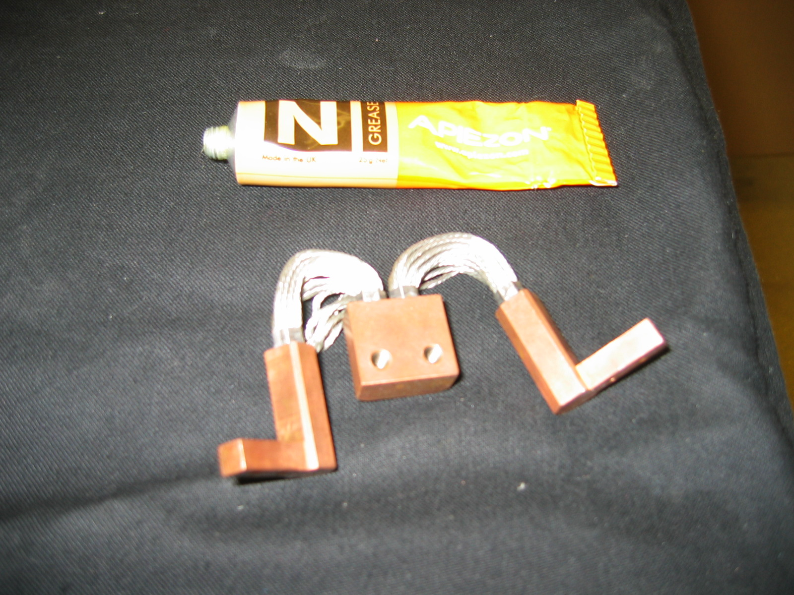
Figure 1 Carriage wick assembly

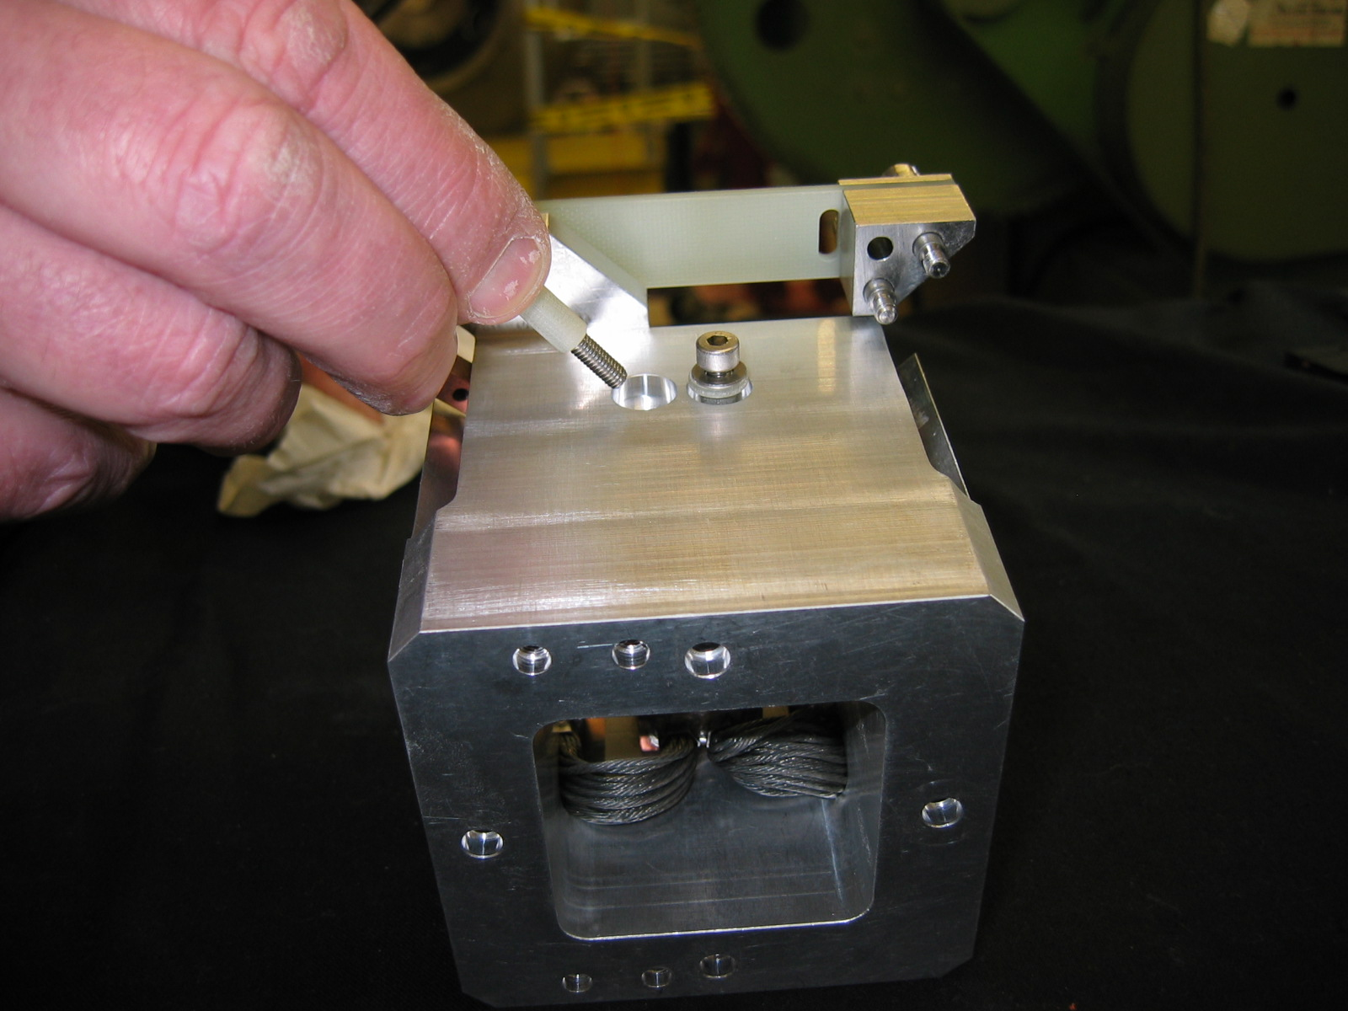

Figure 2 Fastening wick to carriage

    - Assemble composite flexures
The focus flexure blades are manufactured from G10 glass fibre and are arranged in sets of 3 per flexure assembly. These assemblies provide the support and parallel movement required for detector box.

The internal carriage should always be dismantled with the upper set of flexure assemblies in place (Fig 3)

Run a flat surface, straight edge or stone along the mating surfaces to check for bruising. Dress any damage found with a stone or file.
Completed (date) | Checked (date) | Comment

With the carriage in place within the spider place a carriage flexure bracket to the upper surface of the carriage using 2 M4 shoulder screws. NOTE: do not tighten these screws at this point.
Completed (date) | Checked (date) | Comment

Then locate a flexure block 1 onto the carriage flexure bracket place 3 off composite flexures blades on the flexure block. Place another flexure block 1 on top of the flexures at the carriage bracket end. Attach the composite flexures to the brackets via 2 M4 shoulder screws and spacers.

NOTE: do not tighten these screws. Place a flexure block 2 under and a flexure block 1 on top of the flexures at the spider end.

Hold these blocks in place by locating the M4 shoulder screws and spacers. Finally add the M4 socket head cap screws- again do not tighten.
Completed (date) | Checked (date) | Comment

Repeat above for the remaining composite flexures assembly on the upper surface of the spider hub. Taking care that the correct flexure bracket is used.
Completed (date) | Checked (date) | Comment

Repeat the composite flexure assembly procedure above for the 2 remaining flexures on the lowermost surface on the spider hub. Taking care that the correct flexure bracket is used.
Completed (date) | Checked (date) | Comment

DO NOT TIGHTEN THESE SCREWS.

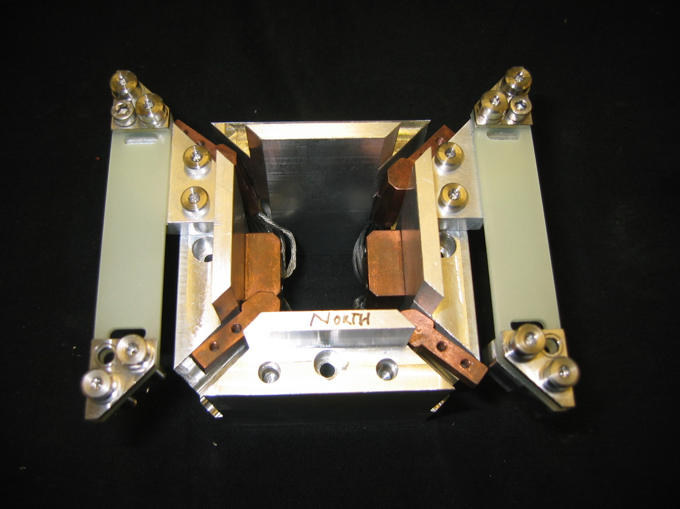
Triple flexure assembly
Cooling wicks bolted to internal carriage
Internal carriage

Carriage bracket

Figure 3 Internal carriage assembly

    - Assemble flexure brackets
This is structural mechanical joint.

Following the procedure described above assemble the lower pair of triple flexures to the spider. Remembering not to tighten the screws.

Completed (date) | Checked (date) | Comment

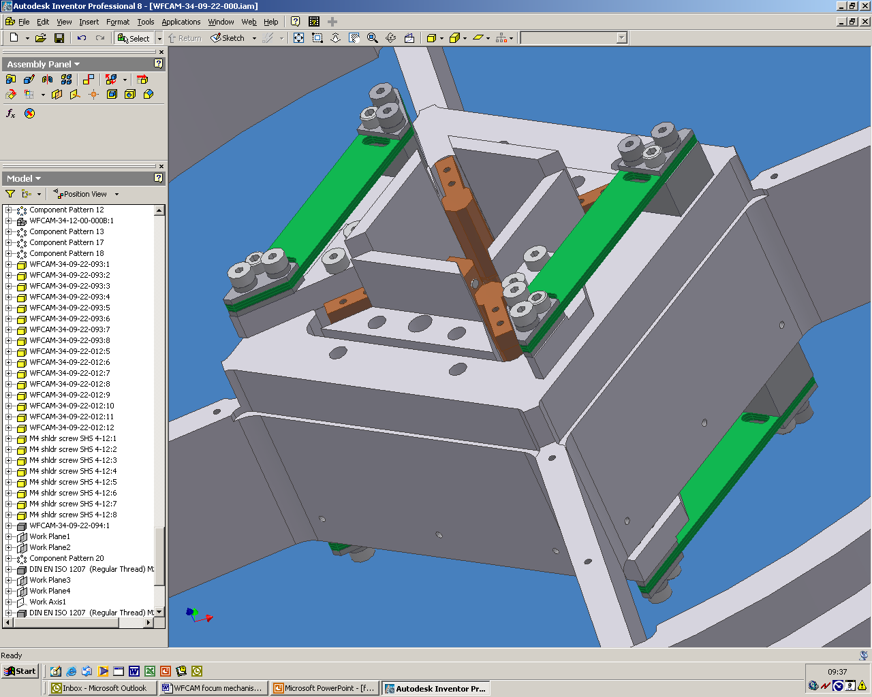
Assembly both upper and lower pairs of triple flexures
All screws not to be tightened

Flexure block 2

Flexure block 1

Figure 4 Internal carriage assembled in spider hub

i. Mid position
Once the focus assembly is in place the mid position of the carriage has to be established and the carriage made parallel to the spider hub prior to tightening the flexure screws. This provides the starting point when all the limit and datum switches are programmed into the mechanism software.

Carefully lift the internal carriage until the 3mm shim can be placed under the flexure bracket. Repeat for other flexure bracket.
Completed (date) | Checked (date) | Comment

Torque all the screws associated with the triple flexure assembly brackets to 3.8Nm for M4 and 7.6 for M5.
Completed (date) | Checked (date) | Comment

Assembly both upper and lower pairs of triple flexures
All screws not to be tightened
Figure 4 – Internal carriage assembled in spider hub
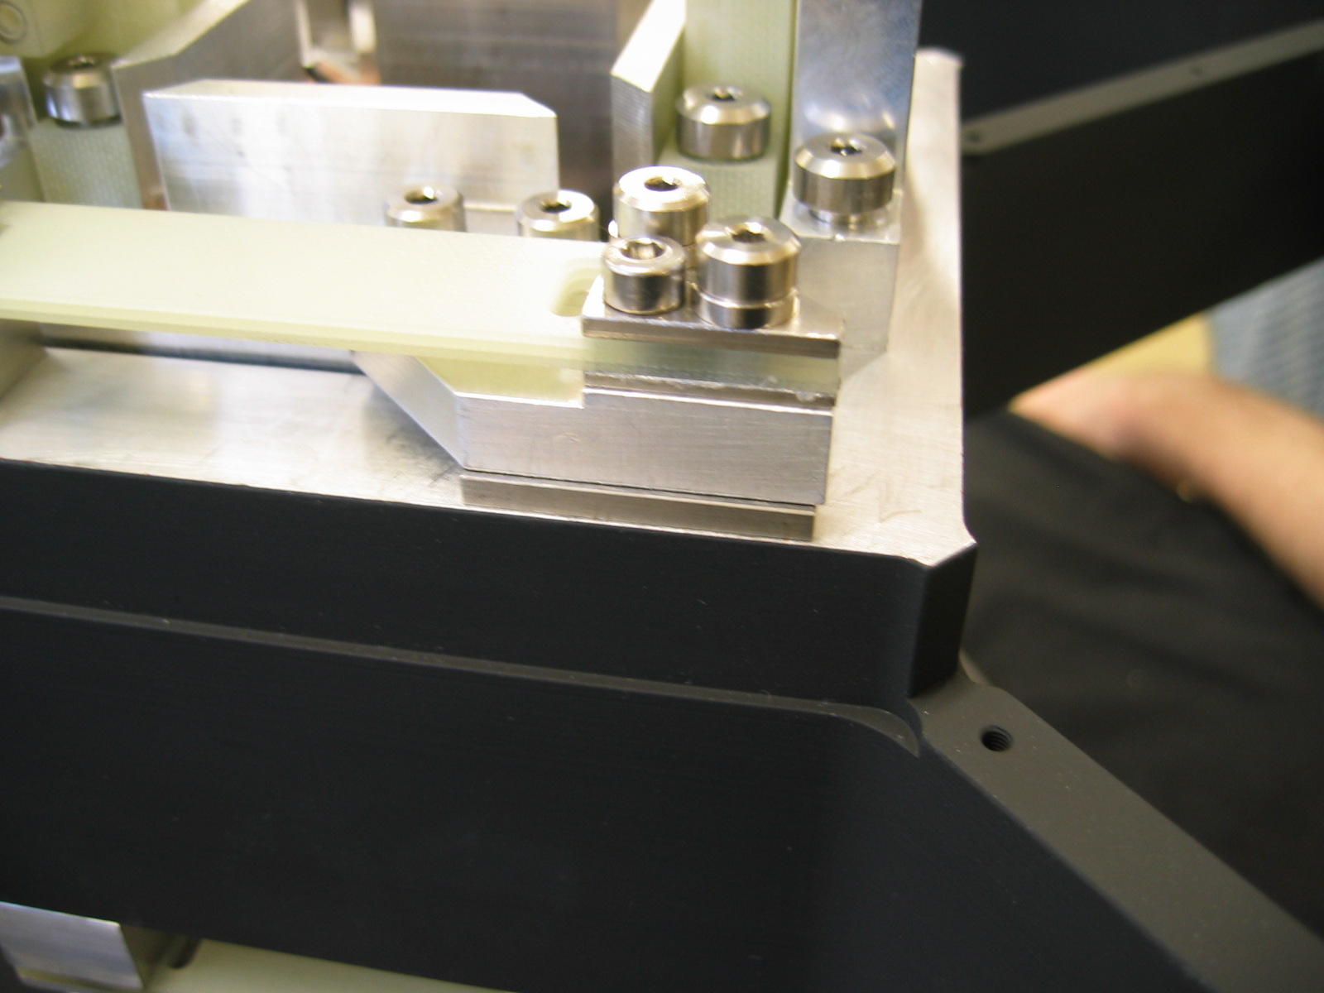
Flexure bracket
3mm shim
Tighten all associated screws
Figure 5 Establishing mid position

    - Lead screw and focus motor support structure
The support structure of the focus mechanism consists of 2 brackets. A smaller G10 bracket and a larger Aluminium bracket.

i. Assembling the G10 bracket
The smaller bracket is manufactured from G10 glass fibre and is designed to hold the leadscrew nut in place and also provide a suitable location for the actuators of the micro switches. It also provides all the support for the mechanism counterbalances.

Attach the leadscrew nut into the bracket with 4 M3 screws. Ensuring that the raised shoulder of the nut is placed in the correct orientation i.e. east to west. Torque screws to 1.6Nm.
Completed (date) | Checked (date) | Comment

Run a flat surface, straight edge or stone along the mating surfaces to check for bruising. Dress any damage found with a stone or file.
Completed (date) | Checked (date) | Comment

Attach the 2 micro switch actuators to the G10 bracket via 4 M3 countersunk screws. Ensuring that the actuators are in the correct orientation. Torque to 1.6Nm.
Completed (date) | Checked (date) | Comment

    - Assembling main focus bracket
The main focus bracket is manufactured from Aluminium alloy and provides the support for the lead screw and focus motor.

Run a flat surface, straight edge or stone along the mating surfaces to check for bruising. Dress any damage found with a stone or file.
Completed (date) | Checked (date) | Comment

i. Focus leadscrew assembly
The leadscrew and its associated parts provide the required movement of the mechanism. It is essential that the parts are located correctly to ensure optimum operation of the screw.

Place the bearing collar into the leadscrew bearing housing, ensuring that the collar is seated correctly. Then place the bearing into the bearing collar, again, ensuring that it is seated correctly.
Completed (date) | Checked (date) | Comment

Put the leadscrew through the bearing until the shoulder of the screw is seated onto the bearing. Clamp leadscrew to bearing using washer and M6 nut. Torque nut to XXNm. Place the bearing retaining plate into position and slide in its retaining tube.
Completed (date) | Checked (date) | Comment

Attach the leadscrew assembly to the main bracket via 6 M4 screws. Torque screws to 3.8Nm.
Completed (date) | Checked (date) | Comment

ii. Axial counterbalance
The detector box and carriage are counterbalanced in the axial direction by 2 steel weights. These weights are supported via arms which are pivoted on the main bracket with a lever ratio of 4:1. The other end of the arm is connected to a G10 flexure which in turn is connected to the moving carriage via the G10 bracket bridge.

Slide a bearing onto the pivot shaft until it locates at one end. Slide the pivot through the main bracket ensuring that the bearing is seated correctly. Then slide another bearing onto the shaft and ensure that too is seated correctly in the main bracket. Secure this bearing with a circlip. Repeat for the other pivot arm assembly.
Completed (date) | Checked (date) | Comment

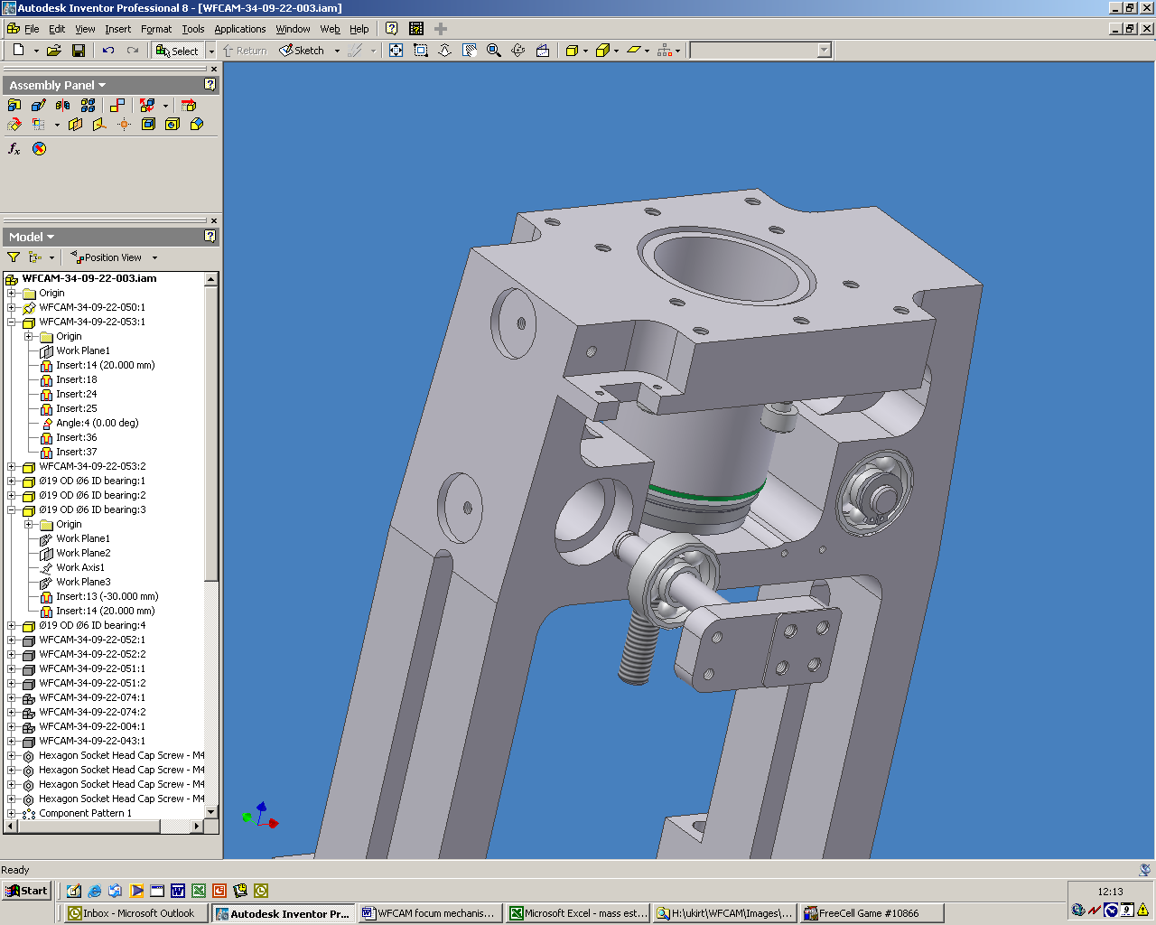
Pivot shaft
Pivot spacer
Bearing
Circlip
Figure 6 Pivot shaft assembly

It is essential that the micro switches and wiring be attached to the main bracket at this point in the build as access becomes very limited as the build progresses.

Attach each of the two micro switches (activated by the lower arms) to the main bracket with 2 off M2.5 cheese head screws and anti vibration washers. Tighten these screws.
Completed (date) | Checked (date) | Comment

Each micro switch is activated by a screw in the actuator arm. Ensure that these screws are in place and in a nominal position.
Completed (date) | Checked (date) | Comment

Place the preload spring spacer and then the spring into the recess in the G10 bracket, carefully place the main bracket over the G10 bracket until the leadscrew is in position over the lead nut. Gently turn the leadscrew so that it engages the nut.
Completed (date) | Checked (date) | Comment

Engage leadscrew and nut so that mounting faces of both brackets are coplanar. Attach the micro switch activated by the upper arm to the main bracket with 2 off M2.5 cheese head screws and anti vibration washers. Tighten these screws.

Hand tighten these screws.
Completed (date) | Checked (date) | Comment

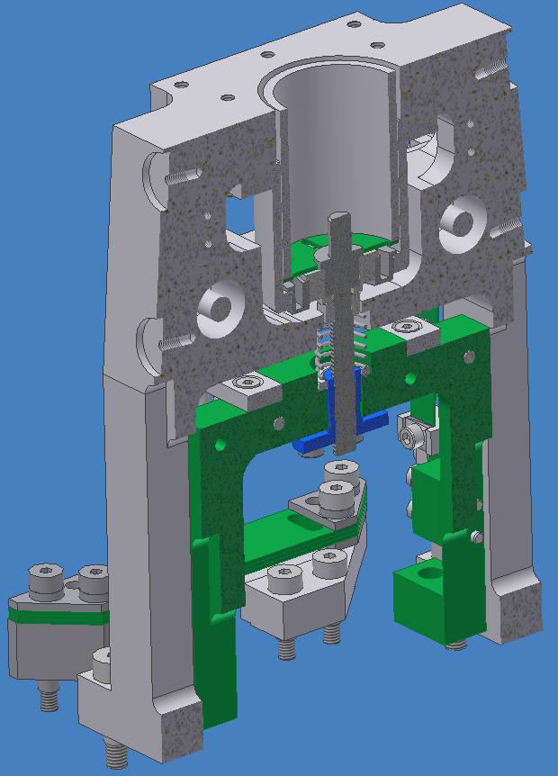
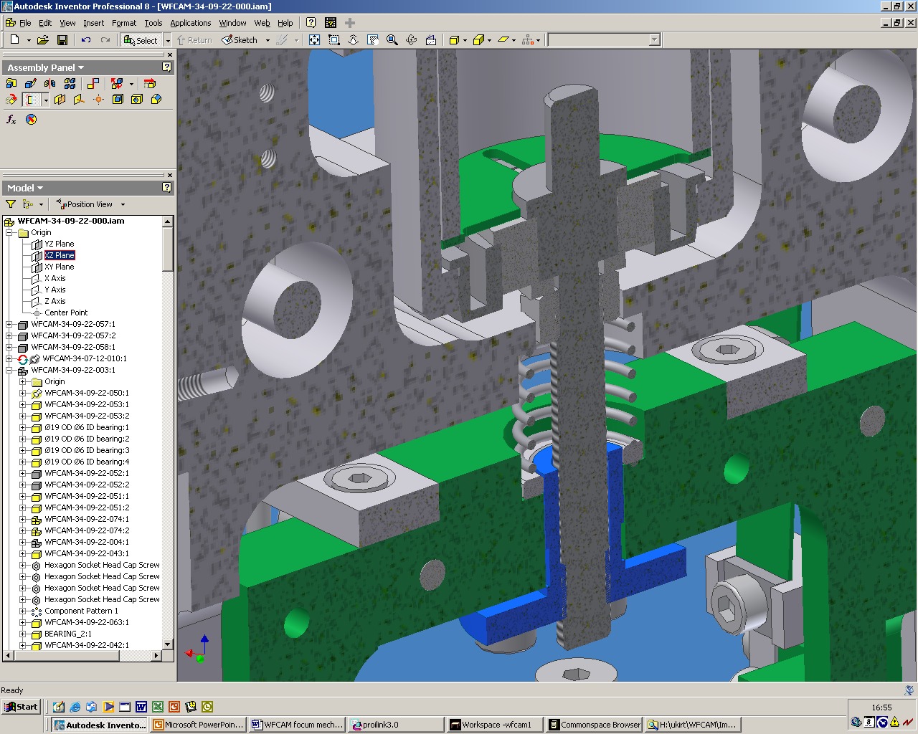
Bearing Collar
Leadscrew
Bearing
Pre-load spring
Spring spacer
Bearing housing
Main bracket
Bearing retaining plate
Leadscrew nut
Bearing plate retaining tube

Figure 7 Section view of leadscrew assembly

iii. Motor assembly
The motor assembly consists of a Berger Lahr stepper motor, a connector panel, 2 ‘D’ type connectors and 2 cable protectors. To avoid any confusion in the connecting of the mechanism the 2 connectors are arranged so that the plug connector caries the motor power and the socket type is for the micro switch status lines.

Feed each connector through the hole in the motor connector panel. Align the cable protectors and attach each one with appropriate jacking posts for the connector. Note that the socket connector is stood off from the motor assembly on longer jacking posts.
Completed (date) | Checked (date) | Comment

Align the connector panel with 4 fixing holes on the top of the motor and attach via 4 M3 screws.
Completed (date) | Checked (date) | Comment

Attach the motor and coupling to the focus main bracket. Align the four fixing holes on the motor housing to the corresponding holes on the top of the main bracket, taking care to align the coupling with the leadscrew.

Through the hole in the bearing housing turn the motor so the fixing screw of the coupling can be seen, using a 2.5mm allen key tighten the coupling onto the leadscrew. Ensure that the motor is seated correctly in its appropriate recess and attach the motor to the bracket via 4 M4 screws. Torque screws to 3.8Nm.
Completed (date) | Checked (date) | Comment

Ensure that the pivot spacer is in place and then attach the pivot arm to the pivot via 4 M3 screws for each arm. Attach the counterbalance to the pivot arms via 4 M3 screws for each. Torque screws to 1.6Nm
Completed (date) | Checked (date) | Comment

Align the axial counterbalance weights with the 4 fixing holes at the end of the pivot arm. Attach weight to the arm via 4 M3 screws. Repeat for other weight.
Completed (date) | Checked (date) | Comment

Align the counter weight flexures to the 2 fixing holes at the other end of the pivot arm. Attach flexure to the arm via 2 M3 screws. Repeat for the other flexure.
Completed (date) | Checked (date) | Comment

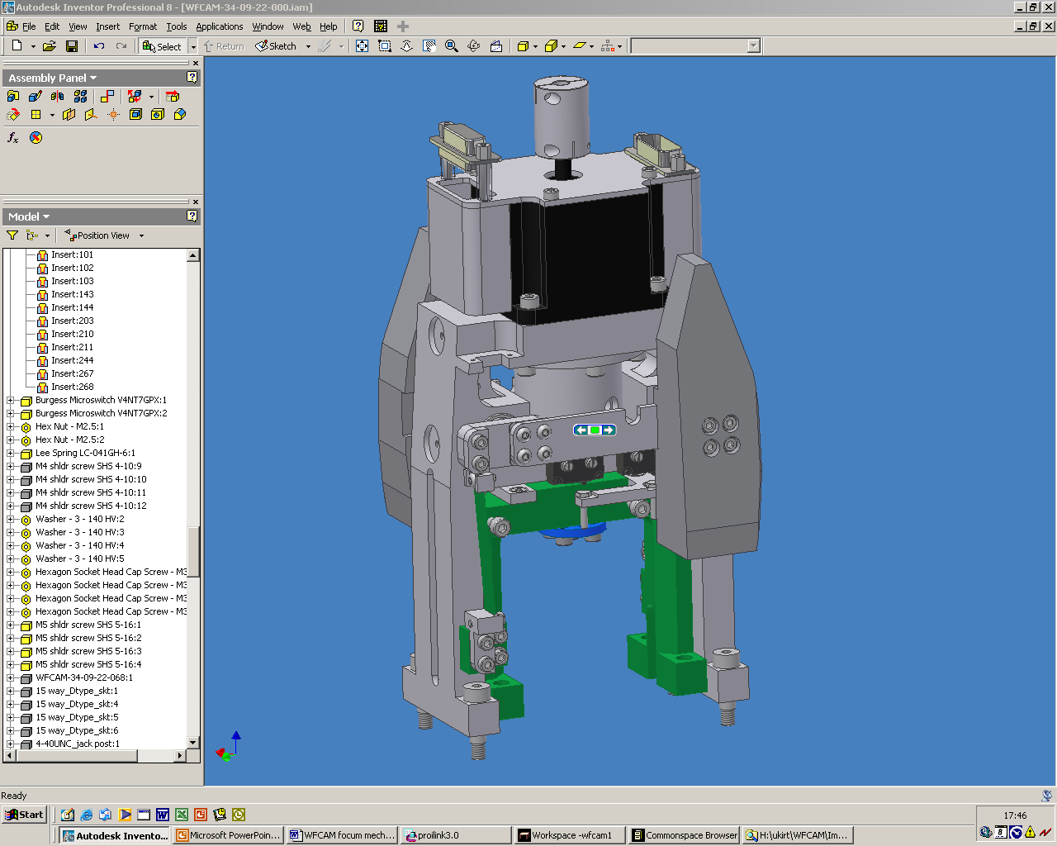
Stepper motor
Connector panel
Cable protectors
Axial counter weights
Pivot arm
Counter weight flexures
Connectors
Actuator arms

Figure 8 Motor and counterweight assembly

    - Focus Mechanism to spider assembly

The focus assembly is now at a point where it needs to be attached to the spider. Care has to be taken to prevent any damage to the triple G10 flexures and counterweight flexures.

Run a flat surface, straight edge or stone along the mating surfaces to check for bruising. Dress any damage found with a stone or file.
Completed (date) | Checked (date) | Comment

Carefully place the focus assembly into position on the upper surface of the spider. Align the screw holes in the smaller G10 bracket with the corresponding holes in the internal carriage. Attach bracket via 4 M5 shoulder screws. Torque screws to 7.6Nm.
Completed (date) | Checked (date) | Comment

Align holes in the main bracket to the corresponding fixing holes in the spider hub and attach with 4 M5 shoulder screws. Torque screws to 7.6Nm.
Completed (date) | Checked (date) | Comment

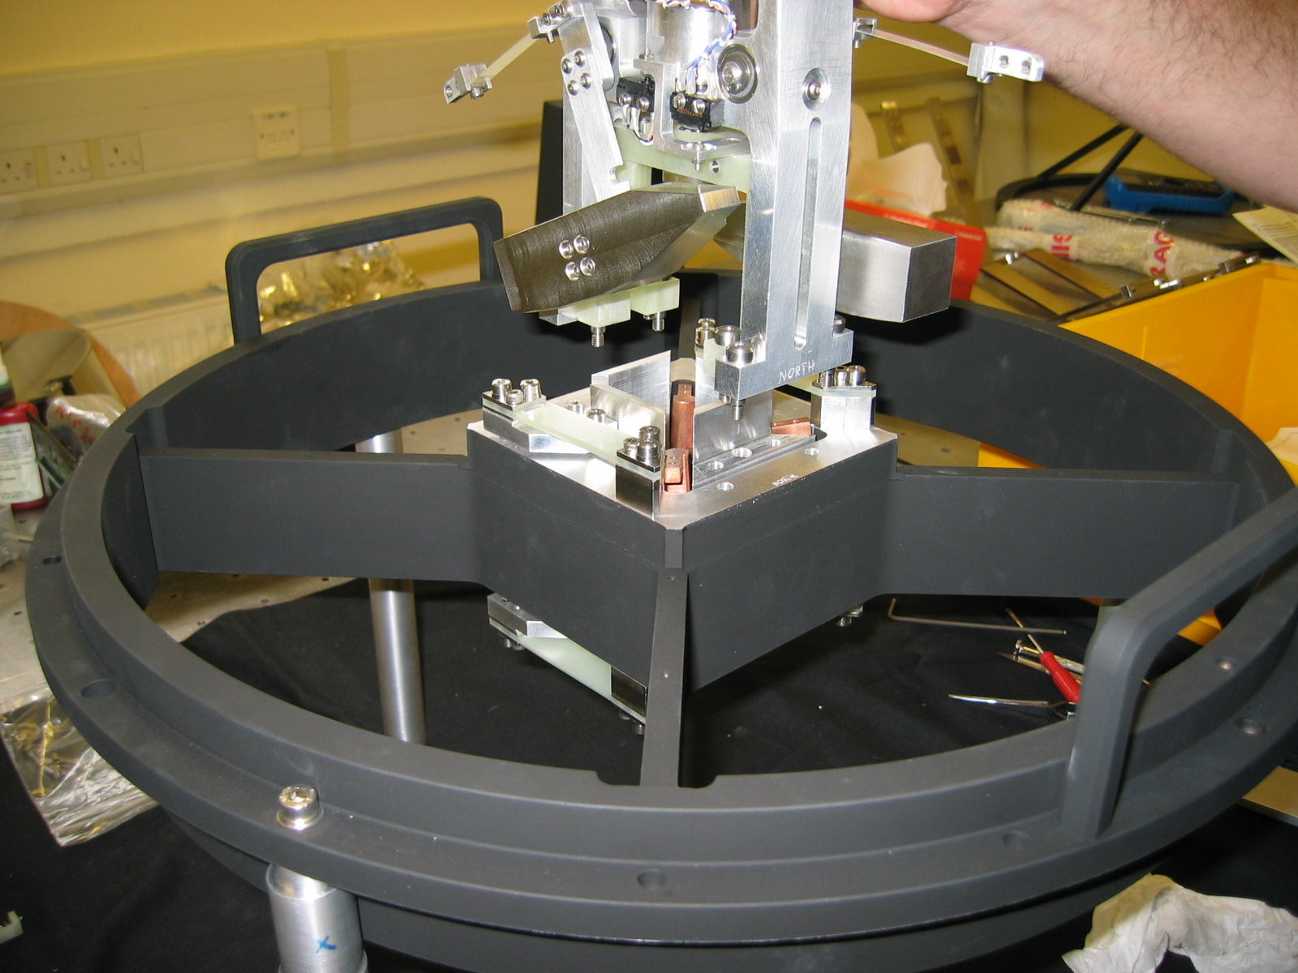
Figure 9 Assembling mechanism into spider

i. Axial counterbalance flexures
To provide the counterbalance of the mechanism the large steel weights have to be attached to the internal carriage. This is achieved by attaching the small flexures to the small G10 bracket via 2 G10 connecting pieces.

Align the connecting piece to the fixing holes in the smaller bracket and attach via 2 M3 screws and washers. Do not tighten these screws. Repeat for the other flexure.
Completed (date) | Checked (date) | Comment

Carefully lift each axial counterbalance in turn to allow the alignment of the fixing holes between the small counterbalance flexures and the flexure tabs. Attach each flexure to the tabs via 2 M3 screws. Repeat for other counterbalance assembly. Torque these screws and the screws on the smaller bracket to 1.6Nm.
Completed (date) | Checked (date) | Comment

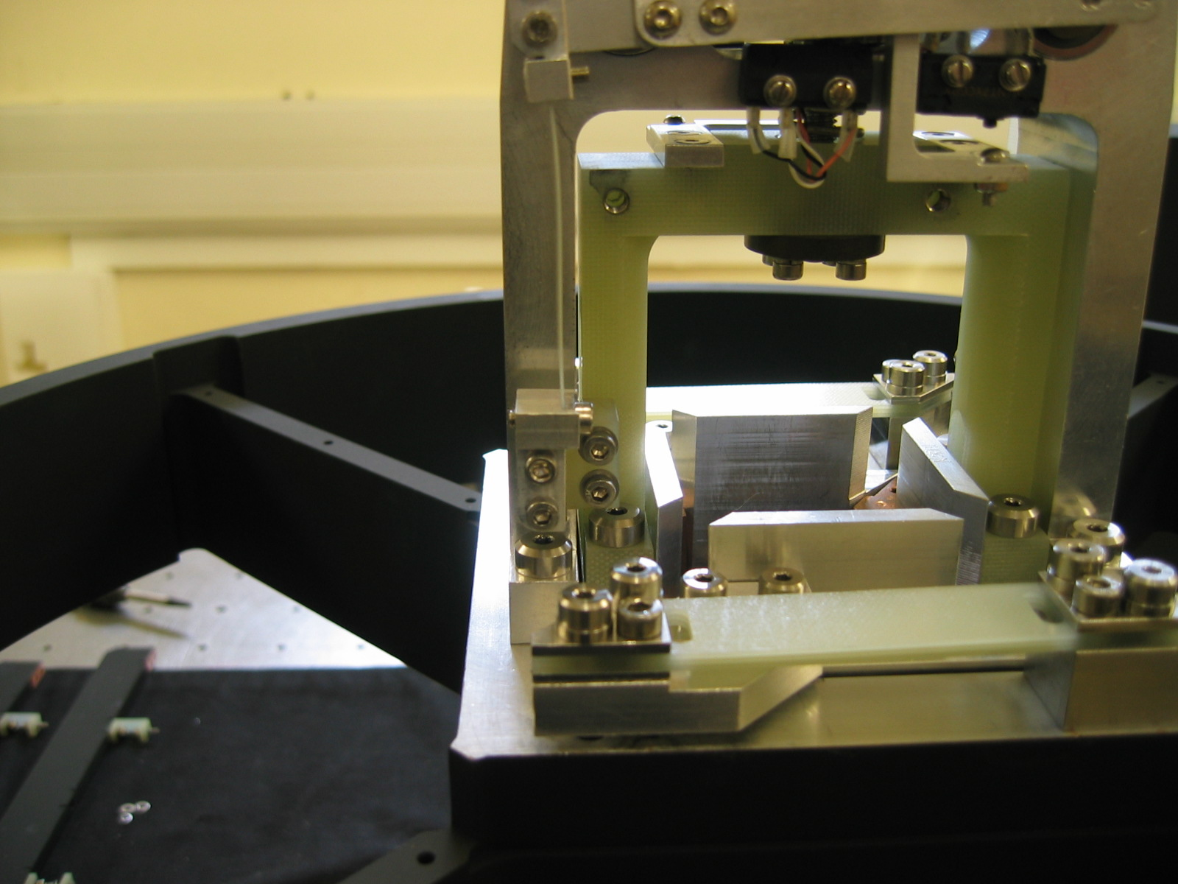
Smaller G10 bracket
Counterweight flexures
Flexure connecting tabs
Figure 10 Flexure connecting tabs

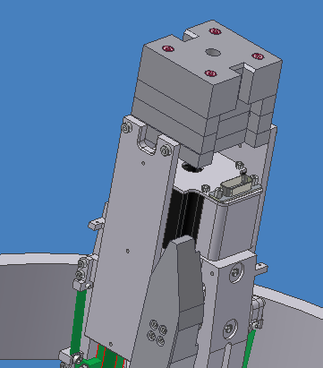
    - Horizontal counterbalance weights
The focus assembly has a counterbalance weight which prevents the detector box from tilting when the instrument is pointing away from zenith. These are the last components to be assembled onto the mechanism.

Align counterbalance support to the fixing holes in the smaller G10 bracket. Attach support with 2 M4 screws. Torque screws to 3.8 Nm. Repeat for other support.
Completed (date) | Checked (date) | Comment

Attach focus weight 3 to the support via 4 M4 screws, torque to 3.8Nm. Attach remaining weights as per fig 12.
Completed (date) | Checked (date) | Comment

Tilt counterbalance weights

Figure 11 Tilt counterbalance supports

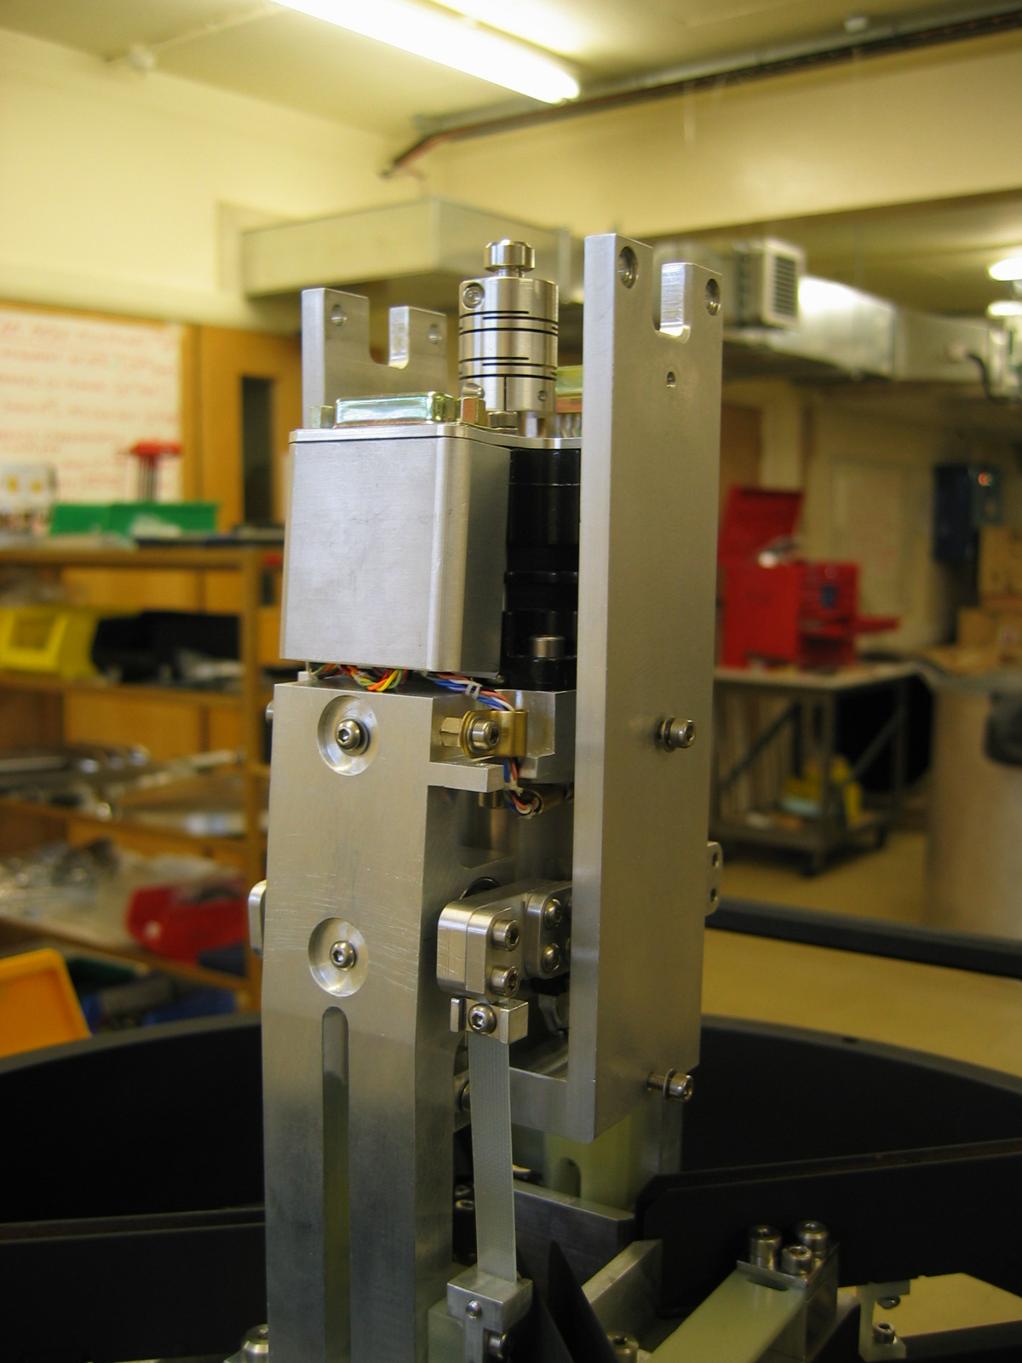
Figure 12 Tilt counterbalance weight assembly

    - Thermal wick assembly
Before the focus spider assembly can be assembled to the instrument the remaining wicks have to be assembled. These wicks consist of a copper ring and 4 copper/G10 hybrid troughs which not only carry the cooling to the detector box but also provide cable management for the detector, autoguider and motor cables.

i. Wick troughs
Each leg of the spider has a wick trough assembled to it. Each trough assembly consists of a G10 trough, Copper wick and 2 G10 supports.

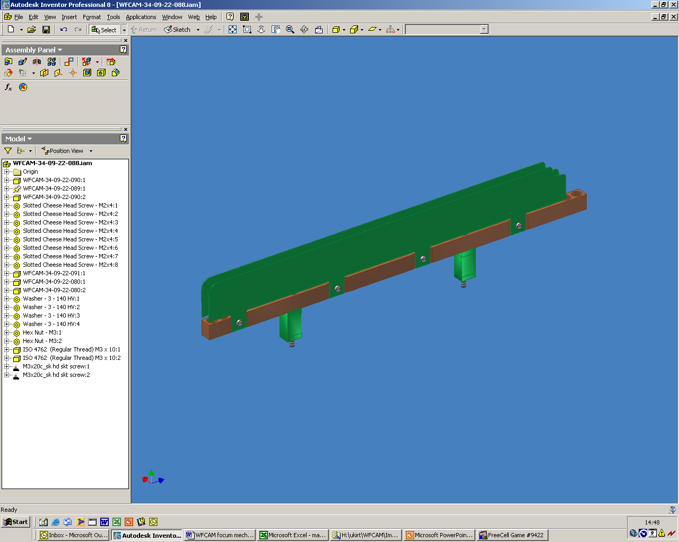
G10 trough
G10 supports
Copper wick

Figure 13 Wick trough

Align the wick supports with the fixing holes in the leg of the spider. Ensuring that the exposed holes at the end of the trough are furthest away from the focus mechanism. Attach the trough via 2 M3 screws.

Carefully align the holes at the mechanism end with the fixing holes of the internal carriage wicks. This is a mechanical and thermal joint so ensure that the mating surfaces are covered in a film of vacuum grease. Attach the wick trough to the carriage wicks via 2 M3 screws. Torque the screws to 1.6Nm.
Completed (date) | Checked (date) | Comment

There are 4 wick troughs. Two of these carry the detector cables and one carries the autoguider cables. The remaining one carries the motor and status cables. The connector brackets at the opposite ends of the troughs from the carriage are different depending on the cables and connectors within the trough.

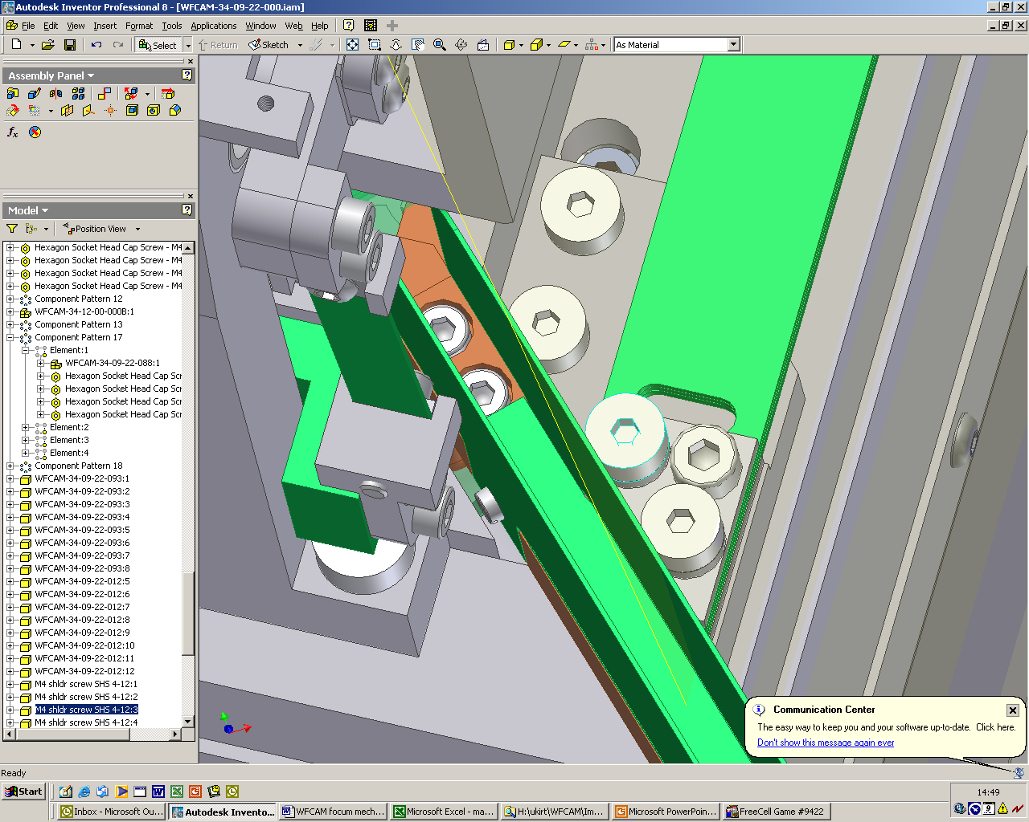
Wick trough
M3 fixing screws

Figure 14 Wick trough to carriage wick connection

ii. Detector cables
Spider wick connector bracket
Flexi bracket steady
Flexi support bracket

Figure 15 Illustrates the components required to terminate the detector cables

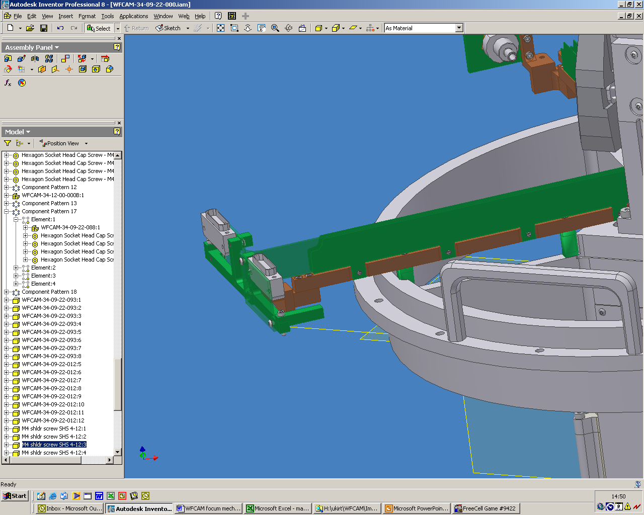
These are located NE and SW

Attach the spider wick connector bracket to the wick trough via 2 M3 screws. Torque screws to 1.6Nm.
Completed (date) | Checked (date) | Comment

The flexi bracket is attached to the wick connector bracket by 2 M3 screws. Torque screws to 1.6Nm
Completed (date) | Checked (date) | Comment

Repeat for other detector cable assembly

iii. Autoguider cables
Figure 16 illustrates the components required to terminate the detector cables.

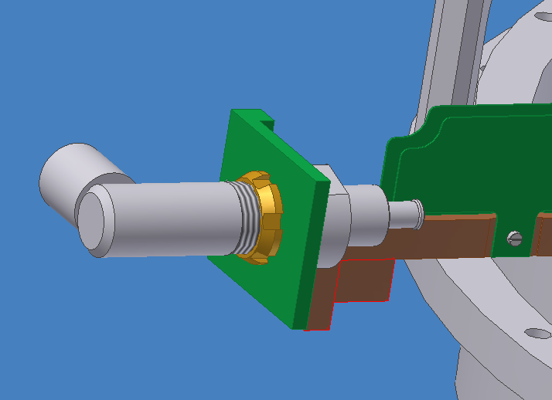
Autoguider cable bracket
Autoguider cable shield clamp
Spider wick connector bracket
Figure 16 Autoguider cable termination

This is located NW

The wick connector bracket is attached as per the procedure above. Attach autoguider cable bracket to the wick connector bracket via 2 M3 screws and torque to 1.6Nm.
Completed (date) | Checked (date) | Comment

iv. Motor and status cables
Figure 17 illustrates the components required to terminate the detector cables.

The wick connector bracket is attached as per the procedure above. Attach cable support bracket to the wick connector bracket via 2 M3 screws and torque to 1.6Nm.
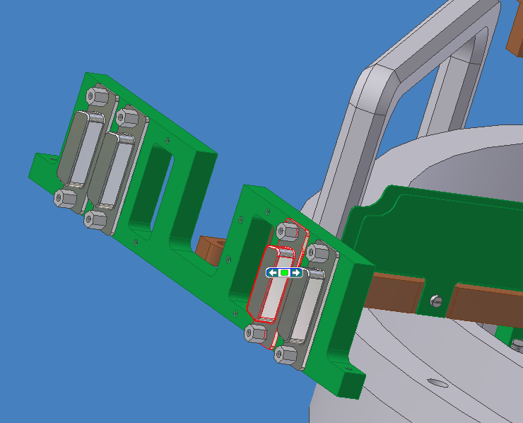  Completed (date) | Checked (date) | Comment

Cable support bracket
Spider wick connector bracket
Figure 17 Motor and status cable termination

This is located NW.

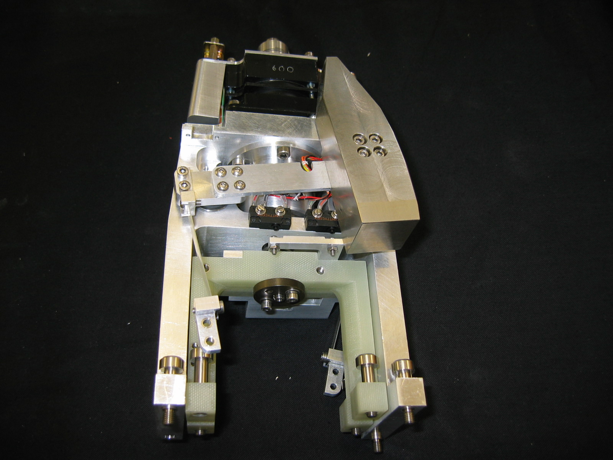
Figure 15 – Detector cable termination

Figure 18 Fixed and moving bridge assembly

- FOCUS MECHANISM SETUP and flexure tests

Introduction
This section describes the set up tests, flexure tests and parallel motion tests carried out on the WFCAM focus mechanism.
The purpose of the parallelism tests is to determine the tilt on the detector box when the focus mechanism is deployed.
It should not be necessary to do these tests after routine maintenance or the removal and replacement of the detector box. They may have to be repeated should significant work be required on the focus mechanism components or the masses change significantly.

Test setup
The test setup requires the focus mechanism to be fully assembled on the focus spider. The spider was fitted with four stands that attach the focus spider to the small Bode manipulator as shown in figure 1. The focus mechanism black shroud must be removed to allow access to the mechanism.
Figure 19 Focus assembly on manipulator (picture to be included)

Test procedures
    - Adjusting the limit switches

i. Datum / Limit Devices
If the focus mechanism has been disassembled it is necessary to check that there are no mechanical clashes and that all the datum and limit switches activate properly. Firstly using a 3mm allen key turn the motor my hand so that the focus activates its upper datum and limit switches. Next turn the motor in the opposite direction so that the lower limit switch is activated.

ii. Setup end of travel switches
There are two end of travel switches, one for each end of travel. They are located on the fixed bridge piece on the West side.
Remove the two M3 button head cover screw and remove the focus mechanism cover.
Remove the moving counterbalance weights by unscrewing the four M3 screws and disassembling the counterweight from the pivot arm. Repeat for the other side.
Using an Allen key on the rear motor shaft coupling, move the mechanism to each end of travel and ensure that the mechanism reaches both physical end stops without stressing the microswitches.
Back off the mechanism from the physical end stop by 1/8 to ¼ of a turn and adjust the end of travel micro-switch to actuate at this point. Repeat for the opposite end of travel.

iii. Setup primary and secondary datum
There is one microswitch for the primary and one for the secondary datum. They are located on the fixed bridge piece on the East side.
Turn the motor until the mechanism is against the upper physical end stop (away from the tertiary). Back off by ¼ to ½ turn and set the primary and secondary datum microswitch to actuate at this point.

    - Detector box tilt

ii. L.V.D.T. probes
Attach the two blocks to the side of the lens bezel, it will be necessary to remove the grub screw in the bezel. Care must be taken that the length of screw used to attach the blocks is short enough not to touch the lens.

Attach the L.V.D.T. probe jig on the focus spider as shown in figure 2. Clamp the probes in place noting the orientation of the two probes (i.e North – South or East – West).

iii. Checking tilt with telescope angle
With the L.V.D.T. probes reading zero rads tilt when at 0º deploy the bode so that the focus assembly is at 60º and record the difference between the two probes. Next bring the bode back to 0º and note the difference. Perform this test several times to give a good indication of the tilt.

iv. Checking tilt with telescope rotation
With the bode at 60º rotate the focus about the telescope axis. Record the differences of the probes at 90º, 180º, 270º & 360º. Perform this test several times.

v. Checking tilt of box with focus deployment
With a 3mm Allen key rotate the motor from the coupling at the rear motor shaft so that the focus mechanism is touching its positive limit switch i.e. position where the detector box is furthest away from the M3. Readjust the L.V.D.T. probes so allow for a further 3mm of travel of the detector box. With the Allen key turn the motor half a turn at a time and record the differences in the probes. Perform this test for 3 complete turns of the motor.

With the detector box at its mid position re-adjust the probes again to allow a further 3mm of travel and begin turning the Allen key a half turn at a time and recording the probes differences.

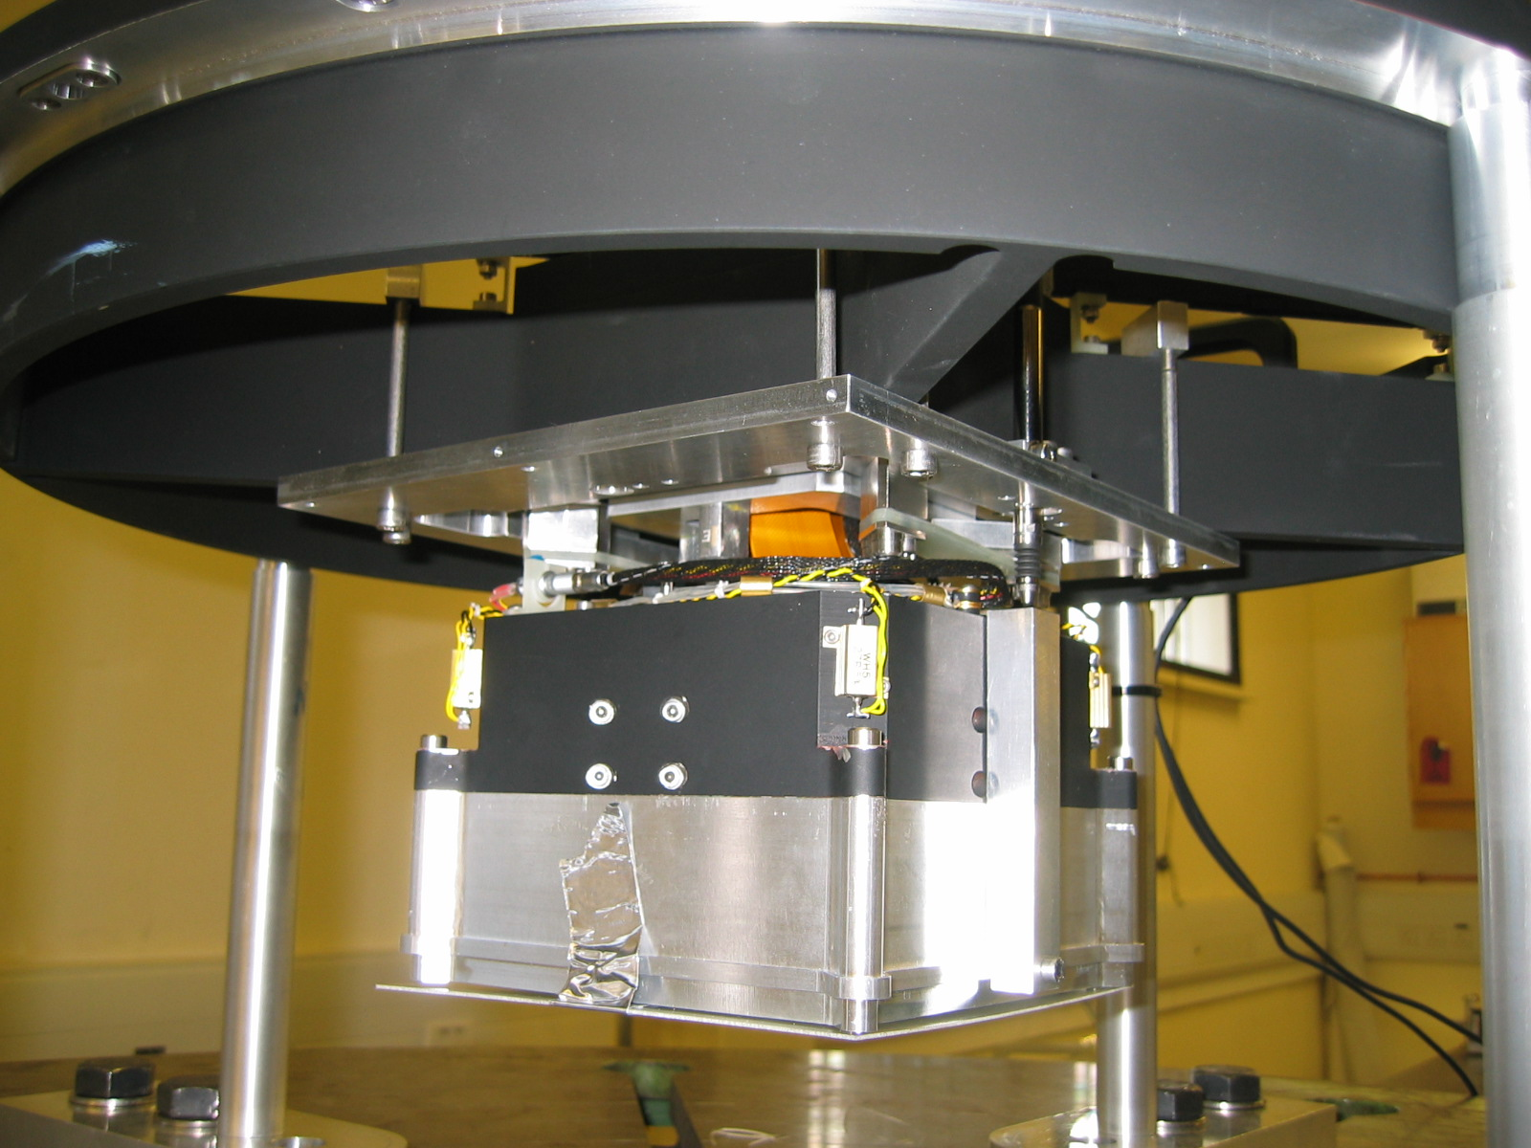
LVDT
Jig
Block
Manipulator
Legs

Figure 20 LVDT setup with mechanism on manipulator

The results of the above procedure are recorded below. The results are spilt according to the probe orientation.

Figure 21 Tilt measurement setup

i. North – South

Telescope tilt
Orientation (º) | Probe difference (µm) | Detector box tilt (µrad)
0 | 0 | 0
60 | 0 | 0
0 | -1 | -6.173
60 | -1 | -6.173
0 | -1 | -6.173
60 | -1 | -6.173
0 | -2 | -12.346
60 | -1 | -6.173
0 | -2 | -12.346

Telescope rotation at maximum tilt
 | 1 |  | 2 |  | 3 |  | 4
Rotation (º) | Probe  diff (µm) | Box tilt  (µrad) | Probe  diff (µm) | Box tilt  (µrad) | Probe  diff (µm) | Box tilt  (µrad) | Probe  diff (µm) | Box tilt  (µrad)
0 | 0 | 0 | 0 | 0 | 0 | 0 | 0 | 0
90 | -4 | -24.691 | -2 | -12.346 | -3 | -18.519 | -2 | -12.346
180 | 1 | 6.173 | 1 | 6.173 | 1 | 6.173 | 1 | 6.173
270 | 8 | 49.383 | 9 | 55.555 | 8 | 49.383 | 9 | 55.555
360 | 2 | 12.346 | 3 | 18.519 | 2 | 12.346 | 3 | 18.519

Through focus
 | 1 |  | 2 |  | 3 |  | 4
Turns | Probe  Diff (µm) | Box tilt  (µrad) | Probe  Diff (µm) | Box tilt  (µrad) | Probe  Diff (µm) | Box tilt  (µrad) | Probe  Diff (µm) | Box tilt  (µrad)
½ | 2 |  | 3 |  | 3 |  | 2
1 | 4 |  | 6 |  | 5 |  | 6
1½ | 4 |  | 6 |  | 6 |  | 5
2 | 6 |  | 8 |  | 8 |  | 8
2½ | 6 |  | 9 |  | 9 |  | 8
3 | 8 |  | 11 |  | 11 |  | 11
Max diff | 6 | 37.038 | 8 | 49.383 | 8 | 49.383 | 9 | 55.555
Reset probes
3½ | -3 |  | -4 |  | -5 |  | -4
4 | -4 |  | -6 |  | -6 |  | -4
4½ | -6 |  | -7 |  | -6 |  | -6
5 | -5 |  | -6 |  | -6 |  | -5
5½ | -4 |  | -6 |  | -6 |  | -6
6 | -3 |  | -5 |  | -6 |  | -6
Max diff | -3 | -18.519 | -3 | -18.519 | -1 | -6.173 | -2 | -12.346

ii. East - West
Orientation (º) | Probe difference (µm) | Detector box tilt (µrad)
0 | -1 | -6.173
60 | 3 | 18.519
0 | -1 | -6.173
60 | 3 | 18.519
0 | -1 | -6.173
60 | 4 | 24.691
0 | -1 | -6.173
60 | 4 | 24.691
0

 | 1 |  | 2 |  | 3 |  | 4
Rotation (º) | Probe  diff (µm) | Box tilt  (µrad) | Probe  diff (µm) | Box tilt  (µrad) | Probe  diff (µm) | Box tilt  (µrad) | Probe  diff (µm) | Box tilt  (µrad)
0 | 0 | 0 | 0 | 0 | 0 | 0 | 0 | 0
90 | 3 | 18.519 | 4 | 24.691 | 4 | 24.691 | 4 | 24.691
180 | 6 | 37.038 | 8 | 49.383 | 8 | 49.383 | 8 | 49.383
270 | -1 | -6.173 | 0 | 0 | 0 | 0 | 0 | 0
360 | 0 | 0 | 1 | 6.173 | 1 | 6.173 | 1 | 6.173

 | 1 |  | 2 |  | 3 |  | 4
Turns | Probe  Diff (µm) | Box tilt  (µrad) | Probe  Diff (µm) | Box tilt  (µrad) | Probe  Diff (µm) | Box tilt  (µrad) | Probe  Diff (µm) | Box tilt  (µrad)
½ | 4 |  | 5 |  | 6 |  | 5
1 | 8 |  | 10 |  | 9 |  | 9
1½ | 6 |  | 8 |  | 8 |  | 8
2 | 8 |  | 10 |  | 10 |  | 9
2½ | 4 |  | 6 |  | 6 |  | 6
3 | 5 |  | 7 |  | 8 |  | 8
Max diff | 4 | 24.691 | 5 | 30.865 | 4 | 24.691 | 4 | 24.691
Reset probes
3½ | -2 |  | -1 |  | -1 |  | -2
4 | 1 |  | 1 |  | 1 |  | 0
4½ | -4 |  | -4 |  | -4 |  | -3
5 | -6 |  | -6 |  | -5 |  | -6
5½ | -9 |  | -8 |  | -8 |  | -9
6 | -10 |  | -9 |  | -9 |  | -10
Max diff | 11 | 67.901 | 10 | 61.728 | 10 | 61.728 | 10 | 61.728

- Filter Paddle mECHANISM ASSEMBLY

Introduction
This document is intended to define the assembly procedure for the WFCAM filter paddle mechanism applicable for the initial build after shipping or in the eventuality of a complete strip down. A description of the process is given along with equipment and personnel required. A checklist is also provided for QA of the process itself.

Preparing for assembly
It is assumed for the purposes of this document that the mechanism is being assembled from a completely dismantled state. The process is taken through to the stage where the mechanism is assembled onto the top ring. Further assembly is dealt with in the section ‘cryostat top section assembly”.
The disassembly process will not be described where it is simply the reverse of the assembly procedure.
It is recommended that labelled multiple compartment storage trays or similar be used to organise disassembled parts during the procedure. It may also prove useful to take photographs as a reference, adding selected ones to this manual as required.
    - Mechanism support
During assembly the mechanism can be supported on a flat horizontal workbench.

    - Personnel required
The assembly can be carried out by one person. The assembly is a bit involved and it is recommended that the person should have previous experience with it if possible.

    - Equipment required
No lifting equipment is required, the parts and the complete assembly can be manipulated by hand..

Equipment and number | Capacity/Size | Use
Stone/straight edge | 150mm | Detect bruising of interface components
Ball hex drivers x2 | 5mm | Various fasteners on mechanism
Ball hex drivers x2 | 4mm | Various fasteners on mechanism
Ball hex driver x 2 | 3mm | Various fasteners on mechanism
Small screw driver |  | Connector screws
Torque wrench and extension to 5mm hex | To measure 10Nm to 50Nm | Torque radiation shield and vacuum vessel fasteners

    - Part masses and centres of gravity
The approximate masses of the parts and their centres of gravity are listed below.
Part | Mass | Mass centre of gravity
Moving arm | 3Kg | On spindle axis
Complete assembly | 10Kg | -

    - Completing the checklist
The checklist for each task requires two initials and a date. It is recommended that the ‘inspected by’ box be initialled by an observer in charge of the procedure but involved in doing the tasks. A space is also available for comments.

Moving arm assembly
The main components of the moving arm assembly are the gear wheel, stub shafts, paddle arm and filter paddle. This assembly has been carefully balanced around the shaft axis. If significant changes to the parts or heavier/lighter filters are used, the arm should be re-balanced about the axis to within 5 gramms measured at the paddle centre.

    - Worm wheel assembly

Attach the small curved stainless steel counterweight to the larger counter weight and fasten with 3 M3 screws. Tighten screws and repeat for the other counterweight.
Completed (date) | Checked (date) | Comment

Attach the stainless counterweights to the aluminium worm gear using the three M5 screws each and tighten.
Completed (date) | Checked (date) | Comment

Attach the paddle arm to the work wheel using two M6 screws and tighten. Note that the orientation of the arm should have the screws on the left as seen looking from the end of the arm towards the shaft with the work vertical. Tighten the screws
Completed (date) | Checked (date) | Comment

Attach the small stainless steel counter weight on the underside of the arm using a single M4 screw. Tighten screw. Assemble small steel counterweights to the upper side of the arm if used and tighten screw.
Completed (date) | Checked (date) | Comment

Attach cylindrical stainless steel counterweight to the worm wheel using a single M4 screw and tighten.

Ensure that weight position is in the underside of the worm wheel, same side as the small counterweight. This should be the opposite side from the paddle offset with respect to the shaft.

Assemble three M2.5 button head screws into arm for micro-switch actuation. If these have been removed or the arm replaced it will be necessary to adjust the micro-switch set positions and paddle alignment with the fully assembled paddle mechanism.

    - Assembly into paddle mount
If the moving arm is to be re-balanced, it is recommended that the entire moving arm is built up and checked on its bearings using a set of V blocks. Other wise it can be assembled into the paddle mount as described in this section.

Position the mount on a flat surface with the open gap uppermost. Position the worm wheel assembly in the gap and pass the shaft through the left hand bearing housing (looking from the end of the arm towards the mount). Insert and tighten the 4 M4 screws to 3.8Nm.
Completed (date) | Checked (date) | Comment

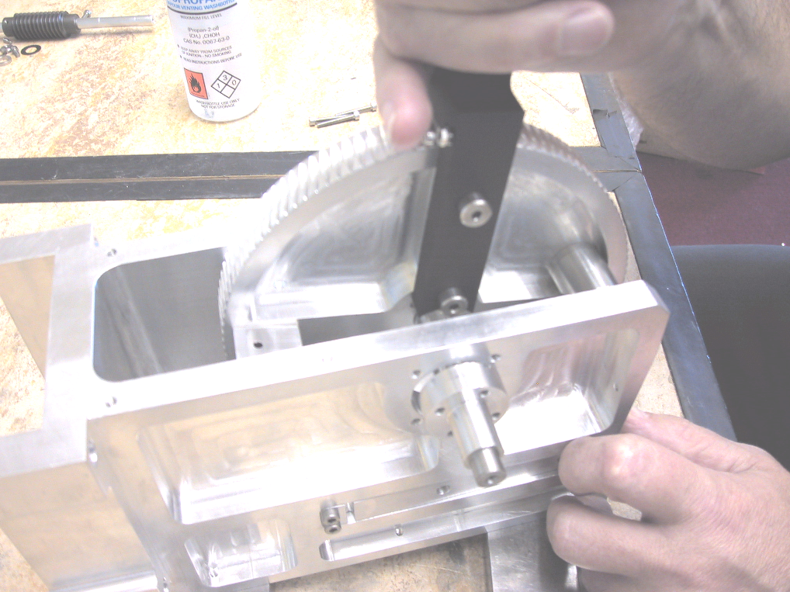
Figure 22 Assembling moving arm and shaft

    - Assemble bearings
Insert a stainless steel bearing sleeve over the moving arm shaft and into the mount. Insert and tighten the 4 M4 screws to 3.8Nm. Repeat for the other side.
Completed (date) | Checked (date) | Comment
Insert a cryogenically prepared bearing over the moving arm shaft and into the stainless sleeve. Repeat for other side. Bearing is Timken precision N180-000.

Check the fit of this bearing on the shaft. It should slide fairly readily on the shaft without picking up. If it is a new shaft, some MoS2 spray should be applied and burnished in. Some of the bearings purchased had bruising of the inners at the radial marks and these picked up on the shaft. Inspect for this and do not use bearings that have this fault (if replacing the bearings).

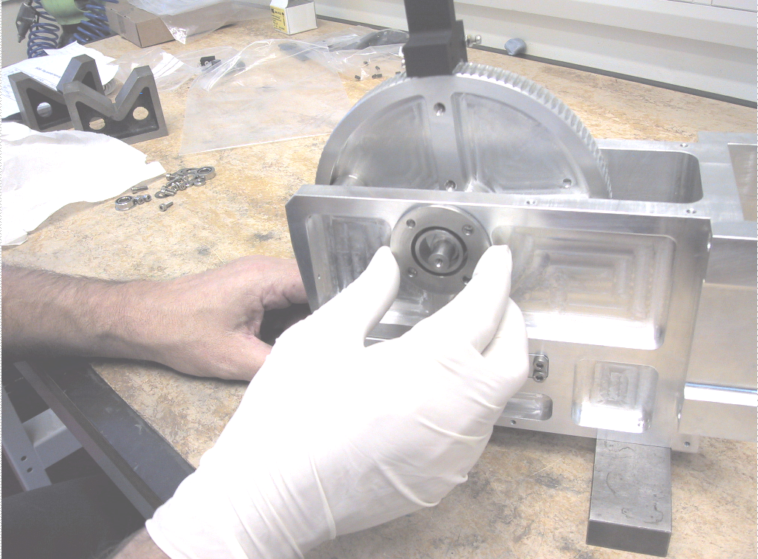
Figure 23 Inserting bearing sleeve

    - Shaft end caps
The shaft is retained axially by means of a stepped circular end cap at one end and a set of disk spring washers retained by another end cap at the other. There is also a shim between the bearings and the disk springs. If parts have been re-manufactured or swapped, it will be necessary to measure the gap between the worm gear and mount (see below). The stepped end cap can be replaced if this gear is not central to within 0.1mm.

Assemble left hand side end cap to the shaft using a single M4 screw (looking from paddle arm towards gear with the gear vertical and uppermost in the mount). Tighten screw to 3.8Nm.
Completed (date) | Checked (date) | Comment

Assemble the shim on the shaft followed by four disk springs configured thus <<>>. Assemble right hand end cap. Tighten the M4 screw to 3.8Nm.

Completed (date) | Checked (date) | Comment

i. Setting paddle arm gap
The gaps between the gear and the housing have been checked on each side and adjusted as required to make the gear central. This must be repeated if the housing or shaft end caps are replaced, and the new dimensions are not known to be within tolerance of the originals. This is a record of the values measured.

Paddle mechanism number | Gap L | Gap R
1 | -9.000 | 9.055
2 | -9.007 | 9.005
3 | -9.012 | 9.006
4 | -9.004 | 9.039
5 | -9.026 | 8.995
6 | -9.042 | 8.996
7 | -9.044 | 9.000
8 | -9.025 | 8.981

ii. Setting pre-load
This will only be necessary if the shaft, housing or end caps have been replaced. The purpose is to set the amount of preload on the disk springs to give nominally 4Kg of pre-load. The technique which should be used is to assembly the shaft without the disk springs and measure the end float. This should nominally be 1.3mm. The end cap can be machined or replaced until this figure is achieved. At which time the disk springs can be assembled.

Pre-load is calculated as follows:
Assembled spring height (no load):1.8mm
Calculated pre-load:0.5mm
End float required: 1.3
All the paddles shafts were adjusted for this during I&T 1/9/03 and 2/9/03.

    - Filter paddle
As the unit must be manually manipulated to complete the assembly and the filter paddle is delicate, it is advisable to do the operations in this section last of all.

i. Assemble filters to the paddle
Check the configuration for the particular filter being assembled, Y, B Gamma e.t.c. The small autoguider filter in the centre has a unique thickness for each. Certain filters are also fitted in the Y type brackets as opposed to the T type and may require a circular baffle.

Completed (date) | Checked (date) | Comment

If the paddle is new, some hand finishing of paint build up may be required to allow the filters to sit properly in their holders. Other wise proceed as follows.

Place the paddle on a flat surface covered with optical tissue with the filter cut-out facing up. Using gloves place the filters in each cut-out followed by the autoguider filter and its shim.
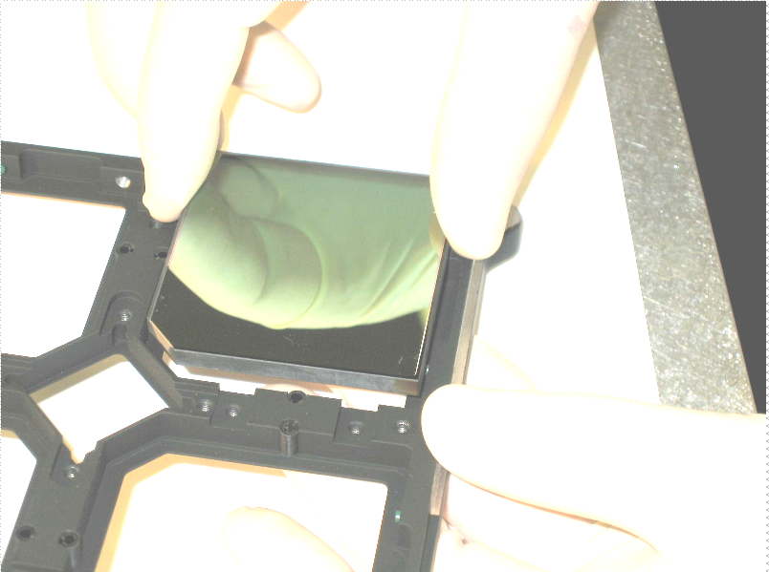

Figure 24 Assembling filter

Insert the 12 nylon tipped M4 set screws until each filter is seen to contact the set screw but is a loose fit (do not tighten). Inset the eight plastic springs for the filter followed by the four smaller springs on the autoguider filter.

Completed (date) | Checked (date) | Comment

Fix the six plastic retaining tabs on the filters using 6 M3 countersunk screws.

Place the four retaining tabs on the autoguider filter.

Place the filter baffle on top and secure with 8 M3 cap screws. Note, depending on filter type and mechanism number this baffle may be square or round in profile. They should not be interchanged between types without re-balancing the paddle arm.
Completed (date) | Checked (date) | Comment

ii. Assemble T or Y bracket
Depending on the mechanism number, the paddle will be fitted with a T or a Y bracket.

Assemble the bracket and secure with two M4 screws for a T bracket, four M4 screws for a Y bracket. Tighten screws to 3.8Nm.
Completed (date) | Checked (date) | Comment

iii. Assemble filter paddle to arm
Assemble the filter paddle to the arm using two M4 shoulder screws with the filter holder standoff in between. Tighten screws to 3.8 Nm.

Completed (date) | Checked (date) | Comment

    - Balancing the moving arm assembly
This will only be required if there is a significant change to the mass of the components as a result of replacement. An example might be the replacement of the filters which are thicker or denser, or replacement of the baffle on the filter paddle. This was carried out for the mechanism as part of the I&T.

The full assembled arm, including bearing assemblies was mounted in blocks and the force required to hold it horizontal and then vertical measured at the paddle centre.

If necessary the arms were balanced by changing the size and positions and number of the balance masses on the paddle arm.

The results re tabulated below:

Filter number | Horizontal force  (g) | Vertical force  (g)
1 | 0 | 2
2 | 1 | 3
3 | 0 | 2
4 | 1 | 2
5 | 0 | 1
6 | 1 | 1
7 | Record lost | Record lost
8 | 0 | 1
The specification was 5g.

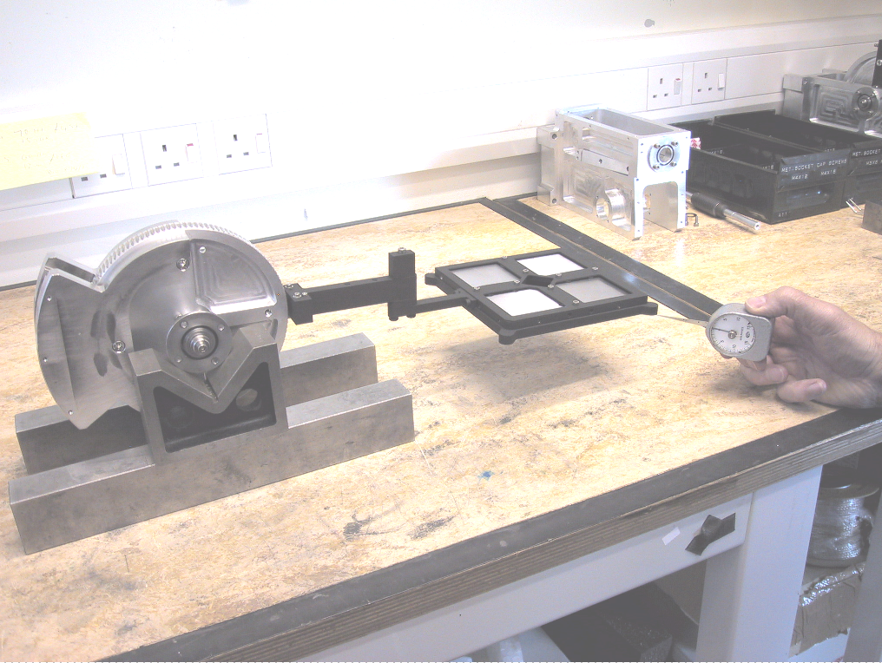
Figure 25 Measuring out of balance

Fit worm shaft assembly
Fit a cryogenically prepared bearing on the worm drive shaft with the flanged end up against the shoulder on the shaft.

Check the fit of this bearing on the shaft. It should slide fairly readily on the shaft without picking up. If it is a new shaft, some MoS2 spray made by applied and burnished in. Some of the bearings purchased had bruising of the inners at the radial marks and these picked up on the shaft. Inspect for this and do not use bearings that have this fault (if replacing the bearings).

Follow this with a stainless steel bearing sleeve ensuring that the groove is facing towards the bearing.
Fit the Vespel worm with the set screw hole towards the bearing assembly. Tighten set screw.

Completed (date) | Checked (date) | Comment

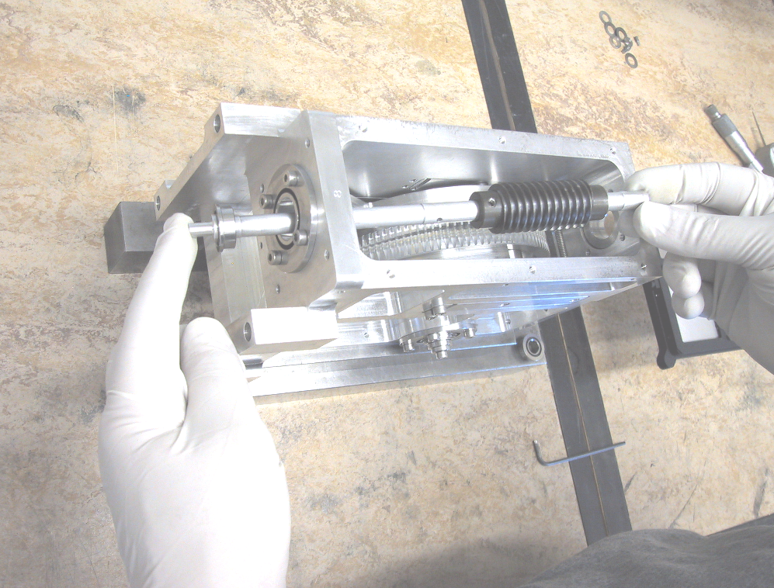
Figure 26 Inserting worm shaft

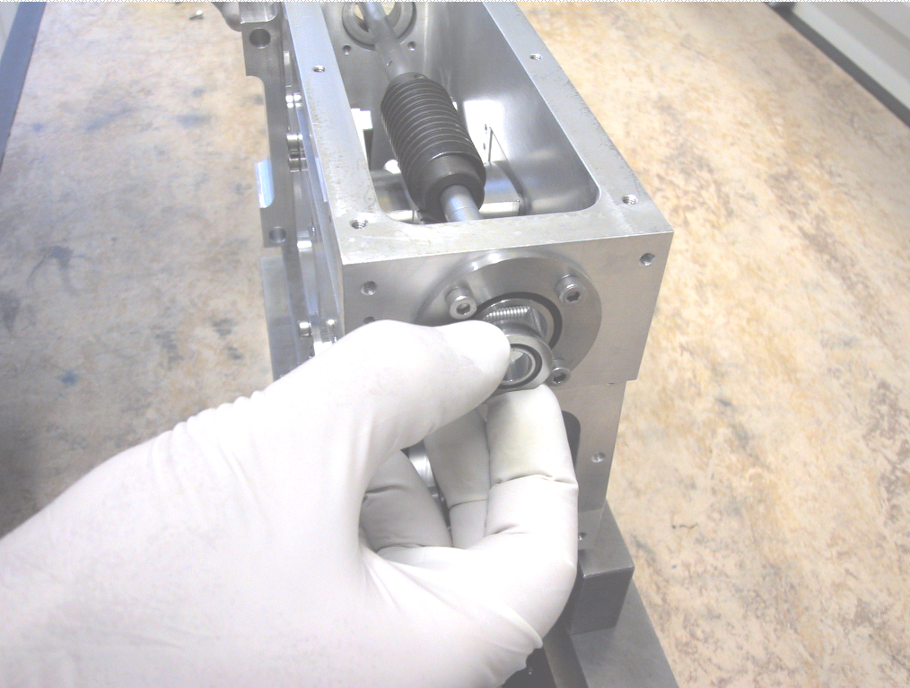
Figure 27 Inserting bearing

Insert the assembly though the mount boss farthest from the worm gear wheel. Insert the four M4 screws to retain the stainless bearing sleeve..
Completed (date) | Checked (date) | Comment

Assemble the second stainless sleeve and cryogenically prepared bearing. Insert the four M4 screws.

Tighten all 8 M4 screws to 3.8Nm.
Completed (date) | Checked (date) | Comment
Assemble the shim on the shaft followed by four disk springs configured thus <<>>. Assemble the end cap. Tighten the M4 screw to 3.8Nm.

Completed (date) | Checked (date) | Comment

Check that the shaft can move axially by compressing the springs and releasing.

Replace the housing cover panel, insert and tighten the six M4 screws.
Completed (date) | Checked (date) | Comment

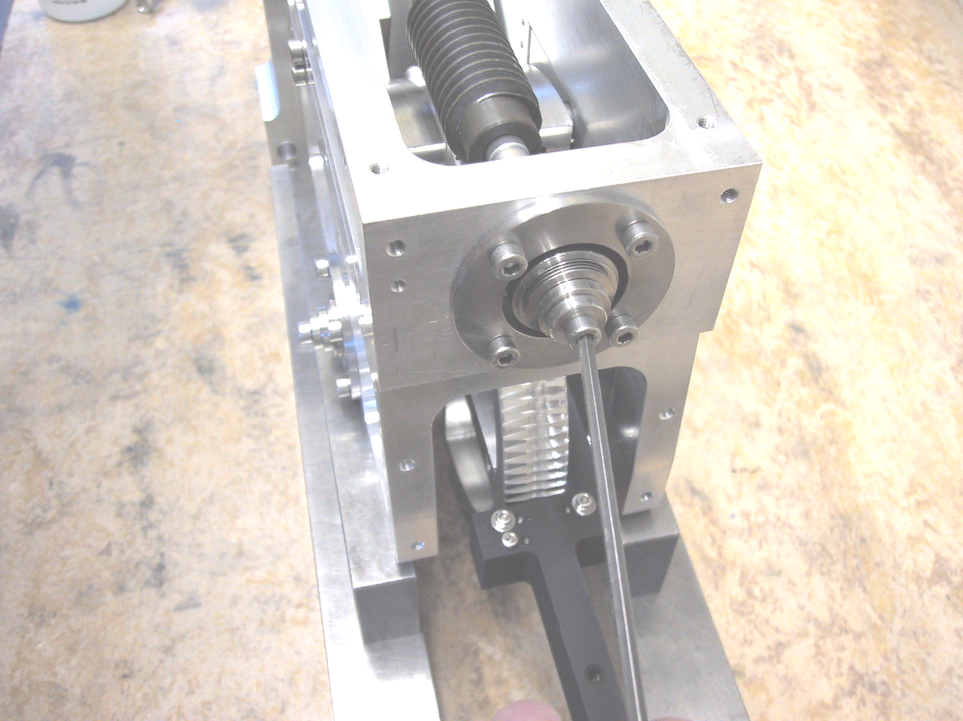
Figure 28 Tightening worm shaft end cap

    - Setting pre-load
This will only be necessary if the shaft, housing or end caps have been replaced. The purpose is to set the amount of preload on the disk springs to give 3 to 4Kg of pre-load. The technique which should be used is to assembly the shaft without the disk springs and measure the end float. This should nominally be 1.3mm. The end cap can be machined or replaced until this figure is achieved. At which time the disk springs can be assembled.

Pre-load is calculated as follows:
Assembled spring height (no load):1.8mm
Calculated pre-load:0.5mm
End float required: 1.3
All the paddles shafts were adjusted for this 1/9/03 and 2/9/03 by J.Elliot @ UKATC workshop

Datum switch assemblies

    - Datum switch block
Place the datum switch block on the housing and insert the four M4 screws. Push block against reference surface and tighten screws.
Completed (date) | Checked (date) | Comment

    - Micro-switch mounting block
Place the mounting block on the housing, inesrt and tighten four M4 screws to 3.8Nm.
Completed (date) | Checked (date) | Comment

    - Micro-switch housing
Place the micro-switch housing on the mounting block, insert and tighten four M4 screws to 3.8Nm.
Completed (date) | Checked (date) | Comment
    - Setting up micro switches
The micro switches have been set up and tested at the UKATC prior to delivery. They may have to be re adjusted if major components are replaced, for example the micro switches.

i. End stops
The end stops should be adjusted first. Start with the microswitch actuator screws at the same level and full in. On the fully assembled mechanism, move the paddle to the datum switch end until the micro switch actuating levers are actuated full travel and back off the backlash plus 1/16th to 1/8th turn of the motor. Adjust the end stop until it touches the arm. Repeat the tests and adjust as required until the mechanism bottoms out on the stop.

The same must now be done for the deployed end of travel but the stop must be set 1/16th to 1/8th of a motor turn past the point where the arm is perpendicular to the housing.

ii. Datum switches
The datum switch actuation points should be adjusted (by adjusting the M2.5 button head screws on the paddle arm) such that they are more or less actuated simultaneously.

iii. End of travel switches
The actuation point of the end of travel switches must be adjusted (by adjusting the M2.5 button head screws on the paddle arm).

At the datum end such that they are triggered approximately midway between the Datum actuation and physical end stop.

At the deployed end approximately midway between the 90 degree arm angle and the physical end stop.

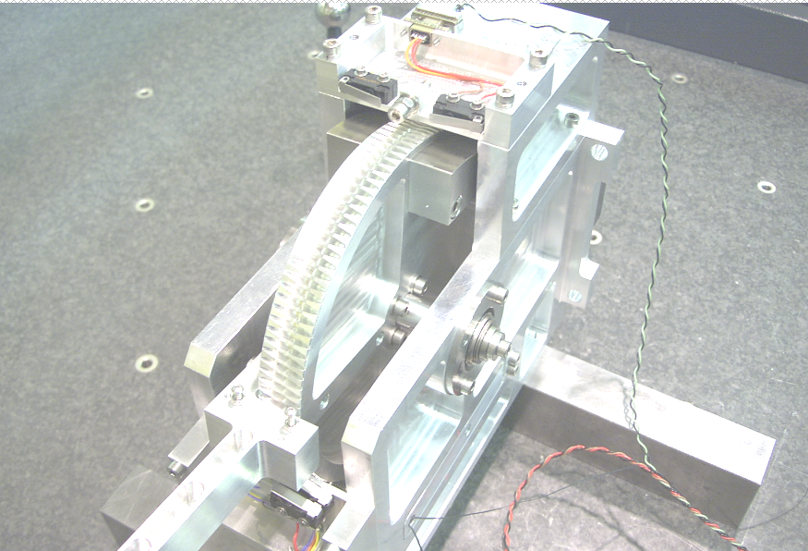
Figure 29 Setting end stops and switches

Motor assembly
Attach the flexible coupling to the stub worm drive shaft.

Fit the motor and motor spacer, taking care that the motor shaft enters the coupling and the coupling is not compressed axially. Ensure that the motor wiring shield is oriented to the back of the mechanism.

Insert four M4x40 screws and tighten to 3.8Nm.
Completed (date) | Checked (date) | Comment

Tighten the coupling clamp screws.
Completed (date) | Checked (date) | Comment

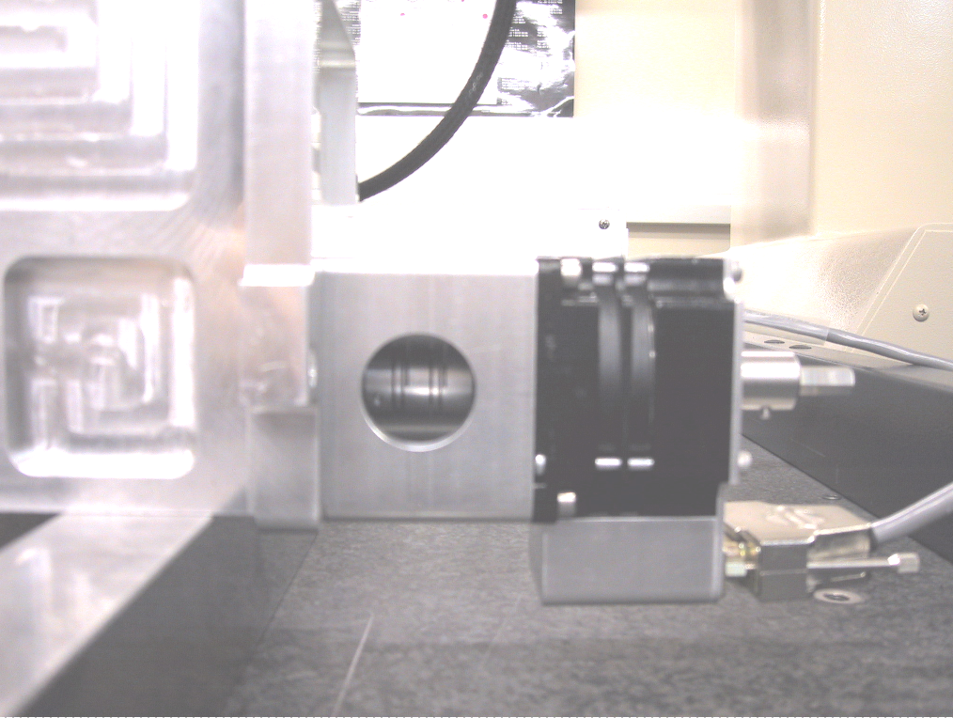
Figure 30 Motor assembly

Brake assemblies
The mechanism is fitted with passive brakes to control backlash and stabilise the filter paddle when the motor is powered off.

    - Brake pads
Assemble the Vespel brake pad by pushing it into the counter-bored hole near the centre of the brake flexure. Repeat for the second brake flexure.
Completed (date) | Checked (date) | Comment

    - Brake spring
Place the brake spring in the 6mm diameter hole at the end of one of the brake flexures and insert the cross pin through the spring end loop. Make sure that the spring is protruding through the same side as the Vespel pad.

Offer the assembly up to the matching slot in the housing, passing the spring through towards the other side. Pass a piece of flexible wire or thread through the spring loop and pull it through the 6mm hole in the second brake flexure. Make sure that this flexure is oriented with the brake pad towards the gear.

Insert the second cross pin and remove the thread/wire.

Push the opposite ends of the flexures towards the housing and insert two M4 screws in each one and tighten to 3.8Nm.

Completed (date) | Checked (date) | Comment

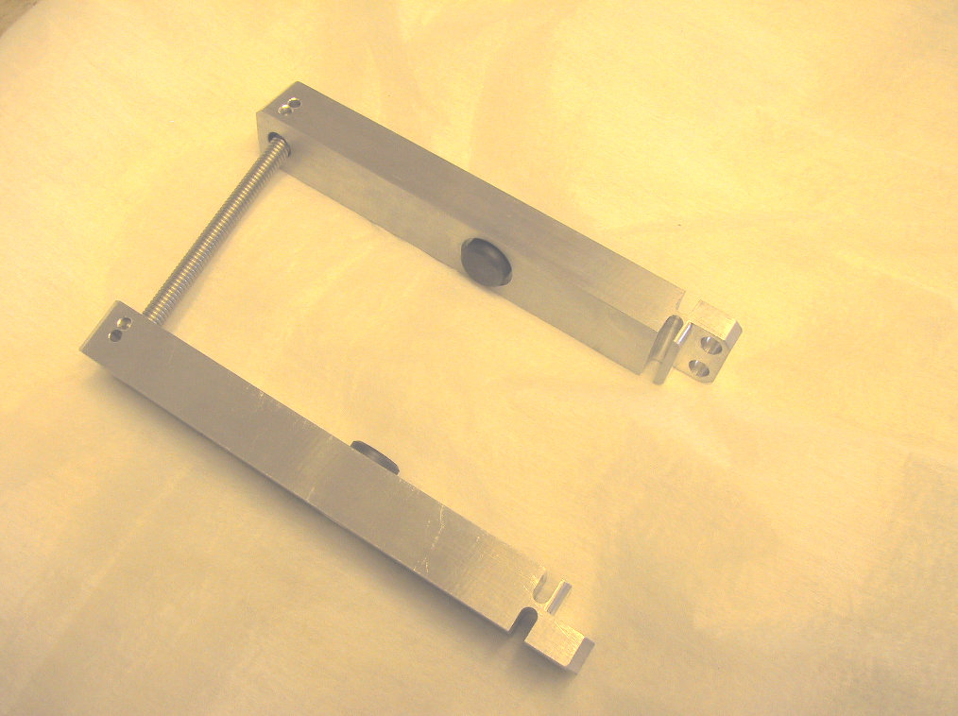
Figure 31 Brake flexures

i. Measuring drive torque
The brake is responsible for the majority of the toque on the motor. This was measured for all the mechanisms at the UKATC during I&T. The results are tabulated below:

Filter number | Operating torque  (Ncm)
1 | 10
2 | 10
3 | 8
4 | 8
5 | 10
6 | 8
7 | 6
8 | 7

Filter housing baffle
The filter housing baffle is a stray light baffle designed to shield unpainted surfaces of the paddle mechanism components.

    - Stand offs
Insert the four hexagonal stand offs into the housing and tighten.
Completed (date) | Checked (date) | Comment

    - Filter housing baffle
Place the baffle over the mechanism. The smaller radius is oriented towards the micro-switch housing.

Insert the four M4 screws and tighten to 3.8Nm. The baffle may have to be removed when the mechanism is assembled to the top ring as some interfere with the top ring stand legs. If this is the case, they can be replaced during installation of the top ring.

System information
This section contains general information on the mechanisms and control parameters at the time of delivery.

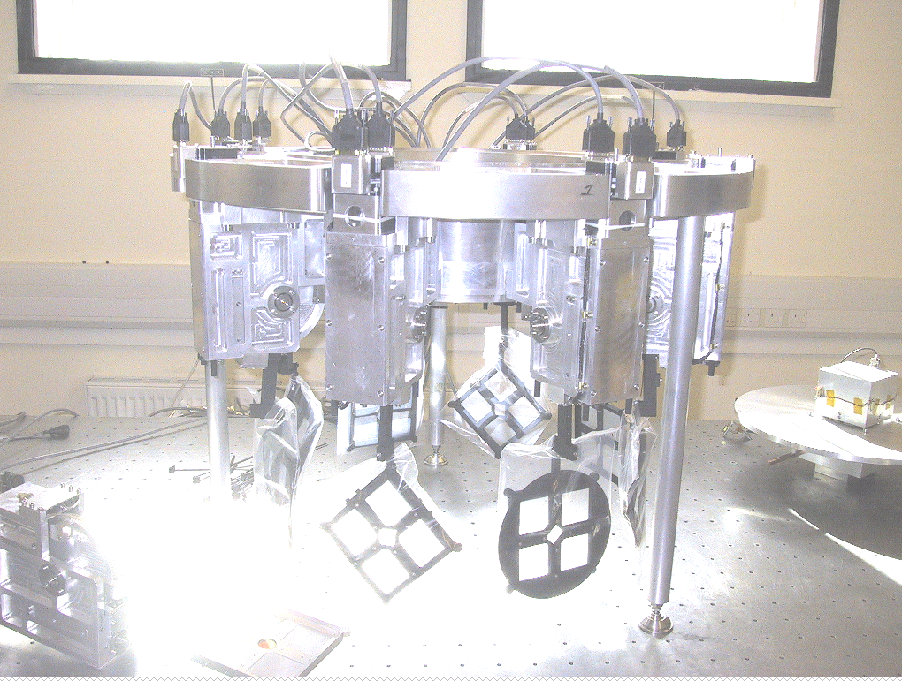
Figure 32 Mechanisms mounted on top ring

Parameter
Worm gear ratio | 120:1
Worm type | Single start, Vespel SP3
Worm gear material | Aluminium
Motor | Berger Lahr VRDM 564/50 LNA modified for cryogenic use
Step/rev | 500, used in half step mode software reads 1000steps/rev
Resolution at paddle | 1 step (in software =1/2 motor step) =0.03 degrees
Datum
Acceleration parameter | 0.2 sec
Velocity | 1600 step/sec
Normal operation
Acceleration | 4 sec
Base velocity | 0 step/sec
Velocity | 10000 step/sec
Positive limit | 32500 steps
Negative limit | 500 steps
Backlash distance | 100 steps
Backlash acceleration | 2 seconds
Backlash velocity | 1000 stps/sec

    - Mechanism set-up
Once assembled onto the top ring, the step count to position can be determined and the look up table modified if required. This is described in document “Filter paddle setup” 6.2D031.

    - Torque settings
If torque settings are not explicitly given the following table should be used. This assumes that the screws are into a minimum of 1.5D aluminium. Use the same values for helicoiled Aluminium and stainless.

Nominal screw size | Recommended torque
M2 | 0.5
M2.5 | 0.9
M3 | 1.6
M4 | 3.8
M5 | 7.6
M6 | 12.9
M8 | 30.9

- FILTER PADDLE SETUP

Introduction
This section is intended as a record of the set up tests carried out on the WFCAM filter paddle mechanisms. The purpose of the tests is to set the step number from datum such that the filters are perpendicular to the optical path when deployed. The fit against the detector box is also verified. These tests may have to be repeated should significant work be required on the filter paddle mechanisms. It should not be necessary after changing filters.

Filter positioning
The following table illustrates the position of each paddle mechanism with respect to the top ring. The orientation of each paddle is looking down onto the top ring towards the tertiary mirror:

Filter number | Filter type | Bracket type | Baffle type | Orientation
1 | Y | Y | Square | NW
2 | H2 | T | Round | W
3 | H | Y | Square | SW
4 | Brγ | T | Square | S
5 | J | Y | Square | SE
6 | Z | T | Square | E
7 | K | Y | Round | NE
8 | Blank | T | Square | N

Test setup
The tests setup requires all the filter paddles to be assembled on the top ring with the detector focus mechanism assembly removed. The top ring must be fitted with the three adjustable stands such that it can sit on an optical bench as shown in figure 1. The filter paddle mechanism baffles must be removed in order to fit the adjustable legs.
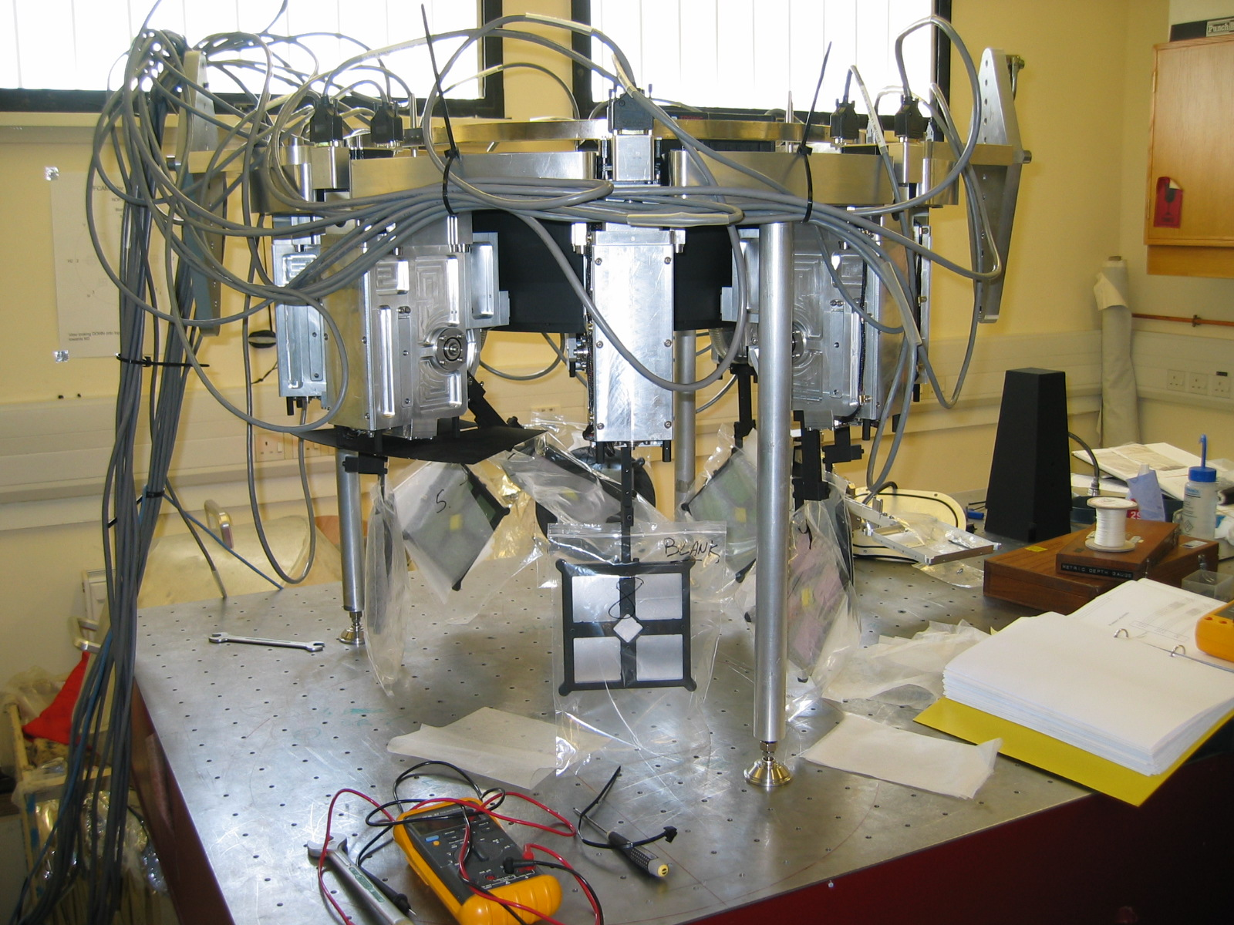
Figure 33 Test setup

    - Software and electrical
The motors and datum switches must be connected to the electronics cabinet (including the focus mechanism). The power can now be switched on and the software run up.

    - Level the top ring to the control cabinet
Using an electronic inclinometer, adjust the three feet until the top ring is level.

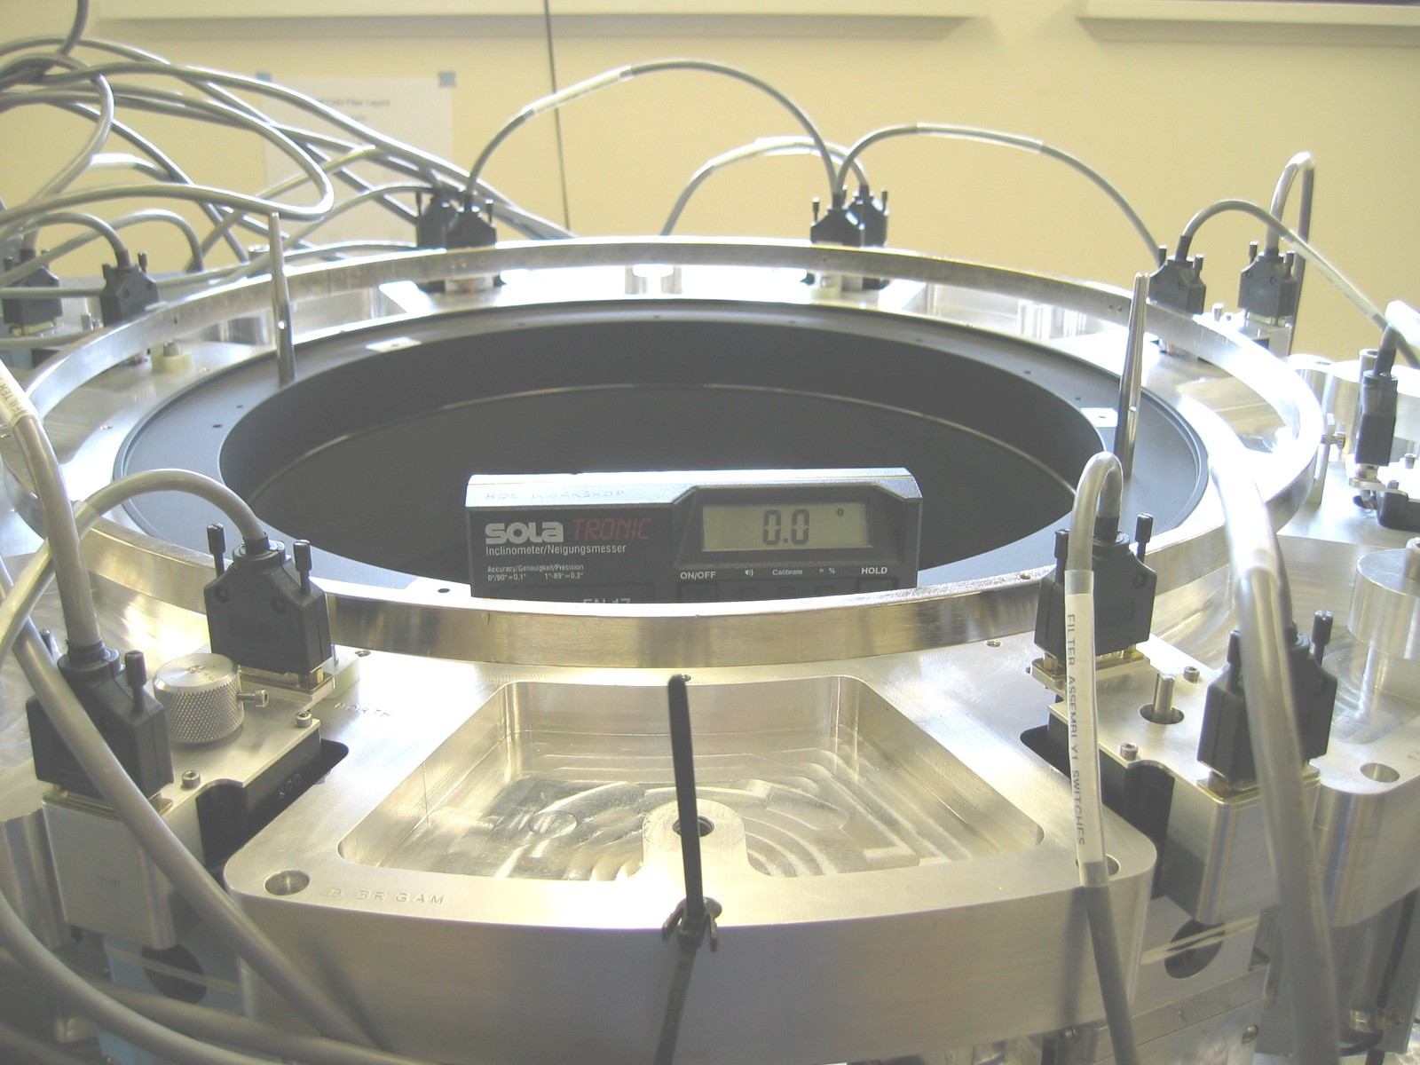
Figure 34 Level top ring

Tests procedure for deployed angle
    - Datum devices
The paddles must now be datumed.

    - Checking deployed angle
Deploy paddle #1 and place level such that it is parallel with the paddle arm and resting on the edge of the filter baffle. Take a note of the reading. This should read between 0 degrees (perpendicular) and -0.3 degrees (below perpendicular).
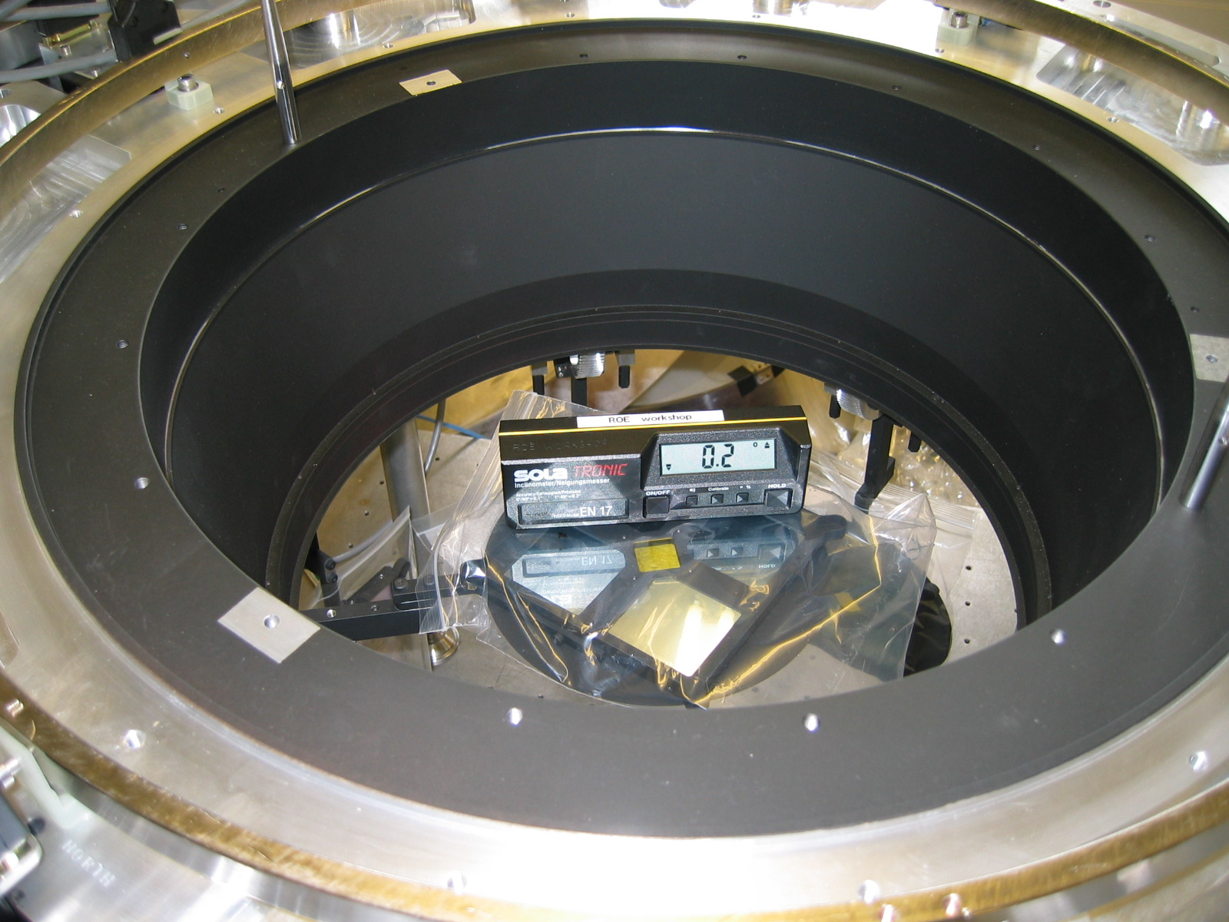
Figure 35 Check deployed paddle angle
    - Adjusting angle
If the angle is outside this range or the end of travel switch is activated, it will be necessary to change the deployed step count for that filter through the GUI.

As an aid to this, 63 half-steps (the mechanism run in half step mode) will move the paddle 0.1 degrees.
Adjust the angle until it is within spec and not activating the end of travel switch.

    - Repeat for redundant datum
The paddle mechanisms have a second datum switch which can be activated in the case of failure of the primary switch. Repeat 4.2 and 4.3 for the secondary switches.

    - Checking the distance to end of travel
Once in spec, use the GUI to move the paddle in the deployment position in increments until the end of travel switch is activated. The paddles have been set up to have an additional 20 steps from deployed until this occurs. This figure is somewhat arbitrary and gives some margin against overrun of the paddle from whatever source.

If there the step count to end of travel is very low , the deployment position can be reduced to give more margin. If even this fails to the point where the paddle is over 0.3 degrees from perpendicular, the micro-switch actuating screw may have to be adjusted. This requires the paddle mechanism to be removed from the top ring.

Tests procedure of detector assembly fit check
The baffles on the filter paddles are re-entrant into a similarly shaped groove on the detector box bezel.
This should be checked to ensure that there is no interference between them. This should only be required after major re-work of the paddle or focus mechanisms.

If the mechanisms touch there is a chance that they will jam or lose steps cold. These devices are also at very different temperatures and if they touch, there may be a thermal short when cold. There is a nominal 1.0 mm clearance between them.

    - Tests setup
Fit the detector focus assembly onto the top-ring ensuring that the filter are in the parked (down as shown in figure 1) position when doing this.

    - Test procedure
Remove the square pyramidal baffle from the focus mechanism by removing the 4 M3 button head screws and lightly pulling on the cover. Set the focus mechanism in the mid position by rotating the motor shaft end using a 3mm hex key (an adapter is mounted on the shaft).

Fit the knurled knob onto the rear extension of a paddle mechanism motor shaft. Deploy the paddle by turning the knurled knob. Visually inspect as the parts mate together. If there is any snagging this can seen and felt. Check that no interference is present until the paddle hard limit end-stop it felt.

Repeat the above with the focus mechanism set at both ends of travel.

If interference is felt, it might be possible to adjust the position of the paddle by loosening the two shoulder screws which hold the paddle on, pushing the paddle away from the interferences and re-tightening. Some movement may also be obtained by loosening the four screws which hold the paddle mechanism on.

    - Results
Each paddle assembly was placed in the top ring and the above procedure was performed. The results of this test are recorded below:

Filter mechanism | Fit (Y/N) | Comments
1 | Y
2 | Y
3 | Y
4 | Y
5 | N | Some alterations to the position of the filter holder was required
6 | Y
7 | N
8 | Y

- CRYOSTAT Bottom SECTION ASSEMBLy

Introduction to Bottom section assembly
This section is intended to define the assembly procedure for the WFCAM vacuum vessel bottom section applicable for the initial build after shipping or in the eventuality of a complete strip down. A description of the process is given along with equipment and personnel required. A checklist is also provided for QA of the process itself.

Preparing for assembly
It is assumed for the purposes of this section that the instrument is being assembled from a completely dismantled state. The process is taken through to the stage where the top vacuum vessel is to be assembled.
The disassembly process will not be described where it is simply the reverse of the assembly procedure.
    - Instrument support
The instrument should be supported in the horizontal orientation on the angle bracket interface to the Michelle handling rig. The bracket can be mounted on the Michelle handling rig or free standing with the support I-beams attached. Facing the instrument from the window end, the ‘North’ side will be uppermost. The West and North references are to the directions to which the instrument will be oriented when mounted on the telescope, telescope pointing directly up. The ‘North’ orientation of the instrument is identified by a series of dowels and corresponding dowel holes at each interface. In addition the major components are marked with an ‘N’.

Once assembled, the instrument can be removed from the bracket and using a crane/forklift with spreader bar rotated in stages to the desired orientation if different from ‘North’ up.

    - Personnel required
The assembly will require two personnel at a minimum. Operation of a hydraulic engine hoist and some rigging and slinging are required and at least one of the personnel should be familiar with the operation of the hoist and rigging. It is also recommended that at least one has carried out the procedure previously.

    - Equipment required
A mobile boom type hydraulic engine hoist is recommended to manipulate the parts during assembly. A spreader bar and lifting accessories must be used in conjunction with hoist as listed below.

Equipment and number | Capacity/Size | Use
Engine hoist | 350Kg min. 2m reach, 2m under hook height when raised | Lift and manipulate support cone, vacuum vessel base, bezel, internal cold structure, internal radiation shield and vacuum vessel base section
Lifting spreader bar | 250Kg min. 1.1 m span  (supplied with instrument) | Lift and manipulate bezel, internal cold structure, internal radiation shield and vacuum vessel base section
2 shackles | 500Kg min. | Connect slings to spreader bar
Fabric sling | 500Kg min. 3000mm long min. | Sling radiation shield top and vacuum vessel top sections
Stone/straight edge | 150mm | Detect bruising of interface components
Ball hex drivers x2 | 5mm | Fasteners on radiation shield top interface
Ball hex drivers x2 | 10mm | Fasteners on vacuum vessel top interface
Ball hex driver x 2 | 3mm | Fasteners on the radshield connector panels
Small screw driver |  | Connector screws
Torque wrench and extension to 5mm hex | To measure 10Nm to 50Nm and 50Nm to 200Nm | Torque radiation shield and vacuum vessel fasteners

    - Part masses and centres of gravity
The approximate masses of the parts and their centres of gravity are listed below.
Part | Mass | Mass centre of gravity
Vacuum vessel base | 60Kg | 800mm from interface
Radiation shield base | 27Kg | 93mm from base
Radiation shield top | 60Kg | 800mm from interface
Vacuum vessel top | 120Kg | 800mm from interface

    - Completing the checklist
The checklist for each task requires two initials and a date. It is recommended that the ‘inspected by’ box be initialled by an observer in charge of the procedure but involved in doing the tasks. A space is also available for comments.

    - Torque settings
If torque settings are not explicitly given the following table should be used. This assumes that the screws are into a minimum of 1.5D aluminium. Use the same values for Helicoiled Aluminium and stainless.

Nominal screw size | Recommended torque
M2 | 0.5
M2.5 | 0.9
M3 | 1.6
M4 | 3.8
M5 | 7.6
M6 | 12.9
M8 | 30.9
M10 | 58.8
M12 | 107.8
M14 | 171.6
M16 | 264.8

Vacuum vessel baseplate
The vacuum vessel base plate has many components mounted on the outside, some of which are large compared to the space available when the conical interface component is assembled. For this reason, assembly is best carried out with the baseplate supported independently. Simple stands made from aluminium rod will be delivered with the instrument. The following assumes that the baseplate is mounted on the stands with the inner unpainted surface facing up.

    - Thermal isolation trusses
There are six trusses each fastened to the baseplate by four M12 shoulder screws. The baseplate has circular clean-up areas where the truss feet attach.

i. Mating surface check
Visually inspect the mating surfaces on the baseplate and truss feet for debris, bruising or dents. Run a flat surface, straight edge or stone along the surfaces to check. Dress any damage found with a stone or file.
Completed (date) | Checked (date) | Comment

ii. Attach trusses
Place a truss on the baseplate and insert a shoulder screw from underneath engaging the thread. Insert a second fastener on the opposite truss foot and engage the thread. Repeat for the remaining two screws and tighten evenly. Torque to 108Nm. Repeat for remaining 5 trusses.
Completed (date) | Checked (date) | Comment

iii. Attach endcaps
CAUTION! Vacuum grease will be used for this part of the assembly. Take care not to transfer this onto eyes as it is an irritant and very difficult to flush.

Each of the 6 trusses has a pair of end-caps that cover the baseplate fasteners and make the vacuum seal.

Each end cap is fastened to the baseplate by a pair of M6 screws.

Visually inspect the mating surfaces on the baseplate, endcap and truss feet for debris, bruising or dents.

Run a flat surface, straight edge or stone along the surfaces to check. Dress any damage found with a stone or file.
Completed (date) | Checked (date) | Comment

Check the O-ring and O-ring mating surfaces for debris, bruising, dents or visible scratches. Dress any damage found with a stone, file or abrasive pad as appropriate. Clean surfaces with alcohol and apply a very thin coat of vacuum grease to the O-ring (Apezone –N).
Completed (date) | Checked (date) | Comment

Place O-ring in the endcap and offer the assembly up to the baseplate, inserting the two M6 cap screws and tighten. Repeat for remaining 11 endcaps.
Completed (date) | Checked (date) | Comment

    - Closed cycle cooler
The closed cycle cooler is mounted on the central port of the base plate by means of a flanged cylinder and interface flange. The cooler is pre assembled onto the flange assembly to begin with.

i. Assemble flange to cylinder
This is a vacuum joint sealed with an O-ring.
Run a flat surface, straight edge or stone along the mating surfaces to check. Dress any damage found with a stone or file.
Completed (date) | Checked (date) | Comment

Check the O-ring and O-ring mating surfaces for debris, bruising, dents or visible scratches. Dress any damage found with a stone, file or abrasive pad as appropriate. Clean surfaces with alcohol and apply a very thin coat of vacuum grease to the O-ring (Apezone –N).
Completed (date) | Checked (date) | Comment

Place O-ring in the annular flange and offer it up to the cyclider, inserting the eight M6 cap screws and tighten.
Completed (date) | Checked (date) | Comment

ii. Assemble CCC to flange assembly
This is a vacuum joint sealed with an O-ring.
Run a flat surface, straight edge or stone along the mating surfaces to check. Dress any damage found with a stone or file.
Completed (date) | Checked (date) | Comment

Check the O-ring and O-ring mating surfaces for debris, bruising, dents or visible scratches. Dress any damage found with a stone, file or abrasive pad as appropriate. Clean surfaces with alcohol and apply a very thin coat of vacuum grease to the O-ring (Apezone –N).
Completed (date) | Checked (date) | Comment
Sit the closed cycle cooler on blocks with the cold finger pointing vertically. Place the O-ring in the cylindrical component and offer over the cold finger, lower until the mating surfaces meet. Take care that the O-ring does not come out of the groove during this process. Insert and tighten the eight M6 cap screws and tighten.
Completed (date) | Checked (date) | Comment

iii. Mounting assembly onto base plate.
This is a vacuum joint sealed with an O-ring. The O-ring is held on a G10 carrier with a locating spigot diameter that interfaces to the bores in the baseplate and annular flange. The joint is electrically isolated and the fasteners have plastic sleeve bushes in the annular flange.

Check the clocking of the assembly relative to the North position indicator on the baseplate prior to assembly.

Run a flat surface, straight edge or stone along the mating surfaces to check. Dress any damage found with a stone or file.
Completed (date) | Checked (date) | Comment

Check the O-ring and O-ring mating surfaces for debris, bruising, dents or visible scratches. Dress any damage found with a stone, file or abrasive pad as appropriate. Clean surfaces with alcohol and apply a very thin coat of vacuum grease to the O-ring (Apezone –N).
Completed (date) | Checked (date) | Comment

Sit the closed cycle cooler on blocks with the cold finger pointing vertically and central to the baseplate central port. Place the O-ring/carrier in the annular flange component and offer up the assembly until the O-ring carrier spigot is engaged in the baseplate port. Insert and tighten the eight plastic sleeves and M6 cap screws and tighten evenly.
Completed (date) | Checked (date) | Comment

Check the electrical isolation between the closed cycle cooler and the base-plate using a multi-meter.
Completed (date) | Checked (date) | Comment

    - Cable connector panels
There are six circular cable connector panels that mount onto the outside surface of the vacuum vessel base and covering 100mm diameter ports. Each panel is held in pace by 6 M6 cap screws. The feed through connectors are hermetically sealed and the panels have a circular O-ring seal. On the inner surface, the panels have cable winders constructed from G10 around which the cables are wrapped.

i. Sealing surface check
Check the O-ring and O-ring mating surfaces for debris, bruising, dents or visible scratches. Dress any damage found with a stone, file or abrasive pad as appropriate. Clean surfaces with alcohol and apply a very thin coat of vacuum grease to the O-ring (Apezone –N).
Completed (date) | Checked (date) | Comment

ii. Mounting the panels
The panels are numbered with corresponding identification on the baseplate.
Place O-ring in the panel and offer the assembly up to the baseplate, feeding the cables through the aperture until the panel is in place. Insert the six M6 cap screws and tighten. Repeat for remaining 5 end caps. Check that the panels are in the right position.
Completed (date) | Checked (date) | Comment

    - Vacuum system elements
There are six 50 mm diameter ports for vacuum system elements. These are assigned to overpressure safety release valve, roughing pump port, turbo pump port, vacuum gauge and two are spare. The vacuum vessel base has a cleaned up annulus on the outside of each port as a sealing surface to an O-ring.

i. Overpressure release valve
Examine over pressure valve prior to assembly and ensure that valve opens without sticking. This can be done easily by pushing the closure plate and visually checking that it opens.
Completed (date) | Checked (date) | Comment

This is a vacuum interface.

Perform sealing surface check as described below on the baseplate and valve interface surface and O-ring.

Offer valve to baseplate, insert and tighten six M6 cap screws.
Completed (date) | Checked (date) | Comment

ii. Roughing pump interface
The rough pump interface is an adapter flange to KF25 style fitting with an O-ring groove. A Speedi-valve is mounted on this component.

This is a vacuum interface.

Perform sealing surface check as described below on the baseplate and flanged KF adapter.
Offer flange to baseplate, insert and tighten six M6 cap screws.
Completed (date) | Checked (date) | Comment

iii. Turbo pump manifold
The turbo pump interface is an adapter flange to KF40 style fitting with an O-ring groove. The pump fits directly onto this component.

This is a vacuum interface. Perform sealing surface check as described below on the baseplate and flange/O-ring groove.

Offer flange to baseplate, insert and tighten six M6 cap screws.
Completed (date) | Checked (date) | Comment

iv. Vacuum gauge
The vacuum gauge interface is an adapter flange to KF25 style fitting with an O-ring groove. The multi-range gauge fits directly onto this component.

This is a vacuum interface. Perform sealing surface check as described below on the baseplate and flange/O-ring groove.

Offer flange to baseplate, insert and tighten six M6 cap screws.
Completed (date) | Checked (date) | Comment

v. Spare blanking flanges
There are two spare ports with blanking flanges.

This is a vacuum interface. Perform sealing surface check as described below on the baseplate and flange/O-ring groove.

Offer flange to baseplate, insert and tighten six M6 cap screws.
Completed (date) | Checked (date) | Comment

vi. Sealing surface check
Check the O-ring and O-ring mating surfaces for debris, bruising, dents or visible scratches. Dress any damage found with a stone, file or abrasive pad as appropriate. Clean surfaces with alcohol and apply a very thin coat of vacuum grease to the O-ring (Apezone –N).
Completed (date) | Checked (date) | Comment

vii. Mounting the panels
The panels are numbered with corresponding identification on the baseplate.

Place O-ring in the panel and offer the assembly up to the baseplate, feeding the cables through the aperture until the panel is in place. Insert the six M6 cap screws and tighten. Repeat for remaining 5 end caps. Check that the panels are in the right position.
Completed (date) | Checked (date) | Comment

    - Radiation shield base MLI
Place MLI blanket sections over the trusses. Temporarily hold in place with ZIP ties if necessary
Completed (date) | Checked (date) | Comment

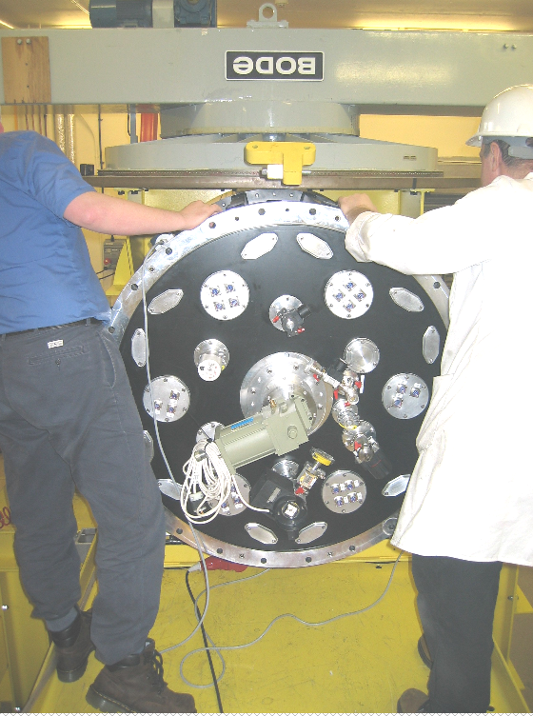
Figure 36 Baseplate and assembled components

Mounting the base plate on the Bracket
This operation has not been done prior to arrival of the instrument in Hawaii. However it is very similar to the mounting arrangement on the UKATC manipulator and is described here.

    - Guide cone
If the guide cone is not attached to the bracket, attach two M8 swivel lifting eyes to the guide cone and using the hoist/spreader bar arrangement lift the guide cone into position and secure with three M8 screws.

    - Tilt shims
If the tilt shims are separate, fasten them together using three M6 screws with the fiducial marks aligned. Attach an M8 swivel lifting eye to the shim pair and lift into position using an engine hoist. Fasten the pair to the bracket using three M8 countersunk screws.

    - Conical interface
Attach two swivel lifting eyes to the conical interface and using the hoist/spreader bar arrangement lift it into position on the guide cone and secure it with twenty four M20 screws and washers.
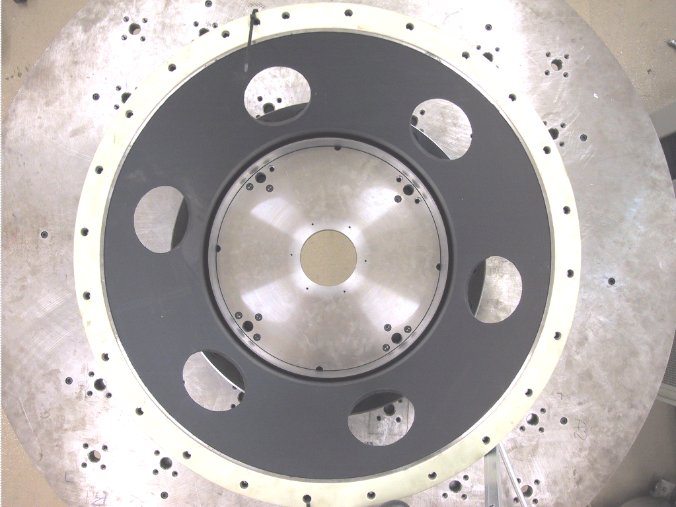
Figure 37 Conical interface and G10 insulating shim

    - Insulating ring
Fit the insulating ring over the conical interface piece, secure temporarily with a zip tie if required.

    - Base plate assembly
Sling the base plate assembly using an M12 swivel lifting eye placed on the North pin location. Alternately a sling can be used around the upper trusses. Using an engine hoist offer the plate up to the conical interface piece, ensuring that the ‘North’ pin on the baseplate engages the ‘North’ hole in the conical interface flange. Insert six M16 screws with insulating sleeves and washers and tighten.

Check continuity between baseplate and interface piece. It should be insulated.
Completed (date) | Checked (date) | Comment

Radiation shield base sub assembly
The radiation shield base subassembly is comprised of the radiation shield base, first stage wick and Liquid Nitrogen can. Start by supporting the radiation shield base on a flat surface or blocks with the dished side down.
    - First stage wick
The first stage wick is the main thermal interface between the instrument cold structure and the closed cycle cooler first stage. It is electrically isolated by means of a Melanex membrane and sleeves on the fasteners. The wick is bolted to the underside of the radiation shield and a temperature sensor assemblies are fastened to the inner and outer wick rings.

Mount the temperature sensors to the wick outer with a smear of vacuum grease on the interface and tighten the two fasteners on each unit.
Completed (date) | Checked (date) | Comment

Check the mating surfaces between the wick and radiation shield base for debris, bruising, dents or visible scratches. Dress any damage found with a stone, file or abrasive pad as appropriate. Clean surfaces with alcohol and apply a very thin coat of vacuum grease to the mating surface of the radiation shield (Apezone –N). Place melanex membrane on radiation shield base.

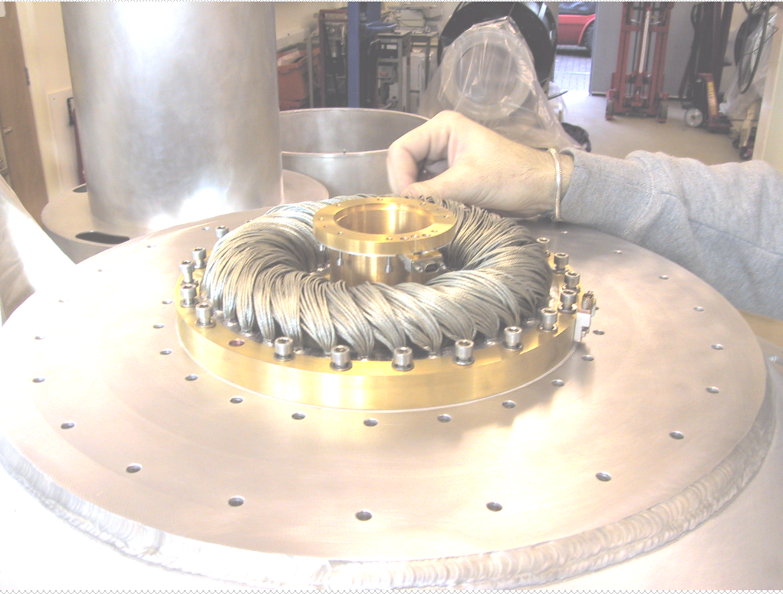
Figure 38 Assembling first tage wick to radiation shield base

Completed (date) | Checked (date) | Comment

Place Melanex membrane on radiation shield base.
Completed (date) | Checked (date) | Comment
Smear thin coating of vacuum grease in mating surface of the wick outer ring.
Completed (date) | Checked (date) | Comment

Place wick on radiation shield base, note that a dowel controls the clocking. Insert insulating sleeves and fasteners. Tighten the 24 M6 fasteners to12.9Nm.
Completed (date) | Checked (date) | Comment

Connect the temperature sensor cable harness to the outer. Check the reading for the temperature sensor of the Lakeshore 218 temperature monitor box.
Completed (date) | Checked (date) | Comment

Using a multi-meter check the isolation of the wick from the radiation shield base.
Completed (date) | Checked (date) | Comment

    - LN Can
Place the LN can on the radiation shield base, orienting it such that the sensor cut out is aligned properly and the sensor wires are captured in the groove on the mating surface. Take care not to bruise the wires between the mating surfaces.
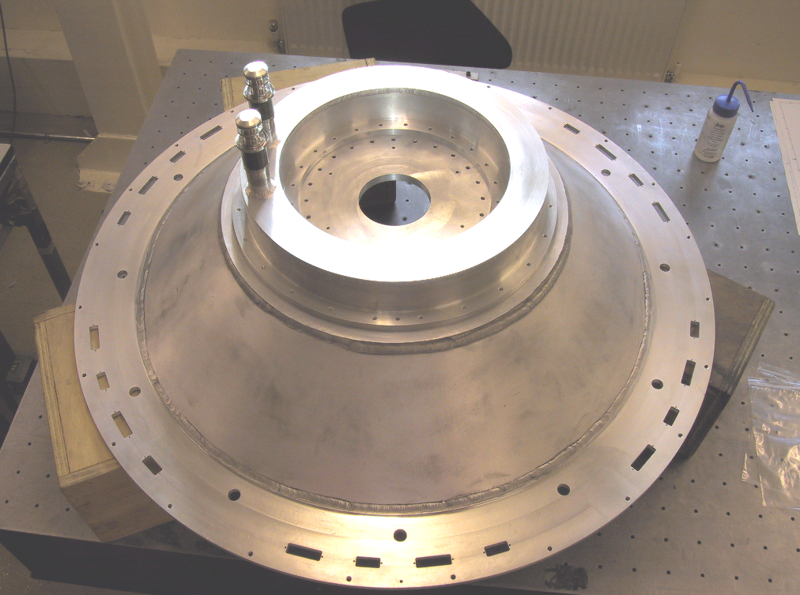
Figure 39 LN can on radshield base

Insert and tighten the 48 M6 fasteners evenly to 12.9Nm.
Completed (date) | Checked (date) | Comment

i. Fill and vent tube steadies
The fill and vent tubes have identical steadies that should be inserted and screwed into place by hand.

ii. Fill and vent tube vacuum seals
These seals are an integral part of the fill tubes and have an O-ring seal to the internal baseplate surface.

This is a vacuum seal.

Check the O-ring and O-ring mating surfaces for debris, bruising, dents or visible scratches. Dress any damage found with a stone, file or abrasive pad as appropriate. Clean surfaces with alcohol and apply a very thin coat of vacuum grease to the O-ring (Apezone –N).

    - Assemble radiation shield base to thermal trusses
The radiation shield base is attached to the apex of each of the six thermal trusses by means of six countersunk M6 screws.

Check the mating surfaces between the radiation shield base and the trusses for debris, bruising, dents or visible scratches. Dress any damage found with a stone, file or abrasive pad as appropriate.
Completed (date) | Checked (date) | Comment

Lift and manoeuvre the radiation shield base oriented with the LN can towards the baseplate. This can be done using the hoist interfaced with eyebolts, shackles and fabric slings. The eyebolts can be placed on the 16mm diameter holes on the rim that will not be interfacing to the truss apex feet.
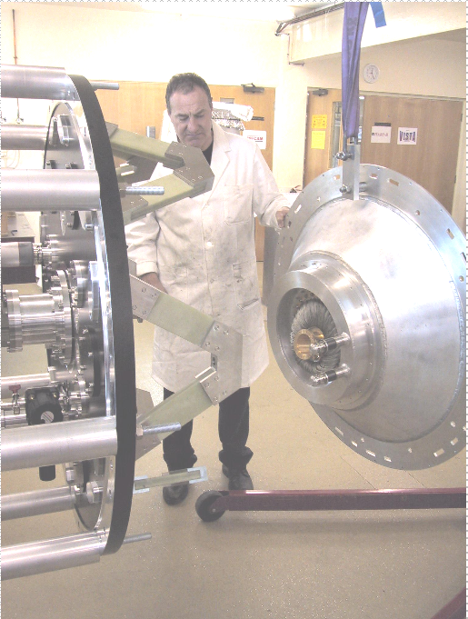
Figure 40 Assembling radshield base to trusses

Lower the radiation shield base (or translate into position if done horizontally), ensuring that the closed cycle cooler cold finger goes through the first stage wick copper ring and enters the central hole without collision.

On lowering (or mating) further ensure that the LN can fill and vent tubes feed through the ports without collision. This should be done with care to avoid damage to the LN fill vacuum seals.

Lower (or translate) the radiation shield base further until the rim is 10mm or so from the truss feet.

Pass the second stage temperature sensor cable harness attached to the inner wick ring through the hole in the radiation shield.

Lower the (or translate) the radiation shield base until it rests on the trusses.

Insert and tighten the six M6 countersunk screws.
Completed (date) | Checked (date) | Comment

i. LN fill and vent tube external sealing components
Each fill and vent tube has a flanged component assembled to it which attaches to the vacuum vessel base by means if four M5 cap screws. Acting against the outside surface of this component is a split clamp. Tightening the split clamp compresses the internal O-ring.

Place flanged component over fill tube on the outside of the vacuum vessel base, insert and tighten four M5 fasteners.

Place split clamp on fill tube and tighten two M4 cap screws
Completed (date) | Checked (date) | Comment

Repeat for vent tube
Completed (date) | Checked (date) | Comment

ii. Fasten first stage wick
Insert and tighten the six captive screws that hold the first stage wick to the first stage of the closed cycle cooler. This is done using a long extension hex driver inserted through the central hole in the radiation shield base.
Completed (date) | Checked (date) | Comment

    - Attach second stage wick
The second stage wick attaches the closed cycle cooler second stage to the wicks leading to the detector box. The wicks must maintain good thermal contact but be isolated from the radiation shield and internal support structure.

i. Outer wick ring
Fasten the three G10 flexures around the central hole on the inside of the radiation shield base using a single M4 cap head screw each. Fasten the outer wick to the G10 flexures using a further three M4 screws.

Completed (date) | Checked (date) | Comment

ii. Inner wick ring
Fasten the temperature assembly to the inner wick boss, smearing the contact surfaces with Apezone-N vacuum grease. Smear a thin film onto the wick contact surfaces. Insert and fasten the six screws that hold the inner wick boss to the closed cycle cooler second stage.
Completed (date) | Checked (date) | Comment

iii. Lower section of fixed wick
There are four of these copper wicks, individually numbered. They are bent to follow the contours on the radiation shield. They attach at the outer wick ring and have insulating steadies at the radiation shield base flange.

Attach the four disk shaped G10 wick steady to the radiation shield base flange using two M3 button heads screws each.
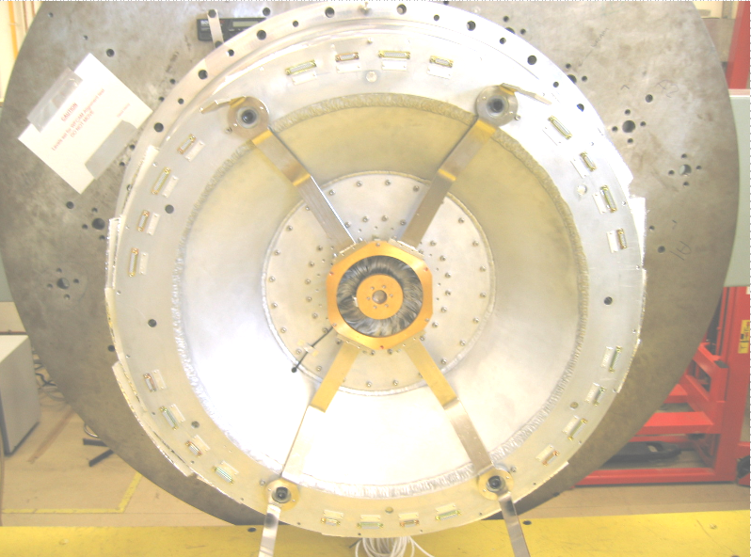
Figure 41 Second stage wicks on radshield base

Check the mating surfaces between the wick and wick ring base for debris, bruising, dents or visible scratches. Dress any damage found with a stone, file or abrasive pad as appropriate. Clean surfaces with alcohol and apply a very thin coat of vacuum grease to the mating (Apezone –N).

Completed (date) | Checked (date) | Comment

Place the Melanex membrane on the wick interface foot (grease will retain it).

Insert the cylindrical insulation components in the wick interface foot.

Check that the numbers correspond to the numbers on the outer wick ring. Assemble the wick to the wick ring with the two M6 screws, insulating washer and special plain washer.

Fasten the wick to the disk shaped steady using two M3 button heads.

Repeat for the remaining 3 wicks

Tighten the M6 screws to 12.9Nm.
Completed (date) | Checked (date) | Comment

Check the insulation using an Avometer to measure continuity between the wick and the radiation shield.
Completed (date) | Checked (date) | Comment

    - Radiation shield base cabling
The cables for the instrument motors as well as the temperature monitoring and control are routed from the break out panel assemblies, along the outside of the radiation shield base and terminate at D-connectors mounted on the radiation shield base flange.

i. Assembling cables
Check that the labelling on the cables correspond to the labelling on the connector cut-outs of the radiation shield base flange. Assemble the D-connector shells in their corresponding slots and secuer with two fasteners each..
Assemble the cable clamps to the radiation shield base with two fasteners each. Do not overtighten

Completed (date) | Checked (date) | Comment

Tertiary bezel assembly
The tertiary bezel assembly consists of the bezel assembly, tertiary assembly, axial spacers, tilt washers and tertiary cover. It is mounted to the truss apexes and fastened by six shoulder screws and stood off by cylindrical spacers. A further four screws are used to fasten it onto the radiation shield base flange with cylindrical spacers in between. Two tapered alignment dowels on the bezel assembly engage with holes in the radiation shield base flange. These have internal threads to take two more fasteners which clamp the bezel to the radiation shield base flange through an internal and external cylindrical spacer.

We will assume that the process is carried out with the instrument axis horizontal with the ‘North’ position uppermost and that the tertiary bezel is fully assembled.

    - Tertiary mirror assembly

i. Radial defining dowels
Insert the three 10mm diameter dowels in the inner flat surface of the mirror bezel (these will not normally be removed and should be in situ).
Completed (date) | Checked (date) | Comment

ii. Tilt washers
Insert the three spherical tilt washer sets in the counter bores on the inner flat surface of the mirror bezel.
Completed (date) | Checked (date) | Comment

iii. Guide spike
Assemble the guide spike to the mirror bezel using three M3 countersunk screws.

Completed (date) | Checked (date) | Comment

iv. Tertiary mirror assembly
Block the Tertiary mirror bezel up to allow access to the three M10 mirror retaining screws underneath.

Assemble a protective cover to the tertiary or above the hoist hook.

Insert the lifting plug with a swivel lifting eye assembled, onto the central handling feature of the tertiary mirror assembly. Insert locking cross-pin. Use a hoist to raise the tertiary mirror and position above the mirror bezel. Lower carefully, ensuring that the guide spike enters the central hole of the mirror base plate. Rotate as required and lower carefully until the radial defining dowels are engaged and the base plate is sitting on the three spherical washers. Insert the fasteners and tighten. Disconnect and remove hoist.

Disconnect and remove hoist interface to mirror central lifting feature.
Completed (date) | Checked (date) | Comment

v. Tertiary retaining ring
Assemble the Tertiary retaining ring to the bezel noting that it will only fit in one position, with the grooved side towards the mirror.
Completed (date) | Checked (date) | Comment

    - Manipulating tertiary bezel assembly
Assuming that the bezel is sitting on blocks or palletised face up.
Attach 2 M8 swivel lifting eyes to the ‘East-West’ positions on the bezel. Using a hoist fitted with the small spreader bar, shackles and slings. Lift the bezel clear and rotate until its axis is horizontal.

    - Mating with the radiation shield base
Manoeuvre the bezel until it co-axial with the radiation shield base and bring the parts near, taking care when the fixed second stage wicks get close to avoid clashes. Insert the four spacers that are located in the holes of the second stage wicks and push the shoulder screws from the back of the radiation shield until the ends of the screws are flush with the spacers. (It will help to coat the shoulder screws with dry lubrication such as MoS2 prior to this operation to prevent the stainless picking up).

Bring the bezel towards the radiation shield, manoeuvring the position of the bezel as necessary until the tapered pins engage the holes in the radiation shield.

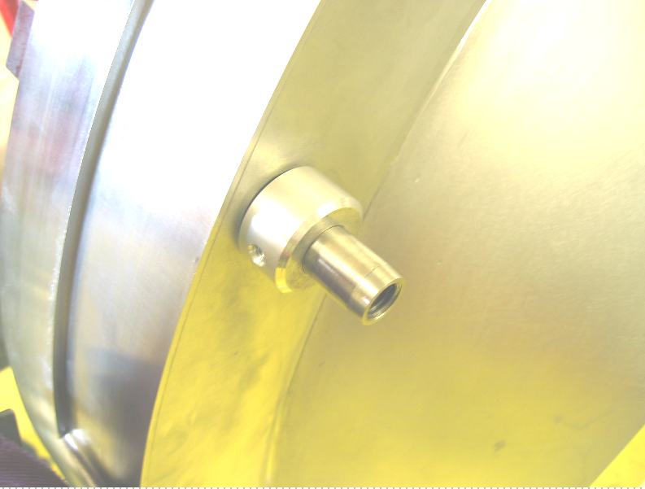
Figure 42 Tapered guide pin and spacer

Continue until the bezel is mated with the spacers.

Insert the brass expanding dowels in the East\West positions and tighten to locate the bezel.

Engage the four shoulder screws and tighten.

Loosen and remove the expanding dowels.

Position the other spacers and insert the remaining bolts at the East/West positions. The spacers are tapped on the side and a long screw inserted in this hole can facilitate this operation, it may be necessary to lever the radiation shield flange away from the bezel using a piece of wood to prevent bruising of the parts. Take care not to damage the connector shell during this operation. Ensure that the long screw used to handle the spacer is not inserted too far as this may pick up on the shoulder bolts.

Insert the four clearance screws with spacers.

Attach spacers over each of the two tapered dowels, washers and insert the M8 screws.

Tighten all the fasteners. Shoulder bolts to 45Nm.

Completed (date) | Checked (date) | Comment

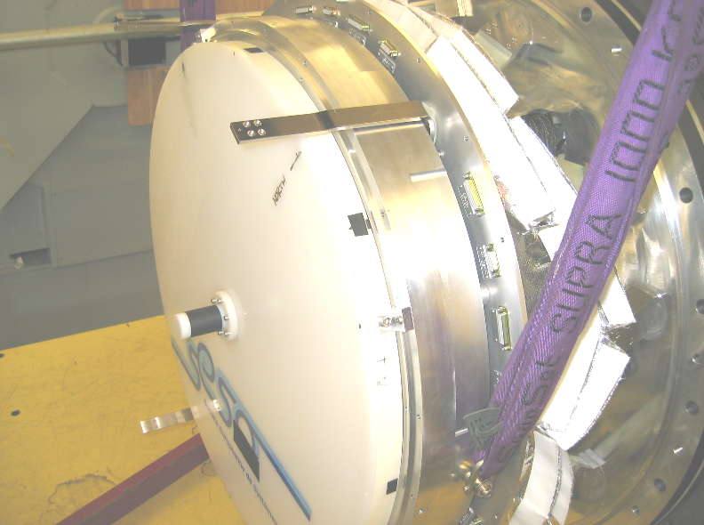
Figure 43 Tertiary bezel mounted on trusses

Internal support tube assembly
The internal support tube assembly supports the top ring off the tertiary mirror bezel. It also provides the support for the second stage wicks, internal baffles and mechanism cable runs.

    - Assembling Internal support tube components

i. Second stage wicks
Each of the four second stage wicks on the support tube are attached by three G10 insulating mounts.

Stand the tube upright and have someone get inside the tube. Attach the 12G10 support from the inside by inserting pairs of M4 screws through the wall into the tapped inserts of the G10 mounts and tightening.
Completed (Date) | Checked by (Date) | Comments

ii. Cable P clips
The cable P-clips use tapped holes in the walls of the support tube. Unused holes should be taped over with aluminium tape.
Completed (Date) | Checked by (Date) | Comments

iii. Heaters and associated components
The heaters are self adhesive and are placed more or less centrally on the tube. They are connected at a terminal block which is screwed on the tube along with an over temperature cut-out switch.
Completed (Date) | Checked by (Date) | Comments

iv. North pin
The north pin is a shaped cross drilled pin which locates on the flat surface of the top flange. It is used to uniquely locate the top ring in angle. Inert and tighten.
Completed (Date) | Checked by (Date) | Comments

v. Baffles
There are five annular baffles within the support tube. The inner aperture gets smaller from the tertiary end towards the top ring. Stand the tube upright and have someone get inside the tube.

Attach the three support brackets using two M5 screws each inserted from the outside.

Pass the first (lowest) baffle into the tube from the top, angling as necessary.

Lower and rotate into position.

Fasten the baffle by inserting two M5 screws in each of the three brackets and tightening.

Repeat for the other 4 baffles.
Completed (Date) | Checked by (Date) | Comments

    - Mating the support tube to the tertiary bezel
Assuming that the support tube is vertical and sitting on the interface surface, the assembly should be lifted with the engine hoist fitted with small the spreader bar, shackles and fabric slings interfaced to two swivel lifting eyes assembled to the lifting points provided on the structure.

Lift the assembly and rotate it until it is vertical with the interface surface facing away from the hoist and the ‘North’ alignment hole uppermost.

This is structural mechanical joint and thermal path.

Run a flat surface, straight edge or stone along the mating surfaces to check for bruising. Dress any damage found with a stone or file.
Completed (date) | Checked (date) | Comment

Clean the surfaces and apply a thin coating of vacuum grease.
Completed (date) | Checked (date) | Comment

Manoeuvre the hoists such that the support tube is co-axial with the tertiary bezel.

Remove the tertiary mirror cover.

Bring the parts together slowly adjusting positions as required, until the North location pin on the bezel engages with the corresponding hole in the support tube flange.

Check the height of the tube by checking that the gap between the parts is even, adjust as required.

Mate the parts and insert the captive screws either side of the ‘North’ pin (assuming this is uppermost).
Now let the hoist down to just take weight off the slings.

Insert the rest of the captive screws and tighten to 12.9Nm.
Completed (date) | Checked (date) | Comment

    - Connecting second stage wick lower joint
These are four copper wicks each joined by four M4 screws. These wicks cool the detector and a good thermal connection is required.

Visually inspect the mating surfaces. Run a flat surface, straight edge or stone along the mating surfaces to check for bruising. Dress any damage found with a stone or file.
Completed (date) | Checked (date) | Comment

Clean the surfaces and apply a thin coating of vacuum grease

Completed (date) | Checked (date) | Comment

Insert the four screws and tighten to 3.8Nm.

    - Connecting the motor, status and thermal control cabling
The cabling is routed from the D-connectors on the radiation shield base flange up the outside of the support tube to the top ring. The cables are held in place by brass P-clips.

Mate the cable connectors on the radiation shield base and evenly tighten the retaining screws. Ensure that the description on each cable matches the one on the connector.
Completed (date) | Checked (date) | Comment

Mid radiation shield
The mid radiation shield attaches to the radiation shield base flange and provides support for the upper radiation shield.

    - Mating the mid radiation shield to the radiation shield base
Assuming that the mid radiation shield tube is vertical and sitting on the interface surface, it should be lifted with the engine hoist fitted with small the spreader bar, shackles and fabric slings interfaced to two swivel lifting eyes assembled to the lifting points provided on the structure.

Lift the tube and rotate it until it is vertical with the interface surface facing away from the hoist and the ‘North’ alignment hole uppermost.

This is structural mechanical joint and thermal path.

Run a flat surface, straight edge or stone along the mating surfaces to check for bruising. Dress any damage found with a stone or file.
Completed (date) | Checked (date) | Comment

Clean the surfaces and apply a thin coating of vacuum grease
Completed (date) | Checked (date) | Comment

Manoeuvre the hoists such that the tube is co-axial with the internal support tube.

Bring the parts together slowly adjusting positions as required, until the North location pin on the radiation shield base flange engages with the corresponding hole in the mid radiation shield flange.

Check the height of the tube by checking that the gap between the parts is even, adjust as required.

Mate the parts and insert the captive screws either side of the ‘North’ pin (assuming this is uppermost).

Now let the hoist down to just take weight off the slings.

Insert the rest of the captive screws and tighten to 12.9Nm.
Completed (date) | Checked (date) | Comment

    - Attach the superinsulation blanket
The blanket is in two layers and the seams for these should be staggered 180 degrees apart. There is an inner and outer blanket. They are labelled on the Velcro fastening.

Wrap the inner blanket around the radiation shield and mate the Velcro seam.

Mate the Velcro seams on the inner blanket on the radiation shield base blanket.

Repeat this with the outer blanket.
Completed (date) | Checked (date) | Comment
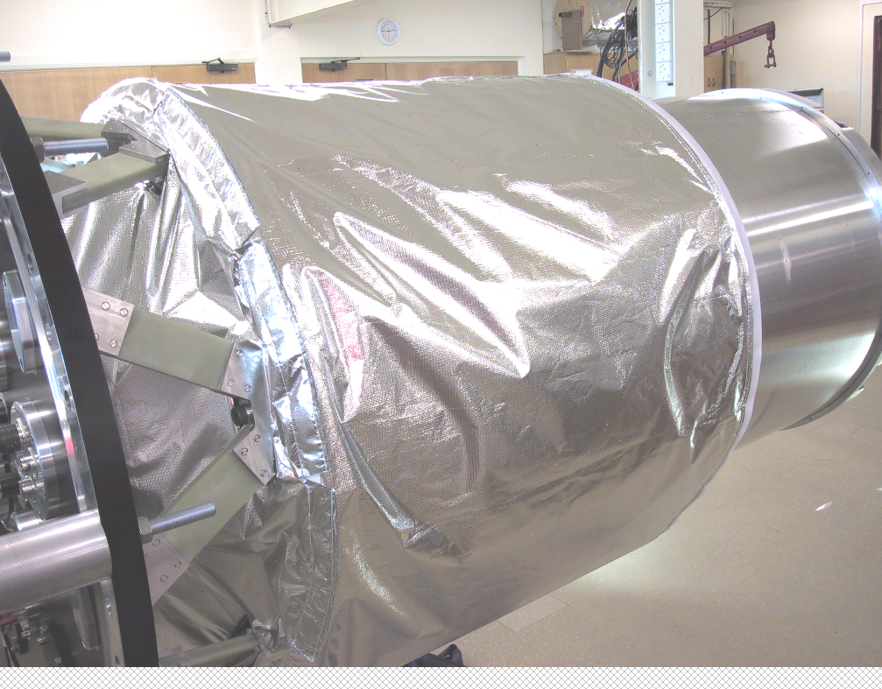
Figure 44 MLI blanket on mid radshield

Vacuum vessel mid section
The vacuum vessel mid section attaches to the vacuum vessel base-plate and provides support for the upper vacuum vessel and external cable runs.

This is structural mechanical joint and vacuum seal.

Clean and visually inspect the mating surfaces including the O-ring groove for debris or damage. Run a flat surface, straight edge or stone along the mating surfaces to check for bruising. Dress any damage found with a stone or file. Dress any scratches on the O-ring sealing surface with an abrasive pad.
Completed (date) | Checked (date) | Comment

Clean the surfaces and apply a thin coating of vacuum grease
Completed (date) | Checked (date) | Comment

Assuming that the vacuum vessel mid section is horizontal, it should be lifted with the engine hoist fitted with the small the spreader bar, shackles and fabric slings interfaced to two swivel lifting eyes assembled to the lifting points provided on the structure.

Lift the tube with the interface surface facing away from the hoist and the ‘North’ alignment hole uppermost.
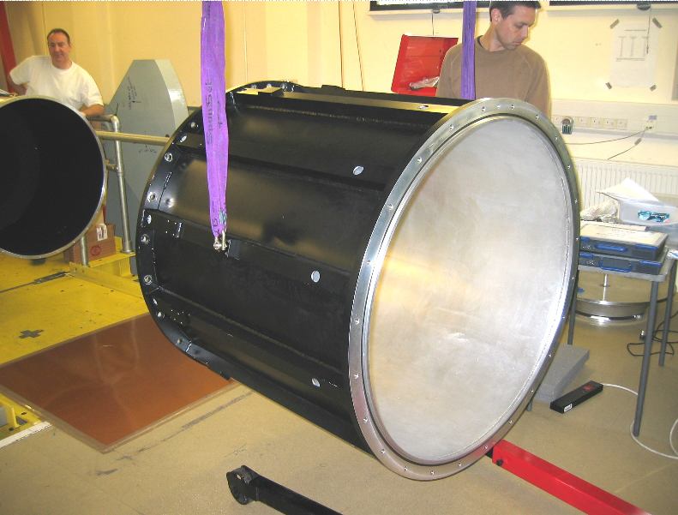
Figure 45 Assembling mid vacuum vessel section

Manoeuvre the hoists such that the tube is co-axial with the mid radiation shield.

Bring the parts together slowly adjusting positions as required, until the North location pin on the vacuum vessel base engages with the corresponding hole in the mid vacuum vessel flange.

Check the height of the tube by checking that the gap between the parts is even, adjust as required.

Mate the parts and insert the M16 screws either side of the ‘North’ pin (assuming this is uppermost).

Now let the hoist down to just take weight off the slings.
Insert the rest of the M16 screws and tighten to 164Nm.
Completed (date) | Checked (date) | Comment

- CRYOSTAT Top section Assembly
This section is intended to define the assembly procedure for the WFCAM vacuum vessel applicable for a typical service of the mechanisms or focal plane. A description of the process is given along with equipment and personnel required. A checklist is also provided for QA of the process itself.

Preparing for assembly
It is assumed for the purpose of this document that the cold structure has been assembled and prepared for vacuum vessel closure according to the relevant maintenance procedure. Normally this will mean that the field lens tower, upper vacuum vessel and upper radiation shield have been removed.
    - Instrument support
The instrument should be supported in the horizontal orientation on the angle bracket interface to the Michelle handling rig. Facing the instrument from the window end, the ‘West’ side will be uppermost and the ‘North’ side will be to the right. The West and North references are to the directions which the instrument will be oriented when mounted on the telescope, telescope pointing directly up. The ‘North’ orientation of the instrument is identified by a series of dowels and corresponding dowel holes at each interface. In many cases, the ‘North’ position is also indicated with a painted or typed ‘N’ or ‘NORTH’.

    - Personnel required
The assembly will require two personnel at a minimum. Operation of a hydraulic engine hoist and some rigging and slinging are required and at least one of the personnel should be familiar with the operation of the hoist and rigging. It is also recommended that at least one has carried out the procedure previously.

    - Equipment required
A mobile boom type hydraulic engine hoist is recommended to manipulate the parts during assembly. A spreader bar and lifting accessories must be used in conjunction with hoist as listed below.

Equipment and number | Capacity/Size | Use
Engine hoist | 350Kg min. 2m reach, 2m under hook height when raised | Lift and manipulate radiation shield top and vacuum vessel top sections
Lifting spreader bar | 250Kg min. 1.1 m span  (supplied with instrument) | Lift and manipulate radiation shield top and vacuum vessel top sections
4 shackles | 500Kg min. | Connect slings to spreader bar
Fabric sling x 2 | 500Kg min. 1000mm long min. | Sling radiation shield top and vacuum vessel top sections
Stone/straight edge | 150mm | Detect bruising of interface components
Ball hex drivers x2 | 5mm | Fasteners on radiation shield top interface
Ball hex drivers x2 | 10mm | Fasteners on vacuum vessel top interface
Ball hex driver x 2 | 3mm | Fasteners on the radshield connector panels
Small screw driver |  | Connector screws
Torque wrench and extension to 5mm hex | To measure 10Nm to 50Nm | Torque radiation shield and vacuum vessel fasteners

    - Part masses and centres of gravity
The approximate masses of the parts and their centres of gravity are listed below.
 | Mass (kg) | CofG (mm) | CofG Comment
Top Vacuum vessel | 186 | 584 | From Mid section mating surface
Top rad shield | 47 | 685 | From mid section mating surface
External tower | 57 | 1120 | From top vac vessel mating surface

    - Completing the checklist
The checklist for each task requires two initials and a date. It is recommended that the ‘inspected by’ box be initialled by an observer in charge of the procedure but involved in doing the tasks. A space is also available for comments.

    - Torque settings
If torque settings are not explicitly given the following table should be used. This assumes that the screws are into a minimum of 1.5D aluminium. Use the same values for Helicoiled Aluminium and stainless.

Nominal screw size | Recommended torque
M2 | 0.5
M2.5 | 0.9
M3 | 1.6
M4 | 3.8
M5 | 7.6
M6 | 12.9
M8 | 30.9
M10 | 58.8
M12 | 107.8
M14 | 171.6
M16 | 264.8

Assembling the Top ring
Assuming that we start with the top ring with it’s removable legs sitting on a bench or on the floor.

    - Mating surface check
Visually inspect the mating surfaces on the top ring and internal support tube for bruising or dents. Run a flat surface, straight edge or stone along the surfaces to check. Dress any damage found with a stone or file.
Completed (date) | Checked (date) | Comment

    - Attach handling brackets to the top ring
Assemble both handling brackets to the top ring using four M12 screws making sure that the long part of the diamond shaped lifting plate is to the side which will be nearest the instrument on assembly. The brackets must be assembles to the East and West. If not already assembled, attach two 8mm swivel lifting rings to the indicated position on the diamond lifting plate.

    - Manoeuvre top ring into position and mounting
Attach the small spreader bar to the boom hoist and attach to the swivel rings using shackles and fabric slings. Steady the top ring by hand and lift clear. The top ring can now be rotated axis horizontal by hand using the legs to control it. Two legs must now be swapped onto the other side of the top ring and the third one removed.

Remove the protective bags from the filter holders.
Completed (date) | Checked (date) | Comment

Attach the top ring guide pins
Completed (date) | Checked (date) | Comment

The top ring can now be manipulated by hand into position using the hoist until it is co-axial with the inner support tube. It can now be carefully moved towards the instrument until the paddle mechanisms enter into the tube and the guide pins are aligned to the appropriate holes, adjusting height and position as required. Continue moving the top ring over the guide pins until the spigot is engaged, the mating surfaces touch and the fasteners can be inserted and engaged.

Check that the North marker on the top ring corresponds with the North marker on the inner support tube.
Completed (date) | Checked (date) | Comment

Remove guider pins
Completed (date) | Checked (date) | Comment

Tighten the 24M6 screws to 10Nm.
Completed (date) | Checked (date) | Comment

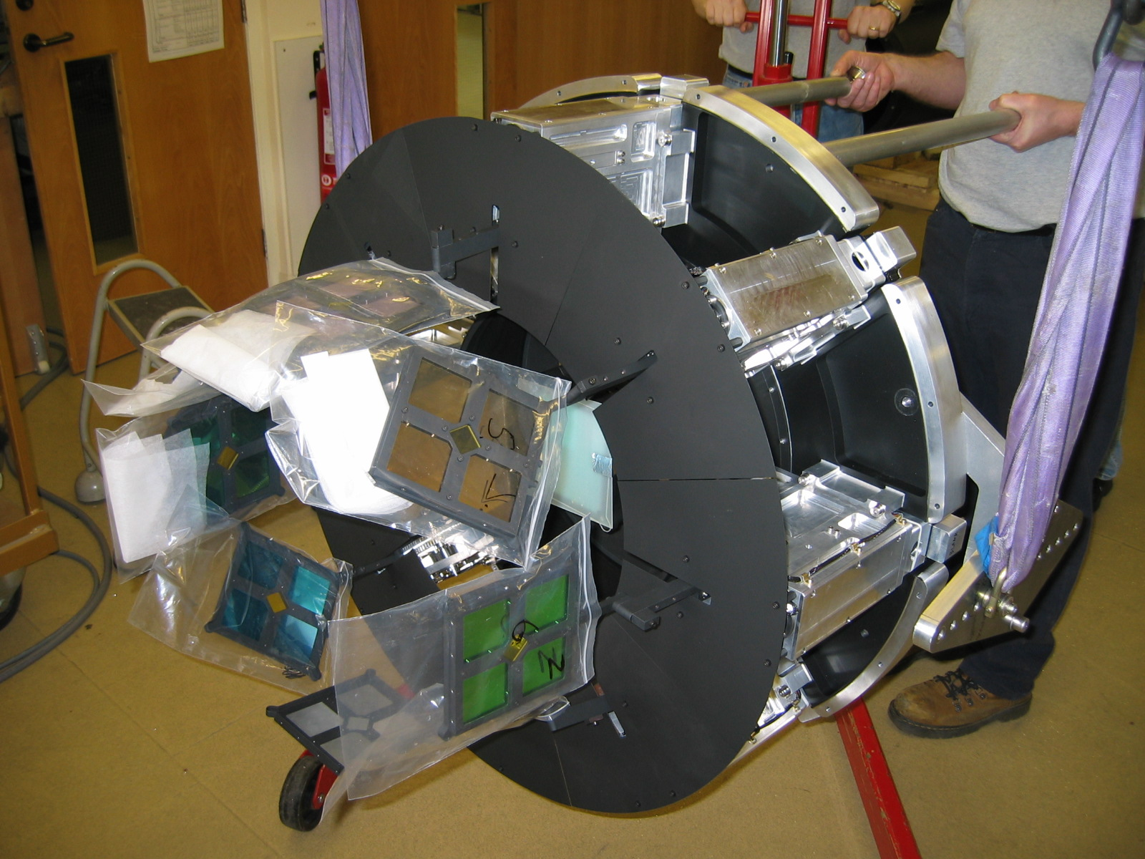
Figure 46 Manouvering the top ring assembly

Remove handling brackets and withdraw boom hoist.
Completed (date) | Checked (date) | Comment

    - Removing top ring
This uses the same technique as assembly but the following additional steps must be observed.

i. Prior to unfastening top ring screws
Ensure that the handling brackets/hoist attachments and legs (for control) are assembled properly and that the hoist is taking some of the top ring load. Attach the guide pins in the east-west position. If the guide pins are not used it is advisable to use a trolley jack under the top ring to prevent it falling once the spigot is disengaged (due to stretch of the fabric slings).
Completed (date) | Checked (date) | Comment

    - Configuration Check
Is the instrument configured properly for the next run? After the detector focus assembly is assembled it is impossible to visually inspect or change the filters. It is necessary at this time to visually inspect the top ring and make the following checks:

i. Filter paddles
Are all the filter mechanisms present and populated with the appropriate filters?
Completed (date) | Checked (date) | Comment

ii. Presence of covers, tools, debris
Inspect the assembly for any covers, tools or debris that has been left in the assembly.
Completed (date) | Checked (date) | Comment

iii. Connectivity of mechanisms
The mechanisms should be checked at this point by datuming and confirming correct operation via the control software graphical interface.
Completed (date) | Checked (date) | Comment

Assemble the focus assembly
It is assumed that the focus assembly is sitting on a bench or on the ground and has its stand legs assembled to it.

    - Mating surface check
Visually inspect the mating surfaces on the focus ring and the top ring for bruising or dents. Run a flat surface, straight edge or stone along the surfaces to check. Dress any damage found with a stone or file.
Completed (date) | Checked (date) | Comment

    - Mount onto top ring
Lift the assembly by hand using the handles and remove to legs. This process is best done using two technicians to lift while a third removes the legs.

Check orientation of the focus spider. The north position is indicated by a small hole, adjacent to one of the M6 clearance holes in the spider flange.
Completed (date) | Checked (date) | Comment

Remove field flattening lens cover
Completed (date) | Checked (date) | Comment

The assembly must now be offered up to the top ring, aligning the North markers and engaging the guide pins.

The assembly can now be slid carefully along the guide pins until the locating spigot is engaged, the mating surfaces touch and the fasteners can be engaged.

Tighten the 12 M6 cap screw fasteners to 10Nm
Completed (date) | Checked (date) | Comment

    - Make cold wick connections
The cold wick connections must now be made on the copper arms that guide the flexi-circuits. Insert and tighten the 4 M4 cap screw fasteners and tighten to 4Nm.

Completed (date) | Checked (date) | Comment

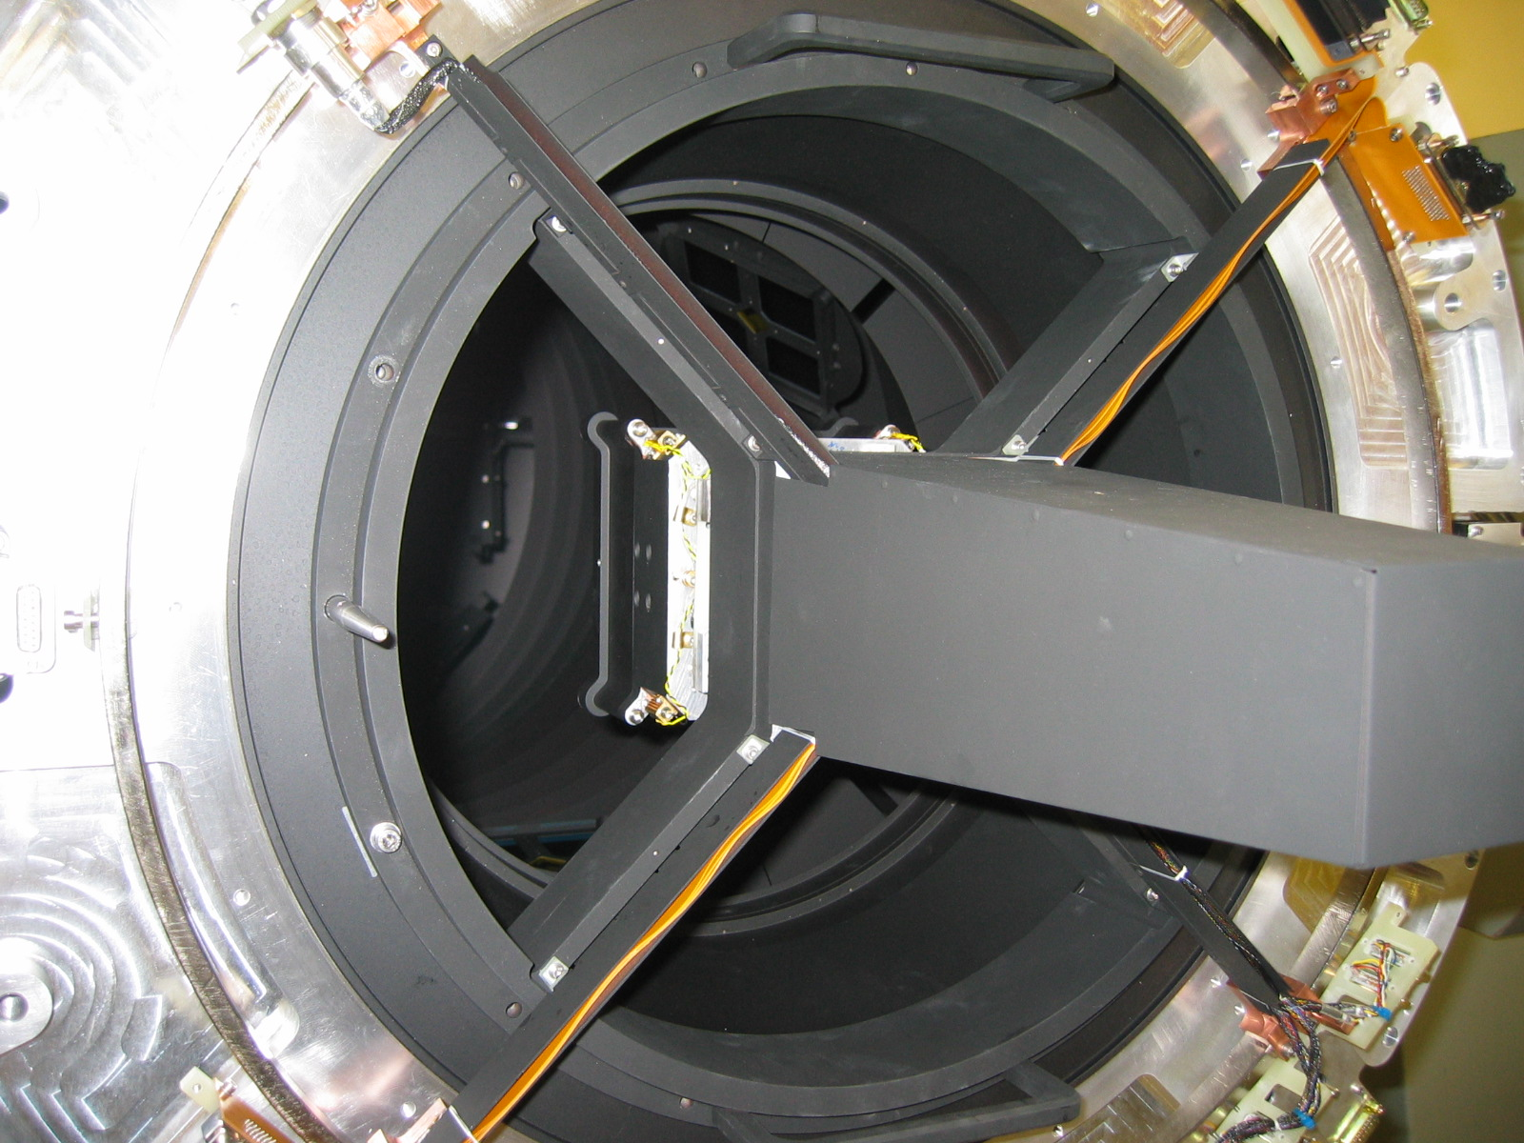
Figure 47 Attaching focus assembly

    - Make the detector motor and status connectors
Connect the D-connectors, one for the motor and one for the status and tighten jacking screws
Completed (date) | Checked (date) | Comment

    - Make the IR detector /guider CCD temperature connectors
Connect the 2 D connectors for the heater and temperature sensors.

Check that thermal readings are correct on the graphical interface for the detector box and guider.
Completed (date) | Checked (date) | Comment

    - Carry out a warm functional check of each science device by connecting the detector flexi cables to a pre-amps/SDSU controller

With the detector box mounted on the focus spider assembly and the four flexi cables plugged into the detector PCBs a functional test of each detector should be performed. This should be done by running the “do_wfcam_science_srr.xml” application on the data acquisition software.
The images should look like this for the four science grade arrays:

Warm image of Science device 41

Figure 48 Warm image of Science device 41 (to be included)

Note the features ****** ***** in quadrants *** ***

Warm image of Science device 60

Figure 49 Warm image of Science device 60 (to be included)

Note the features ****** *****

Warm image of Science device 62

Figure 50 Warm image of Science device 62 (to be included)

Note the features ****** *****

Warm image of Science device 63

Figure 51 Warm image of Science device 41 (to be included)

Note the features ****** *****

Completed (date) | Checked (date) | Comment

    - Carry out a warm functional check of the autoguider ccd

With the detector box mounted on the focus spider assembly and Nanonics connector plugged into the autoguider housing a functional test of the CCD should be performed. This should be done by running the “wfag_warm_test”, “filename” on the autoguider software running via the VME crate.

A warm image should look like that in fig.*. The increase in brightness from bottom to top is caused by high level of dark current at room temperature. As it takes longer to read out the pixels at the top than the bottom dark current has more time to accumulate therefore causing higher signal levels.


Figure 52 Image of warm CCD

Use IRAF to take a cut from top to bottom of the image above and confirm that the dark current generation is linear over the device.

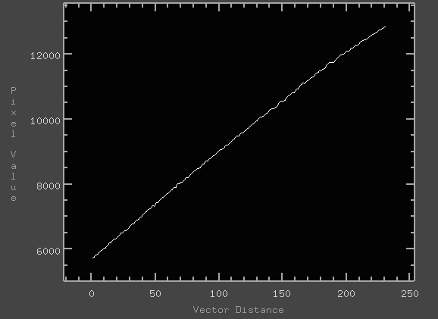
Figure 53 IRAF vertical cut of warm CCD showing linear dark current generation

Completed (date) | Checked (date) | Comment

    - Detector focus assembly cover
Replace the cover, insert and tighten the four M3 button head screws/washers.
Completed (date) | Checked (date) | Comment

    - Configuration Check
Is the instrument configured properly for the next run? After the corrector tube assembly is assembled it is impossible to visually inspect the focus mechanism. It is necessary at this time to visually inspect the focus assembly and make the following checks:

i. Detector field lens bezel
Is this assembled?
Completed (date) | Checked (date) | Comment

ii. Presence of covers, tools, debris
Inspect the assembly for any covers, tools or debris that has been left in the assembly.
Completed (date) | Checked (date) | Comment

iii. Connectivity of mechanisms
The mechanisms should be checked at this point by datuming and confirming correct operation via the control software graphical interface.
Completed (date) | Checked (date) | Comment

iv. Temperature sensors
Each channel of the temperature sensors should be verified for proper operation, the reading for each should be ambient. The sensor on the radiation shield near the window must be checked after the radiation shield top section is assembled and the connection made.
Completed (date) | Checked (date) | Comment

v. Heaters
The heaters should be briefly operated and the appropriate temperature sensor monitored to confirm operation. This includes the radiation shield panel heaters, detector box heaters and the CCD guider assembly heaters.
Completed (date) | Checked (date) | Comment

Assembling the corrector tube
It is assumed that the corrector tube is sitting on a flat surface, axis vertical, and has the corrector plate assembly already attached to it via the 4 flexures.

    - Mating surface check
Visually inspect the mating surfaces on the corrector tube and the top ring for bruising or dents. Run a flat surface, straight edge or stone along the surfaces to check. Dress any damage found with a stone or file.
Completed (date) | Checked (date) | Comment

    - Slinging the corrector tube
Attach 2 off M8 swivel hoist rings onto the tube at the lifting plates. Manoevre the hoist with the speader beam attached over the tube. With shackles attach the beam to the hoist rings and gently lift the corrector tube assembly. Allow the assembly to rotate on the hoist rings so now it is in a horizontal orientation.
The assembly must now be offered up to the top ring, aligning the North markers and engaging the spigot, mating surfaces and fasteners. The 12 M6 fasteners must now be tightened to 20Nm.
Completed (date) | Checked (date) | Comment

    - Configuration Check
Is the instrument configured properly for the next run? After the radiation shield top section is assembled it is impossible to visually inspect the corrector tube and top ring. It is necessary at this time to visually inspect the assembly and make the following checks:

i. Presence of covers, tools, debris
Inspect the assembly for any covers, tools or debris that has been left in the assembly.
Completed (date) | Checked (date) | Comment

ii. Temperature sensors
Each channel of the temperature sensors should be verified for proper operation, the reading for each should be ambient. The sensor on the radiation shield near the window must be checked after the radiation shield top section is assembled and the connection made.
Completed (date) | Checked (date) | Comment

iii. Connectivity of mechanisms
The mechanisms must now be checked by datuming and confirming correct operation visually and via the control software GUI.
Completed (date) | Checked (date) | Comment

Assembling the radshield top section
    - Checking the interface surfaces for damage
A straight edge should be dragged over the interface surfaces to detect possible bruising of the interface. The interface surface must also be visually inspected for damage. Any bruising should dresses with a stone or file and the surface cleaned with alcohol.
Completed (date) | Checked (date) | Comment

    - Slinging the radiation shield top section
The radiation shield top section must be slung about its centre of gravity. This is achieved by 2 swivel hoist rings attached to lifting plates on the radiation shield. The hoist, spreader beam and shackles are also used. The hoist can now be used to lift the top section. The position of the North-locating pin should be verified and the component lifted and rotated in the slings if necessary.
Completed (date) | Checked (date) | Comment

    - Manipulating the top section into place
By hand, the section is manipulated until it is co-axial with the instrument and the interface surfaces are towards each other. The top section can now be moved towards the instrument adjusting position as required until the interfaces are within 1meter.

    - Mating the top section
At this point care must be taken that the internal corrector assembly tube enters the ‘corresponding snout’ of the radiation shield top section as it is slowly moved towards the instrument. The correct position and height and level must be checked constantly during this operation.

As the surfaces are mated, the top section must be aligned in rotation until the North mating pin is engaged and the fasteners can be inserted.

The weight can be taken off the slings by lowering the boom hoist.
The 24 M6 fasteners must now be tightened in stages to a torque of 10Nm.
Completed (date) | Checked (date) | Comment

    - Connecting the temperature sensor
The temperature sensor connector located near the interface at the West position can now be mated.

The correct reading on the temperature controller must now be confirmed.
Completed (date) | Checked (date) | Comment

    - Connecting the wiring panels
Each of the three panels has a similar procedure described as follows:

i. Array panel NW and SW
The four panel screws must be removed to detach the panel from the radiation shield. The two flexi circuit D connectors must be mated including the retaining screws on the connector shells.
Completed (date) | Checked (date) | Comment

ii. Guider CCD panel
The four panel screws must be removed to detach the panel from the radiation shield. The Fisher connector must be mated.

Completed (date) | Checked (date) | Comment

    - Connecting super insulation
The inner and outer Velcro fasteners should be engaged on the super insulation blanket.

Completed (date) | Checked (date) | Comment

    - Assemble superinsulation blankets
Attach the 6 super insulation blanket sections to the upper radiation shield.
Completed (date) | Checked (date) | Comment

    - Assemble conical baffle
Assemble the conical baffle to the end flange of the radiation shield. Tuck the MLI between the radiation shield flange and the baffle. Insert and tighten the 6 M6 screws which retain it.
Completed (date) | Checked (date) | Comment

    - Configuration Check
Is the instrument configured properly for the next run? After the vacuum vessel top section is assembled it is impossible to visually inspect the radiation shield and superinsulation blanket. It is necessary at this time to visually inspect the assembly and make the following checks:

i. Presence of covers, tools, debris
Inspect the assembly for any covers, tools or debris that has been left in the assembly.
Completed (date) | Checked (date) | Comment

ii. Temperature sensors
Each channel of the temperature sensors should be verified for proper operation, the reading for each should be ambient. The sensor on the radiation shield near the window must now be checked.
Completed (date) | Checked (date) | Comment

Assembling the vacuum vessel top section
This is a very similar process to that used with the radiation shield top section described above but the component itself is much heavier and there is less clearance with the presence of the super insulating blanket.

    - Mount the four array pre-amplifier racks and autoguider controller onto the vacuum vessel

The pre-amplifier boxes and autoguider CCD should be mounted on the vacuum vessel using isolating bushes.

The electrical isolation between each chassis and the vacuum vessel should be confirmed using a digital multi-meter.

Completed (date) | Checked (date) | Comment

    - Checking the interface surfaces for damage
A straight edge should be dragged over the interface surfaces to detect possible bruising of the interface.
The interface surface must also be visually inspected for damage. Any bruising should dresses with a stone or file and the surface cleaned with alcohol.

Completed (date) | Checked (date) | Comment

    - Checking the vacuum sealing surfaces
The flat sealing surface on the top sections should be cleaned with Isopropyl alcohol and visually checked for scratches and particulates in the process. Scratches can be dressed with an abrasive pad.

The O-ring should be inspected for damage.

The O-ring should be inspected for debris. Hairs and metal spalled from the tapped holes should are a common contaminant and should be cleaned off.

The O-ring and mating surface should be lightly coated with Vacuum grease.
Completed (date) | Checked (date) | Comment

    - Slinging the vacuum vessel top section
The vacuum vessel top section must be slung about its centre of gravity. This is achieved by 2 swivel hoist rings attached to lifting plates on the radiation shield. The hoist, spreader beam and shackles are also used. The hoist can now be used to lift the top section. The position of the North-locating pin should be verified and the component lifted and rotated in the slings if necessary.

Completed (date) | Checked (date) | Comment

    - Manipulating the top section into place
By hand, the section is manipulated until it is co-axial with the instrument and the interface surfaces are towards each other. The top section can now be moved towards the instrument adjusting position as required until the interfaces are within 1meter.

    - Mating the top section
At this point care must be taken that the internal radiation shield assembly tube enters the ‘corresponding snout’ of the vacuum vessel top section as it is slowly moved towards the instrument. There is very little clearance. The correct position and height and level must be checked constantly during this operation. It is useful to monitor the position and progress through the window opening. Care must be taken to avoid snagging the superinsulation around the snout.

As the surfaces are mated, the top section must be aligned in rotation until the North mating pin is engaged and the fasteners can be inserted.
Completed (date) | Checked (date) | Comment

The weight can be taken off the slings by lowering the boom hoist.

The 24 M10 fasteners must now be tightened in stages to a torque of 50Nm.
Completed (date) | Checked (date) | Comment

    - Connecting the wiring panels
Each of the panels has a similar procedure described as follows:

i. Array panel NW and SW
The four panel screws must be removed to allow the panel to be hinge open. It may be easier to remove the hinges altogether and have someone support the closure plate. The two flexi circuit D connectors must be mated including the retaining screws on the connector shells.
Completed (date) | Checked (date) | Comment

ii. Guider CCD panel
The four panel screws must be removed to allow the panel to be hinged open. The Fisher connector must be mated.
Completed (date) | Checked (date) | Comment

    - Carry out functional tests on the ir arrays & autoguider ccd

Carry out functional checks as outlined in sections 6.3.6 & 6.3.7 using the pre-amplifiers and autoguider controller mounted on the top of the cryostat.
Completed (date) | Checked (date) | Comment

Assembling the window bezel to the vacuum vessel
Starting with the window bezel assembly including the cover and lifting rings attached.

    - Slinging the window bezel
The fabric sling must be passed through the lifting ring located on the ‘West’ side and attached to the hoist ring (if on the Michelle handling rig + bracket). The window bezel can be assembled in any orientation where the fasteners line up, it has no preferred orientation. The hoist is now raised carefully until the assembly is suspended in the near vertical orientation.

    - Checking the interface surfaces for damage
A straight edge should be dragged over the interface surfaces to detect possible bruising of the interface.

The interface surface must also be visually inspected for damage. Any bruising should dresses with a stone or file and the surface cleaned with alcohol.
Completed (date) | Checked (date) | Comment

    - Checking the vacuum sealing surfaces
The flat sealing surface on the top sections should be cleaned with Isopropyl alcohol and visually checked for scratches and particulates in the process. Scratches can be dressed with an abrasive pad.

The O-ring should be inspected for damage.

The O-ring should be inspected for debris. Hairs and metal spalled from the tapped holes should are a common contaminant and should be cleaned off.

The O-ring and mating surface should be lightly coated with Vacuum grease

Completed (date) | Checked (date) | Comment

    - Offering the window assembly up to the vacuum vessel
Using the hoist, the assembly must be moved by hand until the interface surfaces nearly touch. The height must be adjusted as necessary. The assembly can then be pushed by hand against the vacuum vessel interface and the fasteners engaged. Tighten 8 M6 screws to 20Nm.

The lifting attachment can now be removed.

External tower assembly
Inspect the mating/vacuum surfaces for debris, dents and bruising. Run a flat surface, stone or straight edge along the surface to check. Dress any damage with a stone or a file.
Completed (Date) | Checked by (Date) | Comments

Sling the tower at its centre of gravity (use the pintel attachment tapped holes furthest from the lens assembly. Attach the end of the sling to the hook of the engine hoist.

Ensure that the north position is in the correct orientation.

Check that the tower is at the correct height to the instrument.

Manoeuvre the tower towards the instrument, adjust the height of the tower if required and align the bolt holes.

Mate the two surfaces ensuring that the spigot diameter has engaged correctly.

Attach the 12 off M8 x 1.25 cap head screws and torque to 45Nm.
Completed (Date) | Checked by (Date) | Comments

    - Field lens assembly
Inspect the mating/vacuum surfaces for debris, dents and bruising. Run a flat surface, stone or straight edge along the surface to check. Dress any damage with a stone or a file.
Completed (Date) | Checked by (Date) | Comments

Attach 1 off swivel hoist ring into the appropriate hole in the field lens bezel.

Loop a lifting sling through the hoist ring and attach the other end to the hook of the engine hoist.

Ensure that the North position is in the correct orientation.

Manoeuvre the field lens assembly towards the instrument and check the height of the lens assembly.

Position the lens assembly close to the external tower and make any final adjustments to the height.

Align the bolt holes.

Mate the two surfaces ensuring that the spigot diameter has engaged correctly.

Attach the lens assembly to the external tower via 12 off M8 x 1.25 cap head screws and torque to 45Nm.
Completed (Date) | Checked by (Date) | Comments

- MECHANISM SOFTWARE USERS MANUAL

Introduction
This document is a user manual for the mechanism control software. Although it primarily focuses on the engineering software interface it also includes information about how the electronics and mechanical hardware operate in order to explain how to use the software. This document should be read by anyone who intends using the engineering software interface or is involved in the mechanical and electronic maintenance.

    - References
Reference | Document Number | Issue | Date | Title
[RD01] | 5.2d001S | 0.4 | 2002-11-18 | Mechanism Control and Cryostat Services Software Design
[RD02] |  |  |  | Electronics Manual
[RD03] |  | 0.1 | 2004-04-19 | Filter Paddle Set-up

Overview
The WFCAM instrument has nine mechanisms which are all housed inside the cryostat. These mechanisms include eight filter paddles and one focus mechanism. All of these mechanisms are linear devices and therefore the same low-level software is used to drive all of the mechanisms.

The mechanism control software provides an interface for the instrument sequencer which allows it to configure the mechanisms during observations. As well as this there are engineering GUIs available that are be described in this document.

There is added complexity involved in driving the filter paddles that they are all capable of occupying the same space inside the cryostat when they are extended into the beam. Any collisions between paddles could cause considerable damage and therefore safety measures have been put in place for both software and hardware to reduce the risk of this happening as much as possible.

The software runs on a PowerPC 2432 card installed in a VME crate. A XYCOM XVME-240 digital I/O card will be used for sensing micro-switches and a OMS VME58-8 motor card for driving the mechanism motors. The underlying software system is EPICS running on a VxWorks platform.

Mechanism Description
    - Mechanism Design
The diagram in figure1 shows the close proximity of the eight filter paddles as part of the top ring assembly. One of paddles is in position extended into the beam whilst all of the other filter paddles are safely parked out of the beam. It is not to difficult to spot the potential scenario where if more than one filter were extended into the beam then a collision could occur resulting in serious damage. This must be avoided at all costs and therefore certain measures have been built into the electronics and software operational design to prevent such collisions from happening. However, should the mechanisms get into an unexpected state, provisions have been made to provide a safe recovery in order to minimise any potential for collisions from occurring.

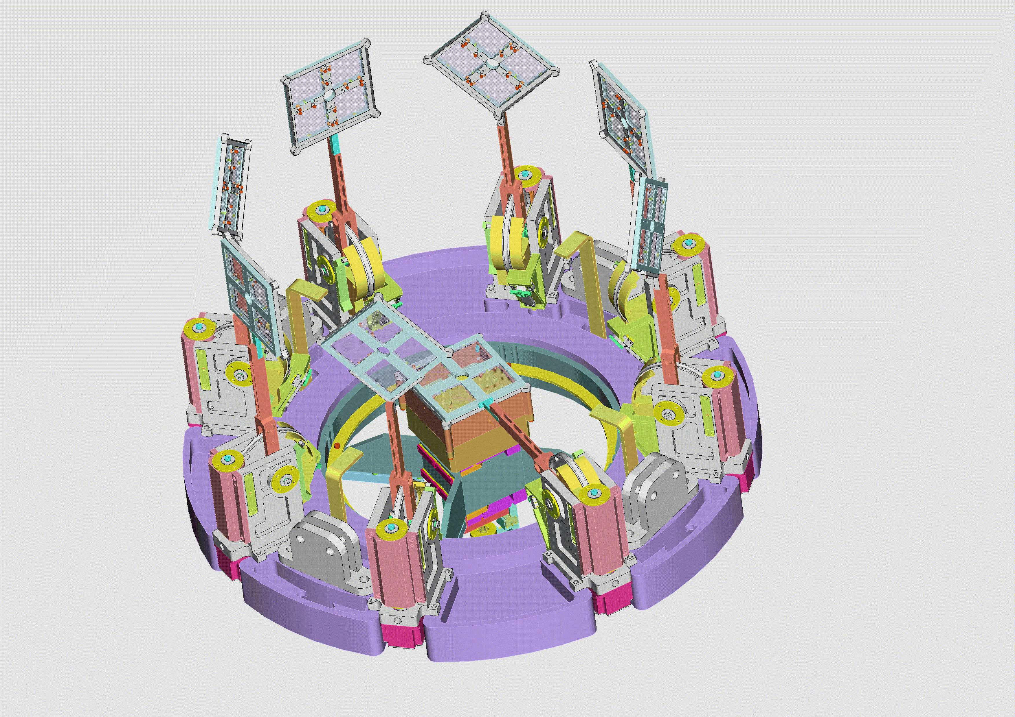
Figure 54 Top Ring Filter Paddle Assembly

    - Electronic Hardware Design
The mechanism control software will run on a PowerPC 2432 (350MHz/64MB) card installed in a VME crate with a XYCOM XVME-240 digital I/O card and two OMS VME58-8 motor board. Other electronics boards built at the ATC provide hardware inputs/outputs and an interlocking system.

Naturally the motor driver cards will drive the stepper motors used on all of the mechanisms. Either the primary datum or secondary datum switch for each mechanism can be selected by a jumper with the resulting output signal wired as an input into the digital I/O board for each mechanism. The power lines for the stepper motors are wired as outputs on the digital I/O board. The limit switches and the selected datum switch are wired into the motor board.

The datum switches are wired as inputs into the digital I/O board as well as the motor board. The reason for this is because the software can only receive an updated status of the datum switch from the motor board after it has driven the motor. Therefore if the mechanism was to move without being driven by the motor board then it is possible that the datum switch status might change and the software would be unaware of this until the next time it drives the motor. In order to overcome this datum switches are wired as inputs on the digital I/O board so the software can scan the status of the datum switches at any time.

The power lines for the stepper motors are wired as outputs on the digital I/O board as opposed to using the auxiliary line on the motor boards. The reason for this is to allow the software the flexibility to switch power on/off at any time without any restrictions. There are limitations in the EPICS motor record that only permit the powering on/off of the motor at the beginning and end of every move. This is inefficient as we must allow the stepper motors some time after power up to stabilise before moving or risk losing positional accuracy. Therefore it would be time consuming during a sequence of moves such as those performed during a datum operation. The optimal operation is to power on at the beginning of a sequence and then power down at the end of the sequence.

The limit switches are wired through the motor board. This is the normal convention and which permits the card the responsibility of stopping the motors without exception once the limit switches are activated.

A basic diagram showing the location of the micro-switches for the filter paddle mechanism is shown in figure 2. As expected the limit switches are located at either end of travel before the hard stop. The datum switches are actually located on the same plane but are unlikely to be activated at the same point of travel. It is expected that there will be a slight offset between the two datum switches.
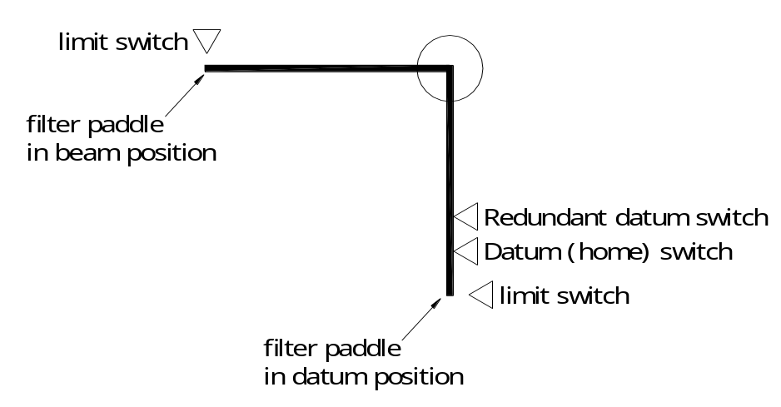
Figure 55 Filter Paddle Micro-switches

Another basic diagram showing the location of the micro-switches for the focus mechanism is shown in figure 3. It is a similar design to the filter paddle micro-switch layout where the limit switches are located at the end of travel before the hard stop and the datum switches are activated on the same plane.

Given that both the filter paddle and focus mechanisms are linear devices and the similarities in the layout of the micro-switches the same software is used to operate both mechanism types. Of course there are some characteristically inherent properties of both mechanisms that will be different (e.g. such as backlash, resonance velocities, etc.) but they are compensated in the operational parameters used for driving each mechanism.

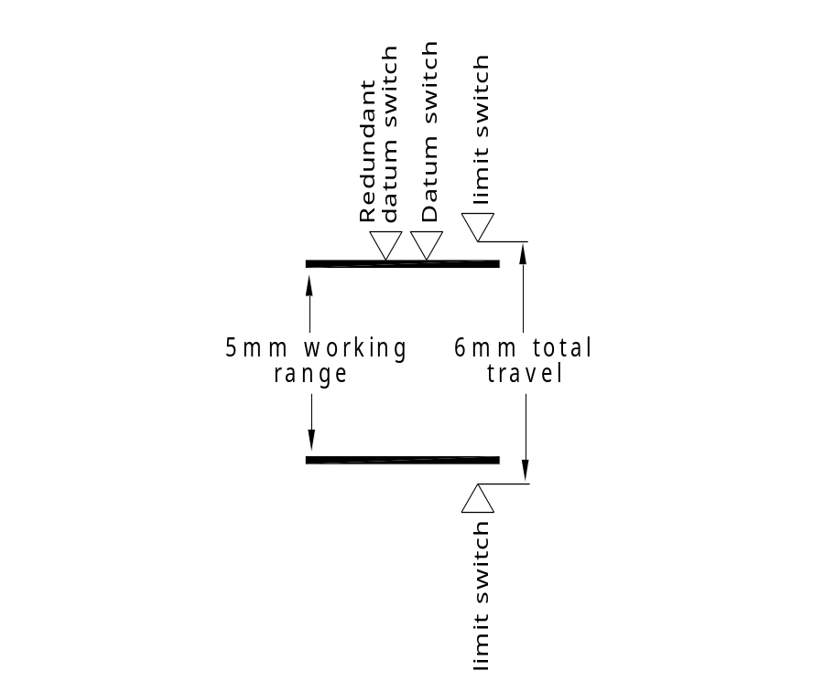
Figure 56 Focus Mechanism Micro-switches

    - Interlocking
An interlocking system is provided to prevent more than filter paddle being driven into the beam position at the same time. A list of the main features of the interlocking system are summarised below:

- Jumpers are used to select whichever datum switch is to be used for each filter. The datum switch signal will be routed to theVME58-8 motor board, the interlock hardware and the digital I/O board.
- It is possible to disconnect any filter mechanism from the interlock hardware so that the state of its datum switch is ignored by the interlock system.
- The interlock hardware will prevent any filter motor from driving if more than one filter datum switch is not activated. The state of the interlock signal is routed to the digital I/O board.
- An interlock override switch is provided to allow the filters to be moved irrespective of the state of the interlock. The state of this switch is also routed to the digital I/O board.

Engineering GUI
    - Overview
The engineering GUI consists of a number of different widgets each with a text name associated with it that describes its purpose. The widgets are summarised below.

- All grey boxes are outputs containing mechanism status information
- All round widgets provide status information that is reflected by the colour of the widget; yellow is idle, green is busy and red is for error. The only exception to this rule is the interlock override status where green means the interlock override is not active and red means the override is activated.
- All brown boxes are inputs. The user can insert new values into these boxes by clicking on them with the mouse and entering text. (NB: Please remember to press the enter key after entering text into the box)
- All brown boxes with black triangles are drop down menus. The user can select these by clicking on the right mouse button and holding it whilst selecting an item on the list.
- All yellow boxes are choice menu buttons. The user can select a menu item by clicking on using the mouse.

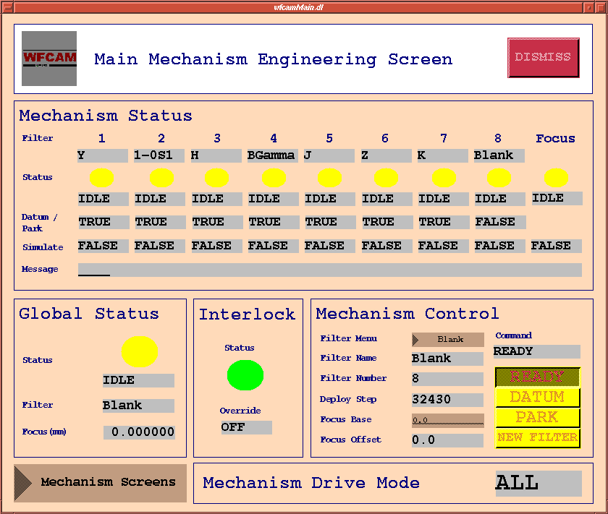
Figure 57 The main mechanism engineering control screen

The main mechanism control screen layout (figure 4) consists of 4 boxed areas which are described below.

- Mechanism Status: Status information for all mechanisms. Each mechanism is identified at the top of each column of widgets. Status information includes the filter name, mechanism state, park/datum switch status, simulation status and a general purpose message feedback widget. Please note that only one filter paddle can be in a busy state at one time but a filter paddle can be busy at the same time as the focus mechanism. Also, only one filter paddle can report FALSE for the park/datum widget status in normal operation otherwise an interlock situation will occur resulting in all mechanisms being powered off (so long as the electronic interlock protection is enabled).
- Global Status: This gives a more general summary of the status for all of the mechanisms. This includes status information for which filter is presently in the beam, the focus position and the overall mechanism state.
- Interlock: Status information for the electronic interlock protection system. This includes status information for the interlock protection state and the interlock override state. If the interlock has been triggered by more than one filter paddle being off its park position then the interlock state will turn red and report ACTIVE otherwise it will be UNACTIVE. The interlock override state is determined by the physical key/switch position on the VME crate which can disable the interlock protection system.
- Mechanism Command: This is the only part of the screen where the user can select commands. There is a pull down menu for selecting a filter paddle. Once a filter is chosen the filter they want user will see the other status fields update displaying the deployment step position and focus offset position. There is also an input text box for given a focus base position which is combined with the focus offset. The command menu button allows the user to DATUM, PARK (interlock recovery) and select a NEW FILTER.
- Mechanism Drive Mode: This provides a single item of status information which is the whether or not the software mode is set for driving ALL mechanisms or just a SINGLE mechanism. When using the main mechanism control screen this status must always display ALL otherwise the user must change it. This can be done by calling up a single mechanism control screen which can be selected from the Mechanisms Screens pull down menu.

    - Mechanism commands
There are three basic high level commands that can be issued to the mechanism control software. These commands can be activated from the command menu button on the engineering screen. Please note that the menu button will normally read READY which is not a command but the default state for the menu button which tells the user they can select a new command. The three commands are DATUM, NEW FILTER and PARK. An explanation for each command is given in the following sections.

i. Datuming
Datuming all of the mechanisms can be done easily by selecting the DATUM command on the command button widget. Datuming is done automatically if the NEW FILTER command is initiated before the mechanisms have been datumed. It is expected that datuming will normally only be carried out during the calibration procedures at the start of the night or in the event of a problem with the mechanisms. Normally datuming will have to be carried out again after an error has occurred to re-initialise the mechanisms and test for any major problems.

ii. Selecting a new filter
In normal operation a typical command would be to select a new filter. This can be done by pressing and holding the right mouse button on the filter name pull down menu widget and dragging the mouse until the appropriate filter has been selected. After the filter has been chosen the NEW FILTER command on the command button widget should be selected. This will initiate the new filter command in the software which can be observed by watching the output status widgets changing their states. Generally, the user should observe a filter paddle being removed from the beam (if one is already in the beam) before the filter selected is moved into the beam position. If the filters have not been previously datum before this command is executed then the datuming command will executed automatically before the new filter is selected.

There is also an input widget for the focus base position in mm units. Each filter paddle has a focus offset associated with it that cannot altered directly. Please refer to section 6 which describes the configuration and set-up. This offset value is added to the focus base value which is zero by default until the user enters a new value. The focus mechanism is moved to this combined base plus offset position in the event of the NEW FILTER command.

iii. Park (Interlock Recovery)
This command can be used at any time, providing another command is not busy. However, it is only intended to be used in the event of a failure to allow for a safe recovery that minimises the risk of any damage caused by mechanisms colliding. Please refer to section 5 which describes the procedure for recovering in the event of an interlock. The safe recovery is executed by concurrently driving all filter paddles, which are not presently parked, out of the beam towards there parked position at a low velocity. Once they reach their parked position (striking the datum switch) they will be halted. Please be aware that a new datum will have to be carried after this command to recalibrate the filter paddles.

    - Driving Individual Mechanisms
Driving an individual mechanism will not normally be necessary unless the user wishes test an individual mechanism that has previously failed or perform calibration. It is possible to drive individual mechanisms by starting up separate GUI by selecting one from the Mechanism Screens pull down menu. By right clicking on the pull down menu the user may select the mechanism they wish to drive by dragging down the cursor. After which a new GUI will appear for the chosen mechanism (figure 5) . Before driving the mechanism it is very important that the user selects SINGLE option in the menu button at the top of the screens where it says Mechanism Drive Mode. This is to let the software system know that a single mechanism is being driven and therefore it should disable some of the higher level functionality. This will prevent conflicts arising in the software. Once the user is finished driving a single mechanism and wishes to return to the higher level GUI they should return the menu button to the ALL option before dismissing the single mechanism screen.

Interlock Recovery
As mentioned in previous sections of this document there is a danger of filter paddle mechanisms colliding resulting in some serious damage to the instrument. Therefore safety checks have been built into the software and the electronics to prevent such a disaster from happening.

A filter paddle may be in one of two positions; in the beam for use in observations or parked out of the way in a safe position where they are in no do danger of colliding with other filter paddles. In normal operation all filter paddles except for the one being used will be parked out of the beam. Whilst a filter paddle is parked it is resting on its datum switch which is used for verification that the filter is safely parked. The software and electronics make use of this verification mechanism to when testing for interlock failure. If more than one filter paddle is not resting on its datum switch (parked out of the way) then the software will report this as an error and refuse to move any more filter paddles into the beam. Of course this check is only carried out intermittently by the software therefore a more full proof solution is provided in the electronics. All power to the mechanism motors is removed when the interlock condition is broken by an electronics circuit board in the VME crate. This is constantly being monitored and is therefore a very good safety mechanism as it stops mechanisms from ever getting close enough to collide. When the interlock safety mechanism is activated the engineers maintaining the system have to go through a procedure to safely recover system. This interlock recovery procedure is outlined below.

    - Interlock safety mechanism is activated
When the interlock safety mechanism is violated the electronics will kill all power to all motor cards. This disables the mechanism from moving therefore preventing any hazard of collisions. When this event occurs the user will be able to observe it by a number of ways. In the VME crate the motor card racks will be switched off and the LEDS indicating the status of the micro switches will show that more than one filter paddle mechanism has an inactive datum switch. Also, the software’s main mechanism control GUI screen will display a warning.

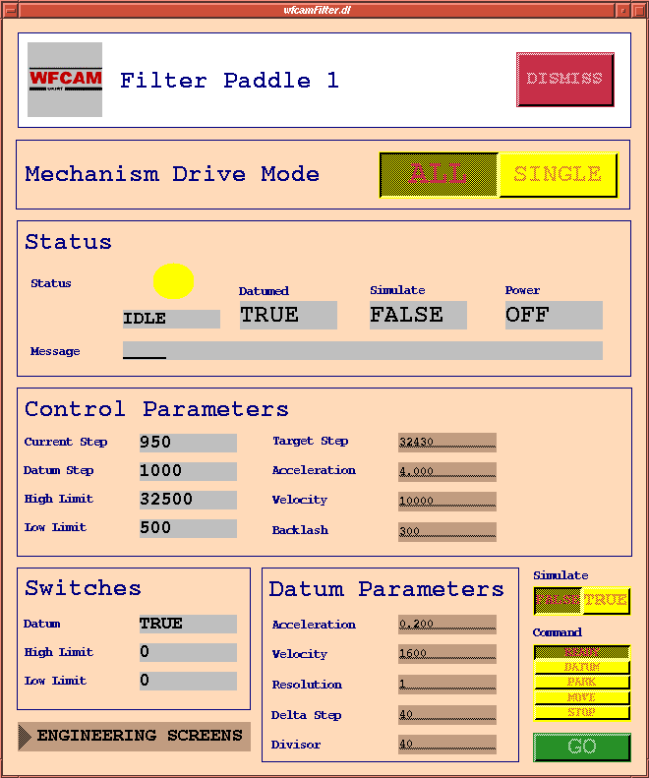
Figure 58 Single mechanism engineering control screen

    - Moving to safety
At this point the user is unable to move any of the mechanisms until power is restored. This can only be done by activating the interlock override switch is can be done by turning a key on the VME crate. Activating the override switch will restore power to the motor card racks allowing the mechanisms to be moved once more. However, at this point to prevent any further mistakes the software will only permit the use of the PARK command. This command is provided especially for safely recovering the mechanisms to a state where they no longer violate the interlock condition. The PARK command concurrently drives all filter paddle that are presently not parked towards their datum positions at a low velocity. Once they activate their datum switches they will be stopped. After the command has completed all filter paddles should be safely restored to their parked positions and the interlock condition should no longer be violated. Therefore the user MUST reactivate the interlock safety mechanism by turning the key back to its original position on the VME crate.

    - Back to normal
At this point the user can start driving the mechanisms as normal. However, as the process of recovering from an interlock failure will mean the mechanisms involved have lost their calibration. They will have to be datumed once again before going any further.

    - What to do if a mechanism consistently fails?

i. Faulty datum switch
If a mechanism is consistently failing there are a couple of options open to the users. If the reason for failure is due to a faulty datum switch then the user can switch to the backup datum switch. This is done by switching jumpers on the electronics board in the VME crate. Please refer to document RD02 for more information.

ii. Running in simulation
The user may decide that they will continue to use the instrument without using the faulty mechanism. This can be done by setting the mechanism to simulation mode in the software. Therefore if the system attempts to drive the simulated mechanism it will give the appearance of still working but will not actually move. Of course the operators should be made aware of this problem so they know which observational data is affected by a missing filter. In order to configure a mechanism to run in simulation the ‘interface.dat’ data configuration file must be update.

However, this may still not be enough for scenario where a mechanism has failed and cannot be returned to its parked position. As the electronics interlock mechanism checks the direct input of the datum switches running the software in simulation will not disable this test. Therefore the user can switch a jumper on the electronics board (reference document RD02) so that the datum switch is permanently active and therefore does not fail the interlock test. Be aware though that such a decision must be made with EXTREME caution. It is advised that this feature should NEVER be used unless the user is completely confident that the failed filter paddle is not in any danger of colliding with another filter paddle. A judgement call like this is almost impossible to make given the limited feedback for the mechanism positional status.

Configuration and Setup
All configuration is handled using the EPICS pvload utility. Data files containing configuration values for EPICS database records are loaded using pvload. This is done automatically as part of the VxWorks boot script that is loaded when the VME system is switched on. The user may edit these data files and modify configuration values and then run pvload to update the database records at runtime or install the data files so they are used by default. This allows the user to re-configure the mechanism control software at any time for temporary or permanent configurations.

There are several data configuration files including one for each individual mechanism (i.e. focus.dat, filter1.dat, filter2.dat, etc) and a global data file for handling the system interface (i.e. interface.dat). Generally each mechanism is configured with similar data values but may be customised to meet that mechanisms particular setup. As we have eight identical filter paddles these data files use identical values. Obviously the focus mechanism is quite different compared to the filter paddles which is reflected in its differing data values. The mechanism data file contains such operating parameters as the positive limit, negative limit, backlash distance, acceleration, velocity, etc. The interface data file contains parameters such as filter paddle filter names, focus offsets, deployment positions, etc. An example of a mechanism configuration file and the interface configuration file are given in the appendix section. A list of all the file names is given below.

Appendix
Below is an example of the contents of the configuration data file ‘filter1.dat’.

# WFCAM FILTER mechanism PV Load .data file
# Initialisation of system parameters by pvload.
# 2003-Oct-13: Use half steps

# Filter Paddle 1
# ---------------
# Motor power - ensure OFF
string wfcam:ccs:fltr1:powerBo.VAL = "OFF";

# Motor Record:
# -> motion-related fields
float wfcam:ccs:fltr1:motor.VMAX = 20000;
float wfcam:ccs:fltr1:motor.VBAS = 0;
float wfcam:ccs:fltr1:motor.VELO = 10000;
float wfcam:ccs:fltr1:motor.ACCL = 4.0;
float wfcam:ccs:fltr1:motor.BDST = 300.0;
float wfcam:ccs:fltr1:motor.BVEL = 2000.0;
float wfcam:ccs:fltr1:motor.BACC = 4.0;
# -> limit-related fields
float wfcam:ccs:fltr1:motor.HLM = 32500.0;
float wfcam:ccs:fltr1:motor.DHLM = 32500.0;
float wfcam:ccs:fltr1:motor.LLM = 500.0;
float wfcam:ccs:fltr1:motor.DLLM = 500.0;
# -> miscellaneous fields
string wfcam:ccs:fltr1:motor.EGU = "steps";
# end Motor Record

# Datum information
# Step position of datum switch 1
long wfcam:ccs:fltr1:datumPosLo = 1000;

# Datum deltaStep size - the number of steps initially used
# to incrementally search for switch, once the switch is found
# the deltaStep is reduced in stages until it is 1 step.
long wfcam:ccs:fltr1:datumDeltaLo = 40;
long wfcam:ccs:fltr1:datumDivLo = 40;
long wfcam:ccs:fltr1:datumResLo = 1;

# Velocity to use during datum search, steps/second
long wfcam:ccs:fltr1:datumVeloLo = 1600;
# Acceleration to use during datum search, seconds
float wfcam:ccs:fltr1:datumAcclAo = 0.2;

# Velocity to use during parking, steps/second
float wfcam:ccs:fltr1:parkVeloLo = 1000;
# Acceleration to use during parking, seconds
float wfcam:ccs:fltr1:parkAcclAo = 0.2;

# Velocity to use during moving, steps/second
float wfcam:ccs:fltr1:moveVeloLo = 10000;
# Acceleration to use during moving, seconds
float wfcam:ccs:fltr1:moveAcclAo = 4.0;

Below is an example of the contents of the configuration data file ‘interface.dat’.

# WFCAM Interface PV Load .data file
# Initialisation of system parameters by pvload.

string wfcam:ccs:focusSimBi.VAL = "FALSE";
string wfcam:ccs:fltr1SimBi.VAL = "FALSE";
string wfcam:ccs:fltr2SimBi.VAL = "FALSE";
string wfcam:ccs:fltr3SimBi.VAL = "FALSE";
string wfcam:ccs:fltr4SimBi.VAL = "FALSE";
string wfcam:ccs:fltr5SimBi.VAL = "FALSE";
string wfcam:ccs:fltr6SimBi.VAL = "FALSE";
string wfcam:ccs:fltr7SimBi.VAL = "FALSE";
string wfcam:ccs:fltr8SimBi.VAL = "FALSE";

# NB: the filter names for filterGen and filterMbbo
# MUST be in identical order
string wfcam:ccs:filterGen.A = "None";
string wfcam:ccs:filterGen.B = "Y";
string wfcam:ccs:filterGen.C = "1-0S1";
string wfcam:ccs:filterGen.D = "H";
string wfcam:ccs:filterGen.E = "BGamma";
string wfcam:ccs:filterGen.F = "J";
string wfcam:ccs:filterGen.G = "Z";
string wfcam:ccs:filterGen.H = "K";
string wfcam:ccs:filterGen.I = "Blank";

# NB: the filter names for filterGen and filterMbbo
# MUST be in identical order
string wfcam:ccs:filterMbbo.ZRST = "None";
string wfcam:ccs:filterMbbo.ONST = "Y";
string wfcam:ccs:filterMbbo.TWST = "1-0S1";
string wfcam:ccs:filterMbbo.THST = "H";
string wfcam:ccs:filterMbbo.FRST = "BGamma";
string wfcam:ccs:filterMbbo.FVST = "J";
string wfcam:ccs:filterMbbo.SXST = "Z";
string wfcam:ccs:filterMbbo.SVST = "K";
string wfcam:ccs:filterMbbo.EIST = "Blank";

# Deployment step positions for primary datum
string wfcam:ccs:deployMbbo.ZRST = "0";
string wfcam:ccs:deployMbbo.ONST = "32460";
string wfcam:ccs:deployMbbo.TWST = "32265";
string wfcam:ccs:deployMbbo.THST = "32330";
string wfcam:ccs:deployMbbo.FRST = "32340";
string wfcam:ccs:deployMbbo.FVST = "32350";
#string wfcam:ccs:deployMbbo.FVST = "32315";
string wfcam:ccs:deployMbbo.SXST = "32270";
string wfcam:ccs:deployMbbo.SVST = "32335";
string wfcam:ccs:deployMbbo.EIST = "32430";

# Deployment step positions for secondary datum
#string wfcam:ccs:deployMbbo.ONST = "32500";
#string wfcam:ccs:deployMbbo.TWST = "32325";
#string wfcam:ccs:deployMbbo.THST = "32330";
#string wfcam:ccs:deployMbbo.FRST = "32355";
#string wfcam:ccs:deployMbbo.FVST = "32345";
#string wfcam:ccs:deployMbbo.SXST = "32360";
#string wfcam:ccs:deployMbbo.SVST = "32355";
#string wfcam:ccs:deployMbbo.EIST = "32340";

string wfcam:ccs:focusOffMbbo.ZRST = "0.0";
string wfcam:ccs:focusOffMbbo.ONST = "-1.33";
string wfcam:ccs:focusOffMbbo.TWST = "+0.49";
string wfcam:ccs:focusOffMbbo.THST = "+0.25";
string wfcam:ccs:focusOffMbbo.FRST = "+0.49";
string wfcam:ccs:focusOffMbbo.FVST = "-0.70";
string wfcam:ccs:focusOffMbbo.SXST = "-1.64";
string wfcam:ccs:focusOffMbbo.SVST = "+0.49";
string wfcam:ccs:focusOffMbbo.EIST = "0.0";

# Blank filter
long wfcam:ccs:defFiltLo.VAL = 8;
long wfcam:ccs:defStepLo.VAL = 32430;

# Initialise the set point
long wfcam:cryo:ls331_1:setsetp.PROC = 1;
long wfcam:cryo:ls331_2:setsetp.PROC = 1;

# end WFCAM PV load file 'interface.data'
- Handling jigs and fixtures
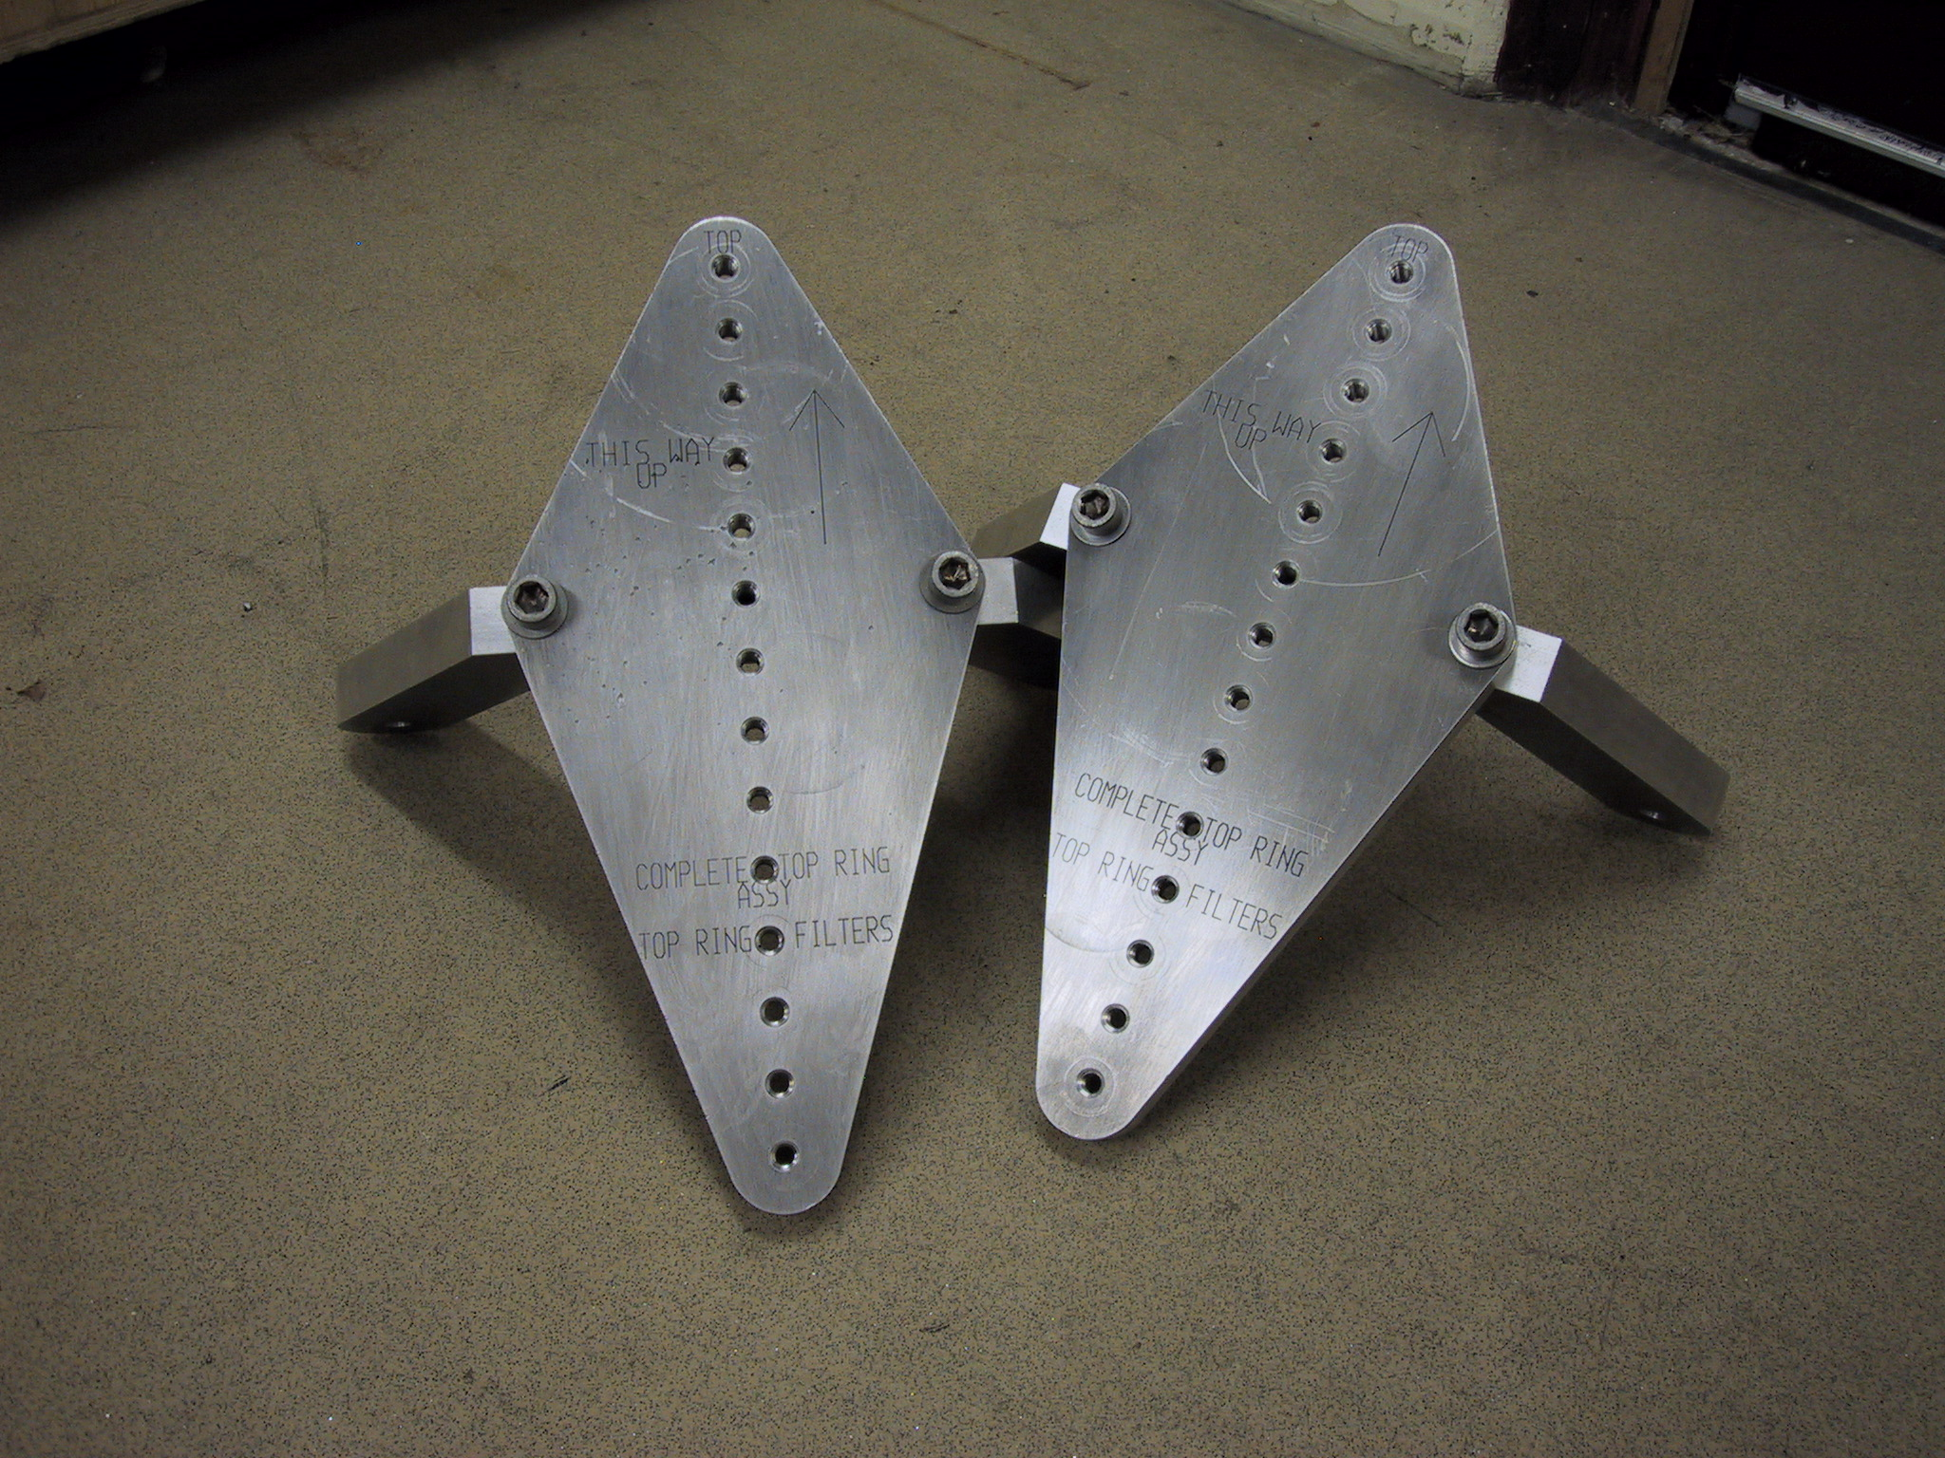

Figure 59 Top ring handling brackets

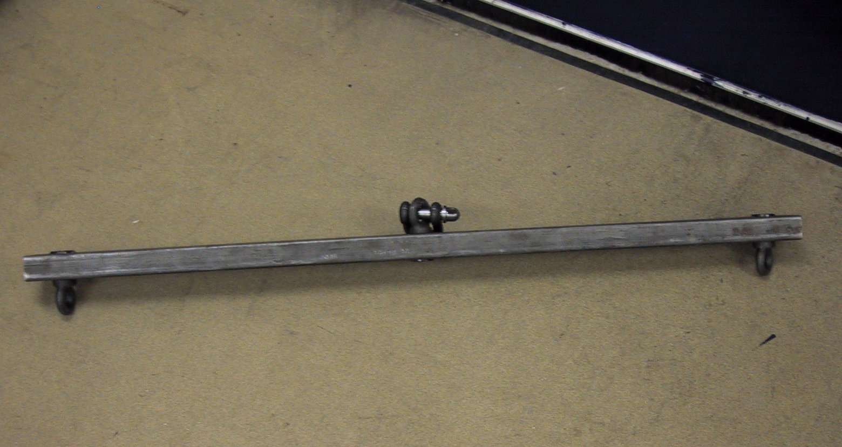
Figure 60 Spreader beam

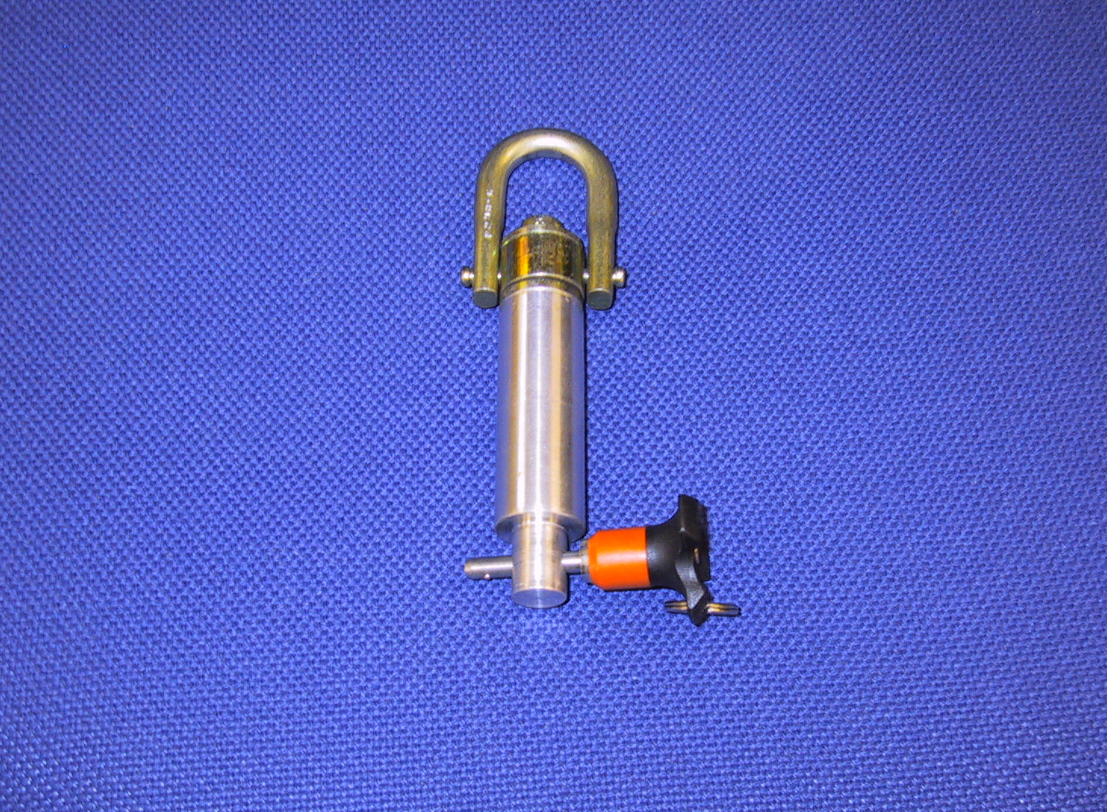
Figure 61 Swivel hoist rings
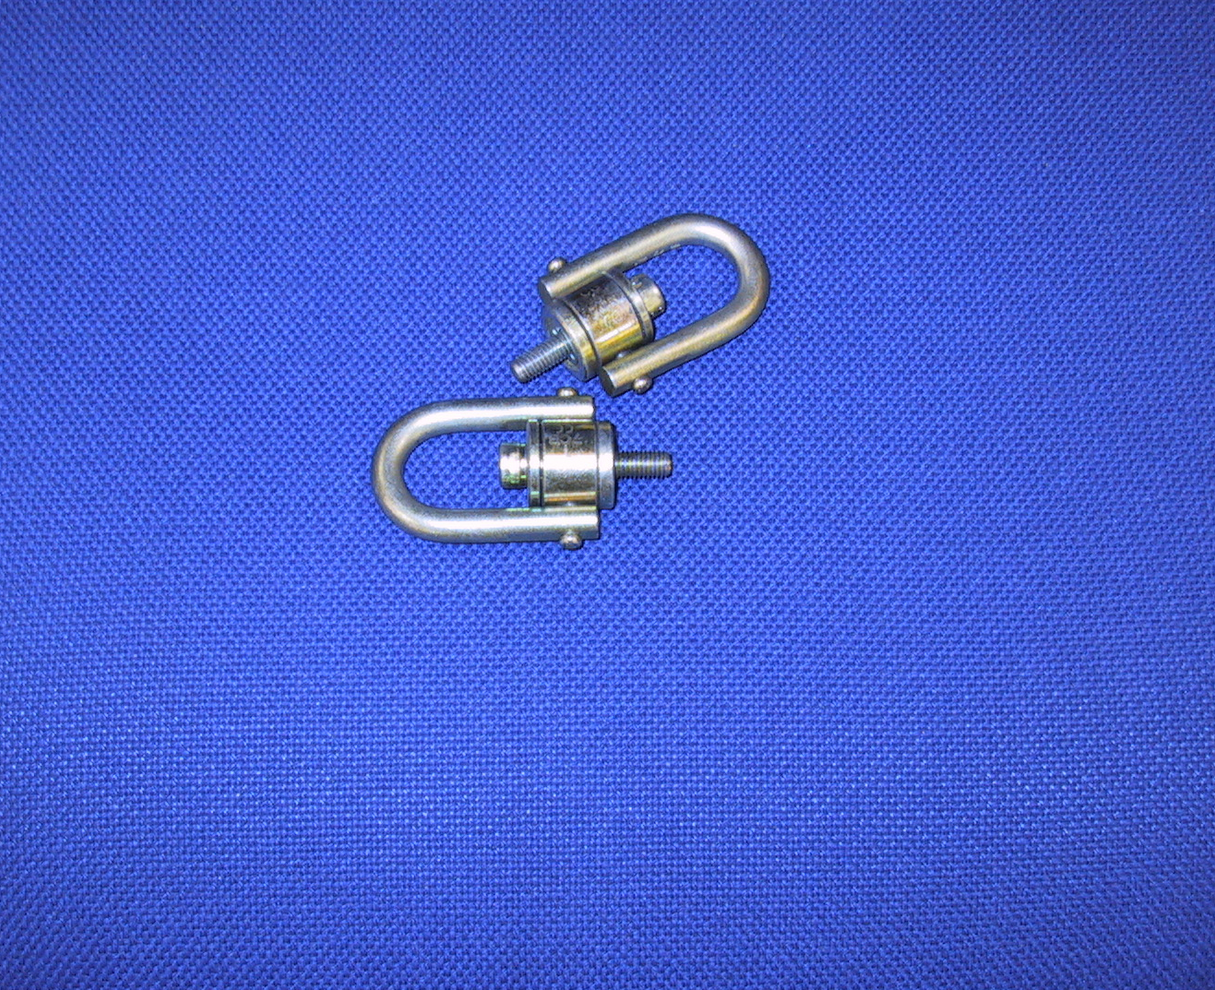

APPENDIX a – RECOMMENDED Spares List

The following table list the recommended spare items that should be available to maintain WFCAM and minimise downtime if a fault occurs. The list of spare delivered with WFCAM is given in document 11d060G. Where an item is a bought out part, details of the supplier it was obtained from are given.

Item No. | Description | Quantity | Part No. | Comments/Supplier info
1 | Cryogenic motor | 2 | Begher Lahr  VRDM56450LNA | SIG Positec Automation  Slough  Berks SL3 7EW
2 | Focus lead-screw nut | 1 | WFCAM 34-09-22-002 | Made in UK ATC workshop
3 | Focus mechanism bearing set | 1 Set | Motor bearing  S36MCJ5LDM2P69LDM2  Flange bearing  N180-000 | Set comprises of 6 motor bearings & 1 flange bearing.  Timken\MPB  10 Optical Ave  Keene,NH 034314319, USA
4 | Filter arm bearing set | 2 Sets | Motor bearing  S36MCJ5LDM2P69LDM2  Flange bearing  N180-000 | Set comprises of 2 motor bearings & 4 flange bearing.  Timken\MPB  10 Optical Ave  Keene,NH 034314319, USA
5 | Vespel worm (filter arm) | 1 | Wfcam-34-08-15-017 | Kingsway Engineering,  1A Lower Hanham Rd  Hanham, Bristol, BS15 2HH
6 | Washer set | 1 Set | N/A | Set comprises 10 each of :-  - M3 plain & split  - M4 plain & split  - M6 plain  - M8 plain
7 | Microswitch | 5 | Burgess  V4NT7-GPX | E Preston Electrical  Broadway  Globe Lane Industrial Estate  Cheshire  SK16 4UU
8 | O-ring set (large outer) | 1 Set | 1028x5 “O-Ring (Viton) | Mantek Ltd  Holder Road  Aldershot  GU12 4RH
9 | O-ring set  (connector panels) | 1 Set | 173x3 “O-Ring (Viton) | Mantek Ltd  Holder Road  Aldershot  GU12 4RH
10 | M2 flexures | 3 | WFCAM-33-05-01-000 Issue 1.1 | Express Engineering  Gateshead, NE11 OEG
11 | Flat panel monitor | 1 | No. AU4831 DG | 19” IIYAMA (1600 x 1200 max resolution).  * Same supplier as item 12
12 | Data reduction PC | 1 | See note 4 | Eclipse Computing,  Eclipse House, Lugar, Ayrshire,  KA18 3JH

Item No. | Description | Quantity | Part No. | Comments
13 | Data acquisition PC | 1 | See note 5 for details | Eclipse Computing,  Eclipse House, Lugar, Ayrshire,  KA18 3JH  * Has PCI card fitted
14 | Motor drive card | 3 | S561 | Cortex Controllers, 50 St Stephens pl,  Cambridge, CB3 0JE  Note these will be fitted into the cortex controller box in the services cabinet
15 | PowerPC | 1 | MVME2434-1 ( 350Mhz, 256MB) | Crellon Microsystems  3 The Business Centre  Molly Millars Lane  Workingham, RG41 2EY
16 | 32 Channel SDSU IR controller | 1 | See note 3 for details | Astronomical Research Cameras, Inc.  3547 Camino del Rio South, Suite A  San Diego, CA 92108
17 | SDSU Controller PSU | 1 | ARC-80 | This PSU can be used with an IR or Optical SUSU Controller.  * Same supplier as item 16
18 | E2V CCD Assembly | 1 | E2V 47-10 | e2v technologies  106 Waterhouse Lane  Chelmsford  Essex CM1 2QU, England
19 | SDSU CCD controller | 1 |  | For use with Autoguider CCD  * same supplier as item 16
20 | Filters | See comment  & Notes 1 & 2 below for supplier details |  | - Y (2 off) Supplied by NDC  - H (2 off) Supplied by NDC  - J (4 off) Supplied by NDC  - K (4 off) Supplied by NDC  - H2 (2 off) Supplied by NDC  - Z (2 off) Supplier by REO Inc  - Br G (2 off) Supplied by NDC
21 | PCB’s | 1 |  | 1) Intend to provide 1 spare array pcb assembly i.e. fully populated
22 | IR array Pre-amp box | 1
23 | Controller Cabinet fan | 1

Item No. | Description | Quantity | Part No. | Comments
24 | Warm up heater panels | 2 | Minco HK5185 R17-6L12D | Minco Products, Inc.  7300 Commerce Lane  Minneapolis, MN 55432-3177  U.S.A.
25 | VME 58 card | 1 | VME 58-8 | Naples Coombe Ltd,  Main Street,  Chaddleworth  Berkshire RG20 7BH
26 | VME Interface card | 1 |  | 1 off I/F BOARD 1. Drawing No WFCAM-24-05-0200  1 off I/F BOARD 2. Drawing No WFCAM-24-05-0300  1 off I/F BOARD 3. Drawing No WFCAM-24-05-0400
27 | Solid state relay unit | 2 |  | Used in motor control enable unit and warm up heater controller ( in service cabinet )
28 | Data acquisition / reduction PC PSU | 4 |  | Eclipse Computing,  Eclipse House, Lugar, Ayrshire,  KA18 3JH
29 | Data acquisition / reduction PC Fan | 4 |  | Eclipse Computing,  Eclipse House, Lugar, Ayrshire,  KA18 3JH
30 | 160GB Hard disk | 8 |  | Eclipse Computing,  Eclipse House, Lugar, Ayrshire,  KA18 3JH
31 | M3 Flexures | 2 | 4187/300.F007 Issue D | Express Engineering  Gateshead, NE11 OEG  * Part no. quoted is SESO dwg ref
32 | Cables | See comment | No number  24-08-409  24-08-414  24-08-417  24-08-407  24-08-408  24-08-410  No Number  24-08-415  24-08-416  No Number  24-07-113  24-07-114  24-07-115 | SDSU CCD PSU cable  SDSU CCD signal cable  Temp sense/control (IR) cable  Filter paddle/Focus Motor cable  SDSU Detector signal/bias cable  SDSU Detector clocks cable  SDSU Detector signal cable  Turbo pump cable  Temperature sensor cable  Filter paddle/focus switches cable  - SDSU IR PSU Cable  - CCD Cryostat Cable  - CCD Cryostat Cable  - CCD Cryostat Cable

Item No. | Description | Quantity | Part No. | Comments
33 | Connectors | 1 OF EACH | DT02H12-10P  DT02H12-8P  DT02H14-12P  DT02H14-19P  DT02H16-26P | TEMP SESNSE CONTROL (IR & CCD)  HEATER SUPPLY  MICRO SWITCHES  MOTOR DRIVES  TEMPERATURE SENSORS
34 | Temperature Sensor | 1 | DT-470-DI-13 | Lake Shore Cryotronics  575 Mccorkle Boulevard  Westerville  Ohio 43082 - USA
35 | Programmed  Interlock Chip | 1 | Wfcam-24-05-020J | Use in VME I/F Board ( IC ref EPM 7032 SLC44)
36 | Thermal switch | 2 |  | Temperature switch used to protect SDSU’s from overheating (30 deg C)
37 | Thermal switch | 3 |  | Temperature switch used to protect SDSU’s from overheating (40 deg C). Note 30 or 40 deg switch may be used)
38 | ASTEC 16.5V PSU | 1 |  | Used in SDSU PSU  * Same supplier as item 16
39 | ASTEC 6.5V PSU | 1 |  | Used in SDSU PSU  * Same supplier as item 16
40 | Temperature Sensor | 2 |  | Used with warm up heaters (AG’s & IR)
41 | Warm up Heater Controller | 1 | Minco CT 16A 2020
42 | ASTEC 5V PSU | 1 |  | Used in SDSU PSU  * Same supplier as item 16

Notes:
- NDC Infrared Engineering Ltd, Bates Rd, Maldon, Essesx CM9 5FA, UK
- Research Electro-Optics Inc, 5505 Airport Blvd, Boulder, Colorando 80301 – USA
- SDSU Controller consists of the following parts, one off 12 slot controller housing containing –
ARC-22 250Mhz fibre optic timing board 1 off
ARC-64 250Mhz PCI interface board 1 off
ARC-30 IR Clock driver board 1 off
ARC-45 Eight readout IR video board 4 off
- Data reduction PC includes
3U 19” Rackmount 8 IDE drive bay Rackmount chassis with -
460Wdual 1+1 redundant PSU, 1 x Slim CD-ROM bay,
1 x Floppy bay & 1 Full Height Tape Drive Bay
Dual P4 Xeon motherboard (E7505 chipset) with AGP slot,
Dual channel Ultra 320 controller, 1x 1000 Gigabit LAN controller
and 3 x 64bit PCI-X slots (2 free slots)
1 x Intel P4 Xeon 2.8GHz 512k processor
1GB DDR266 ECC registered memory upgradeable to 4GB
3Ware Escalade 8 port 7500 series IDE RAID controller
5 x 160GB 7200rpm 2MB cache ATA133 IDE disk drive (640GB as RAID 5)
64MB Nvidia Geforce4 FX5200 AGP 8X DVI 128bit Graphics Card
1 x LTO Ultrium 100/200GB Tape drive
Slimline CD-ROM drive
1.44MB Floppy drive
Redhat Linux installed
- Data Acquisition PC includes
3U 19” Rackmount 8 IDE drive bay Rackmount chassis with -

460Wdual 1+1 redundant PSU, 1 x Slim CD-ROM bay,
1 x Floppy bay & 1 Full Height Tape Drive Bay
Gigabyte Skt 370 Dual PIII motherboard with onboard graphics,
Ultra 160 SCSI controller, 2 x 10/100 LAN controller, 2 x 32bit & 2 x 64bit PCI
2 x Intel PIII 1.4GHz processors
1GB PC133 ECC registered memory upgradeable to 4GB
3Ware Escalade 8 port 7500 series IDE RAID controller
5 x 160GB 7200rpm 2MB cache ATA133 IDE disk drive (640GB as RAID 5)
1 x Intel 1000BaseT Network Adapter
1 x LTO Ultrium 100/200GB Tape drive
Slimline CD-ROM drive
1.44MB Floppy drive
US Power Cord
Redhat Linux installed

